Moduldokumentation

Modul Compilerbau (cpib)

Simon Wächter

2017

Inhalt

1 Einleitung 7

1.1 Einleitung 7

1.2 Lernziele 7

1.3 Prüfungen 7

2 Woche 1 8

2.1 Organisatorisches 8

2.1.1 Deadlines 8

2.1.2 Kommunikation 8

2.1.3 Berichte 9

2.1.4 Rechtliches in Berichten 9

2.1.5 Stil von Berichten 9

2.1.6 Titelblatt 10

2.1.7 Beispiele eines Titels 10

2.1.8 Inhalt eines Berichtes 10

2.1.9 Technischer Umfang des Projektes 11

2.2 Introduction to Compilers 11

2.2.1 Building a Compiler 11

2.2.2 Old versions of IML 12

2.2.3 Old versions of VMCode 12

2.2.4 Possible Extensions for IML 13

2.2.5 Interpreter 14

2.2.6 Compiler 15

2.2.7 Compiler and Interpreter 15

2.2.8 Recipes, Translators and Bakers 16

2.2.9 Exercise 16

2.2.10 Compile Time versus Run Time 16

2.2.11 Internal Construction of a Compiler: Analysis versus Synthesis 17

2.2.12 Internal Construction of a Compiler: Front End versus Back End 18

2.2.13 Lexical Analysis 19

2.2.14 Grammatical Analysis 19

2.2.15 Type and Context Checking 19

2.2.16 Code Generation 20

2.3 Introduction to IML 20

2.3.1 Purpose of IML 20

2.3.2 Kind of Language 20

2.3.3 Example of IML 21

2.3.4 Some Enumerations 21

2.3.5 Integer Literals, Identifiers, Whitespace and Line Comments 22

2.3.6 Symbols 22

2.3.7 Keywords 23

2.3.8 Programs 23

2.3.9 Declarations 24

2.3.10 Parameter Lists 24

2.3.11 Commands 24

2.3.12 Expressions (For Language Specification) 25

2.3.13 Expressions (For Language Implementation) 25

2.3.14 Expressions in IML 25

3 Woche 2 26

3.1 Lexical Analysis 26

3.2 Data Structures (Terminals etc.) 27

3.3 Data Structures (Tokens) 27

3.4 Data Structures (Token List) 28

3.5 Patterns, Lexemes and Tokens 28

3.6 Keywords 29

3.7 Scanning Algorithm 29

3.8 Scanner in Java 30

3.9 Scanner in Haskell 31

3.10 IM Lexical Syntax 32

3.11 Your Task 32

4 Woche 3 33

4.1 Example Command 33

4.2 Alphabet 33

4.3 Context Free Grammars 33

4.4 Notational Convention 34

4.5 Derivations 34

4.6 Leftmost and rightmost Derivations 35

4.7 Derivations 35

4.8 Parse Trees and Derivations 36

4.9 Ambiguity 36

4.10 From BNF to EBNF 37

4.11 EBNF 37

4.12 Regular Languages 38

4.13 Context Free Grammars and Context Dependencies 39

4.14 Example CFG versus Context Checking 39

5 Woche 4 41

5.1 Order of Evaluation in Expressions 41

5.2 Examples of Associativities 41

5.3 Order of Evaluation in Expressions 42

5.4 Grammar for Expressions (Precedence without Associativity) 42

5.5 Grammar for Expressions (Associativity) 43

5.6 Grammar for Expressions (Complete) 43

5.7 Grammar for Expressions 43

5.8 Problem 1: Left Recursion 44

5.9 Problem 2: Alternatives with the same leftmost Symbol 44

5.10 New Grammar for Expressions (Complete) 45

5.11 Expressions in IML 45

5.12 Expressions: User’s Grammar 46

5.13 Expressions: Implementor’s Grammar 46

5.14 Simplified Expressions in IML 46

5.15 Boolean Expressions 47

5.16 Exercise 48

5.17 Parser 49

5.18 Parser in Java 49

5.18.1 Interface 49

5.18.2 Class and Constructor 50

5.18.3 Consume Method 50

5.18.4 Parse Method 50

5.19 Basic Idea of the Parser 51

5.20 Already known Problems for the Parser 51

5.21 Parser Table of the Parser 52

5.22 Parser Table for our Expressions 52

5.23 Example Parser Table 52

6 Woche 5 53

6.1 Construction of Parse Tables 53

6.2 Conventions 53

6.3 NULLABLE 54

6.4 NULLABLE in general 54

6.5 FIRST 55

6.6 FIRST in general 55

6.7 FOLLOW 56

6.8 FOLLOW in general 56

6.9 Example 57

6.10 Strange Recursion 57

6.11 Construction of Parse Table 58

6.12 Resulting Parse Table 59

6.13 LL(1) Grammars 60

7 Woche 6 & 7 61

7.1 Syntax Trees 61

7.2 Concrete Syntax Tree 61

7.3 Class ITerm3 61

7.4 Class Term3 62

7.5 Class IRepMULTOPRfactor 62

7.6 Class RepMULTOPRfactorOpr 62

7.7 Class RepMULTOPRfactorEps 63

7.8 Extension of Parser to return Concrete Syntax Trees 63

7.9 Extension of Parser to return Syntax Trees 63

7.10 Concrete versus Abstract Syntax 64

7.11 Abstract Syntax 65

7.12 Grammar IML (Expressions) 65

7.13 Grammar IML (Base) 66

7.14 Grammar IML (Commands) 66

7.15 Conversion 68

7.16 Test Program 68

7.17 Correcting Associativity 68

8 Woche 8 70

9 Woche 9 71

10 Woche 10 & 11 72

10.1 Machine Specification 72

10.2 Implementations of Virtual Machine 72

10.3 Storage 72

10.4 Initialization 74

10.5 Data 74

10.6 Instructions 75

10.7 Main Loop 76

10.8 A very important Instructions 76

10.9 Inner Classes 77

10.10 Programming the Machine 77

10.11 Kind of Instructions 78

10.12 Further Example: SubInt 78

10.13 Parameters 78

10.14 Format for Instructions 79

10.15 NegInt 79

10.16 AddInt, SubInt 79

10.17 MultInt, DivTruncInt, ModTruncInt 80

10.18 EqInt, NeInt, GtInt, GeInt, LtInt, LeInt 80

10.19 UncondJump, CondJump 81

10.20 InputBool, InputInt 81

10.21 OutputBool, OutputInt 81

10.22 LoadImInt 82

10.23 LoadAddrRel 82

10.24 Deref 82

10.25 Store 83

10.26 Dup 83

10.27 AllocBlock 83

10.28 AllocStack 84

10.29 Call 84

10.30 Return 84

10.31 Stop 85

10.32 Static Analysis 85

10.33 Static Analysis in IML 86

10.34 Terminology 86

10.35 Scope and Visibility 87

10.36 Scopes in IML 87

10.37 Scopes 88

10.38 Global Imports 88

10.39 Example: Assignment Commands 89

10.40 Example: Routine Calls 89

10.41 L-Value and R-Value Expressions 89

10.42 Result of Scope Checking 90

10.43 Scopes and Access Modes 90

10.44 Example 90

10.45 Default Modes 91

10.46 Implementation 91

10.47 Example Type of DyadicExpr 92

10.48 Example Type of VarExpr 92

11 Woche 12 & 13 93

11.1 Static Analysis 93

11.2 Static Analysis in IML 93

11.3 Terminology 94

11.4 Scoping and Visibility 94

11.5 Scopes in IML 95

11.6 Scopes 95

11.7 Global Imports 96

11.8 Example: Assignment Commands 96

11.9 Example: Routine Calls 97

11.10 L-Value and R-Value Expressions 97

11.11 Result of Scope Checking 98

11.12 Scopes and Access Modes 98

11.13 Example 99

11.14 Default Modes 99

11.15 Implementation 100

11.16 Example Type of DyadicExpr 101

11.17 Example Type of VarExpr 101

12 Woche 14 102

13 Woche 15 103

# Einleitung

## Einleitung

Dieses Dokument stellt die Moduldokumentation für das Modul cpib dar. Allfällige Unterlagen sind im Modulordner zu finden.

## Lernziele

Das Modul beinhaltet folgende Lernziele:

* Grundlagen
  + Kompilation und Interpretation; Korrektheit von Compilern
  + Aufbau eines Compilers
  + Formale Sprachen, insbesondere reguläre und kontextfreie
  + Lexikalische Analyse (Scanning)
  + Grammatikalische Analyse (Parsing)
* Abstrakte Syntax
  + Semantische Analyse
  + Virtuelle Maschine
  + Codeerzeugung
  + Werkzeuge zum Compilerbau

## Prüfungen

Die Modulnote setzt sich zu 100% aus einer Präsentation samt Fragerunde und zu bestehenden Vor- und Zwischenberichten zusammen.

# Woche 1

## Organisatorisches

### Deadlines

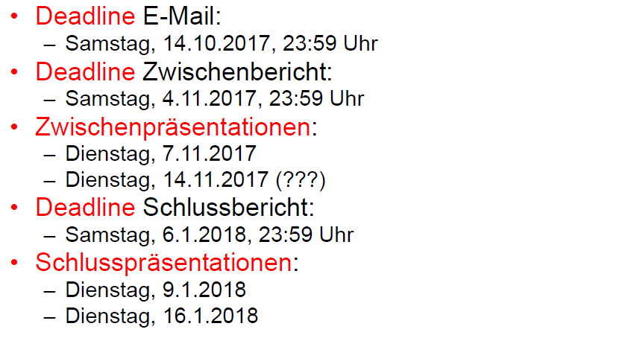

### Kommunikation

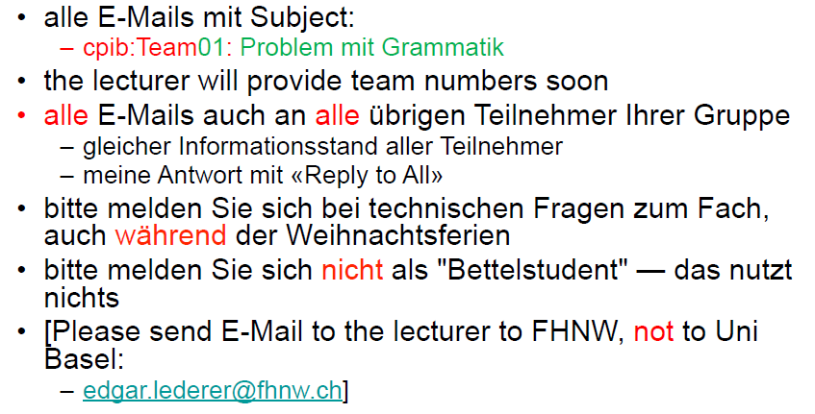

### Berichte

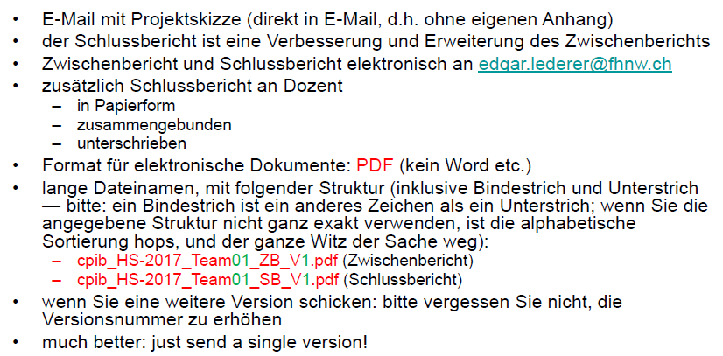

### Rechtliches in Berichten

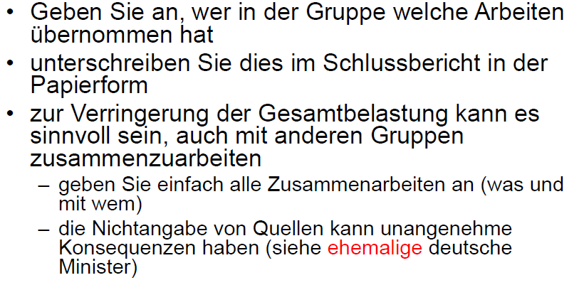

### Stil von Berichten

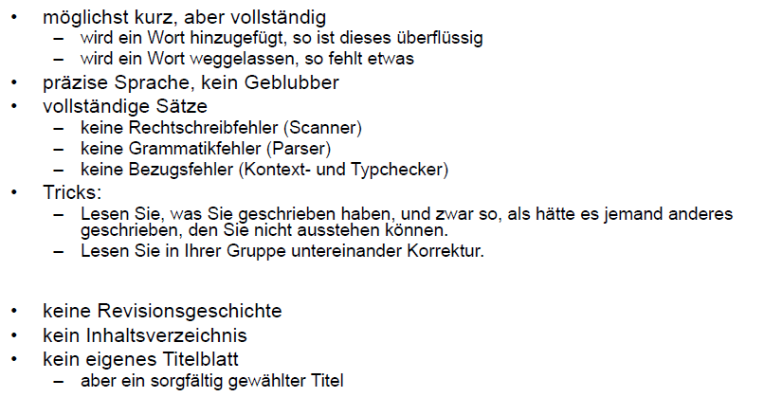

### Titelblatt

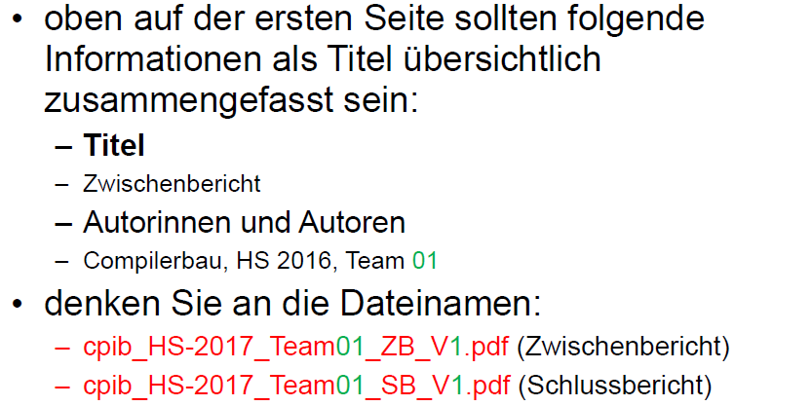

### Beispiele eines Titels

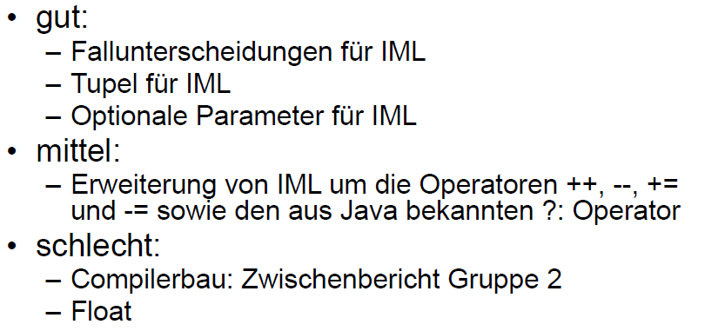

### Inhalt eines Berichtes

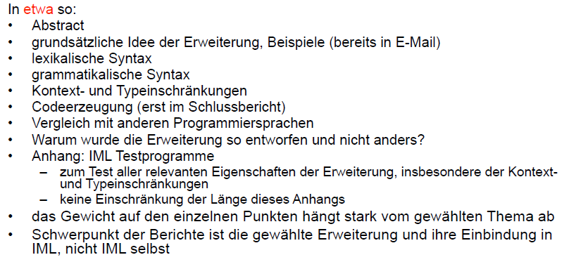

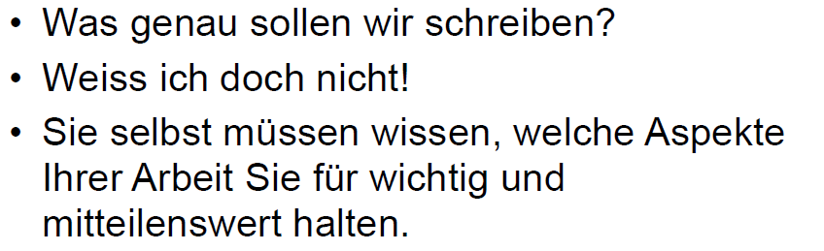

### Technischer Umfang des Projektes

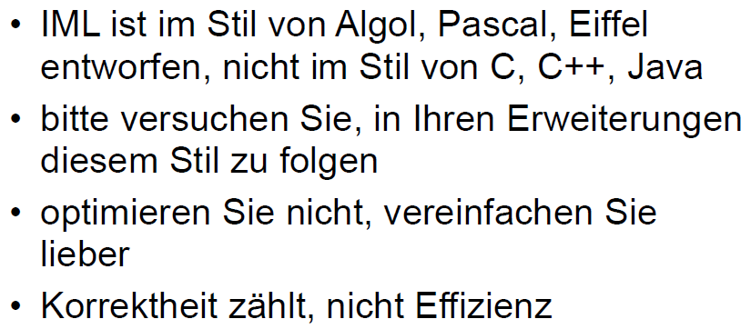

## Introduction to Compilers

### Building a Compiler

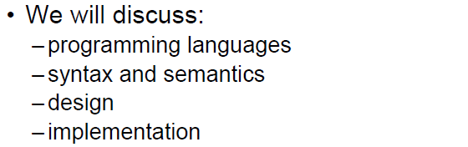

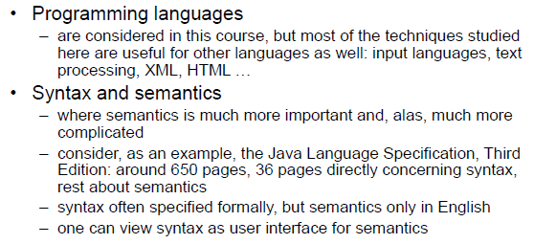

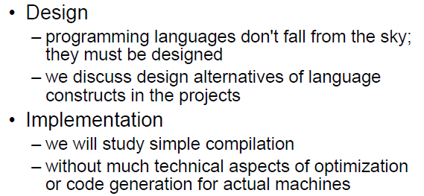

### Old versions of IML

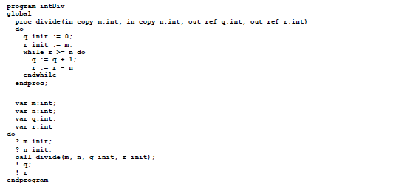

### Old versions of VMCode

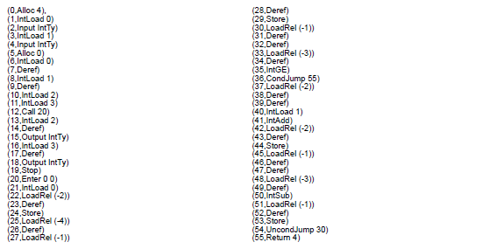

### Possible Extensions for IML

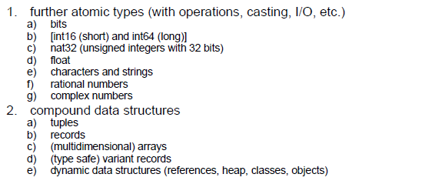

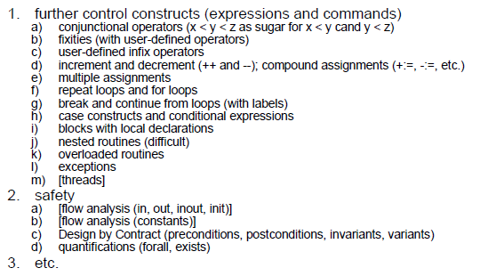

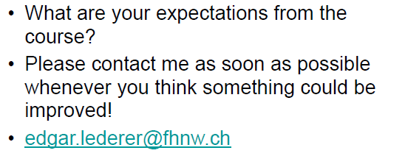

### Interpreter

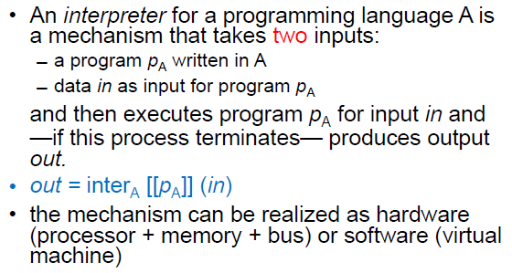

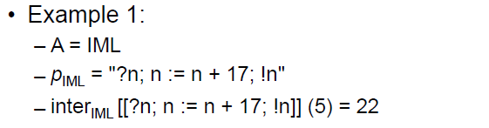

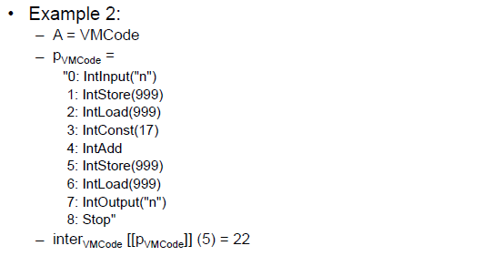

### Compiler

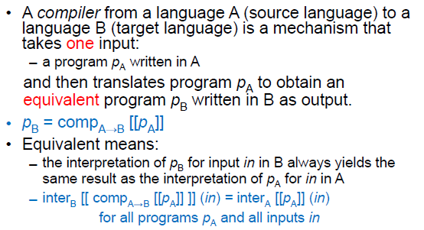

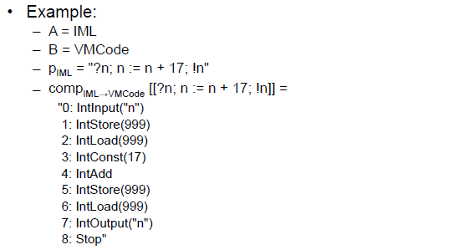

### Compiler and Interpreter

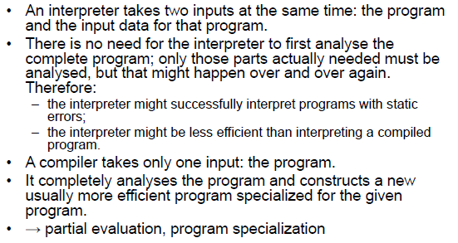

### Recipes, Translators and Bakers

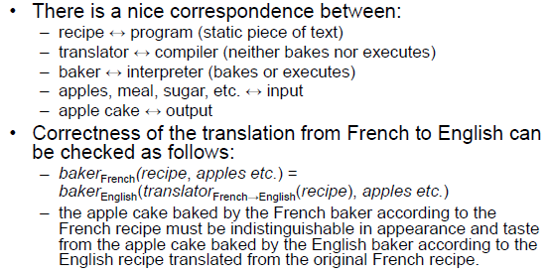

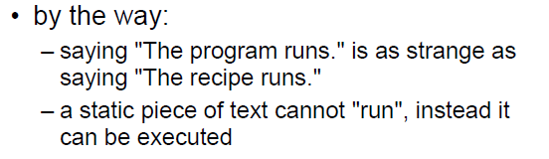

### Exercise

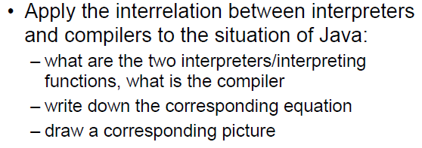

### Compile Time versus Run Time

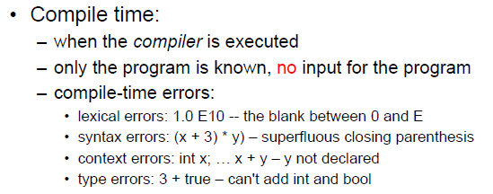

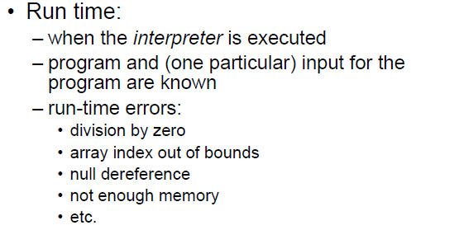

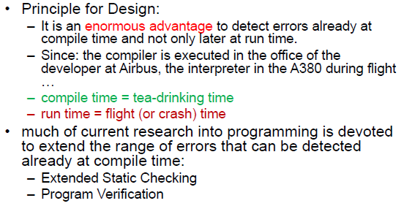

### Internal Construction of a Compiler: Analysis versus Synthesis

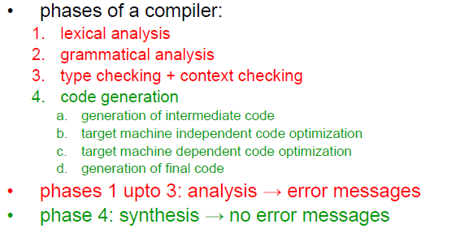

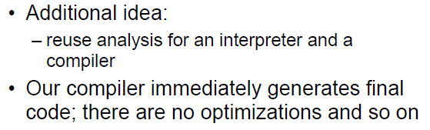

### Internal Construction of a Compiler: Front End versus Back End

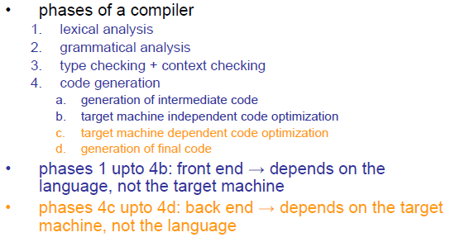

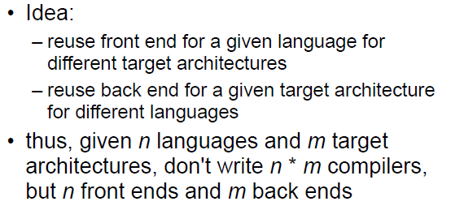

### Lexical Analysis

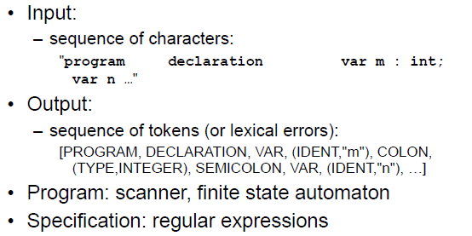

### Grammatical Analysis

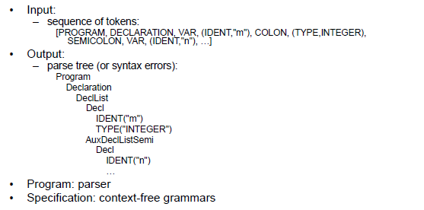

### Type and Context Checking

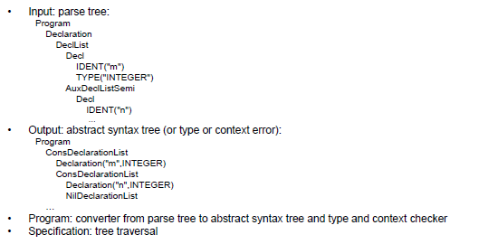

### Code Generation

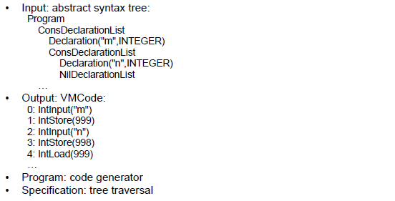

## Introduction to IML

### Purpose of IML

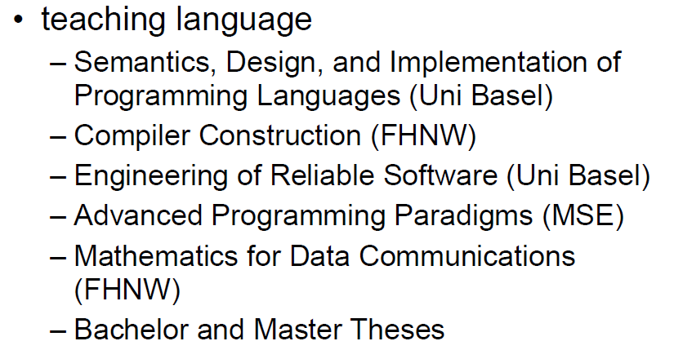

### Kind of Language

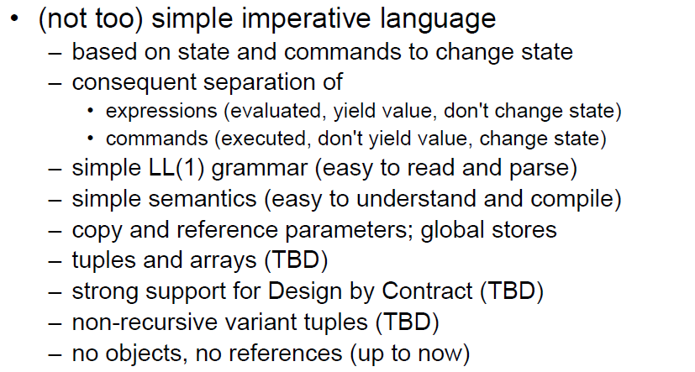

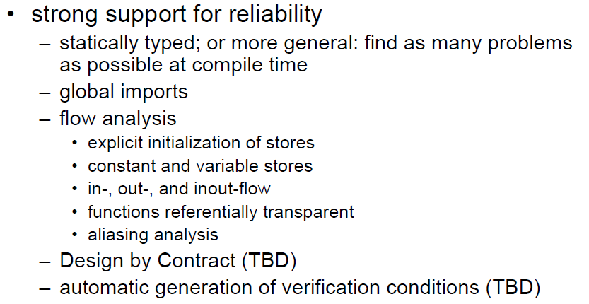

### Example of IML

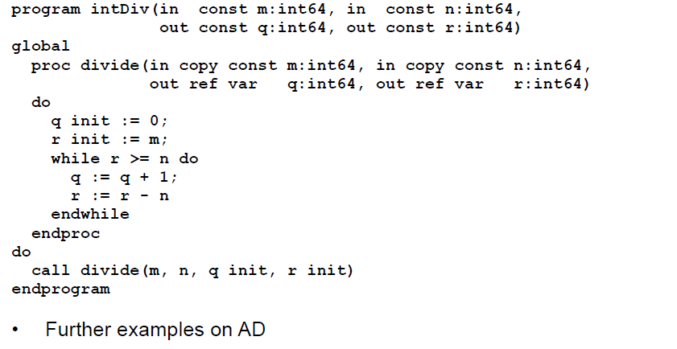

### Some Enumerations

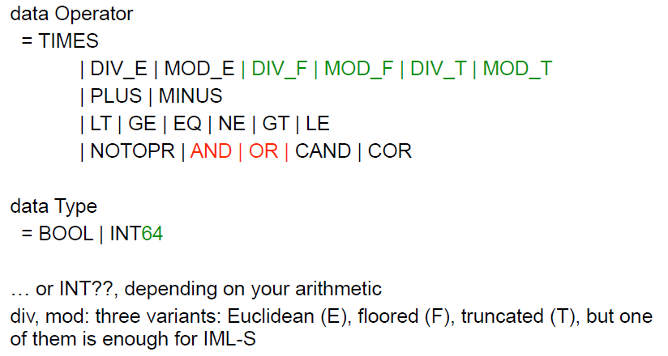

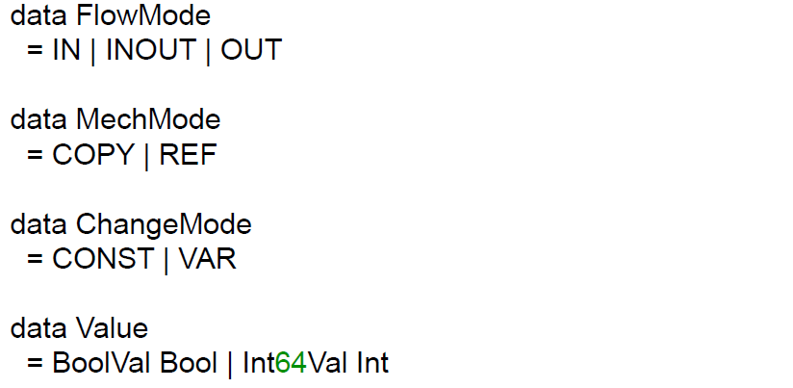

### Integer Literals, Identifiers, Whitespace and Line Comments

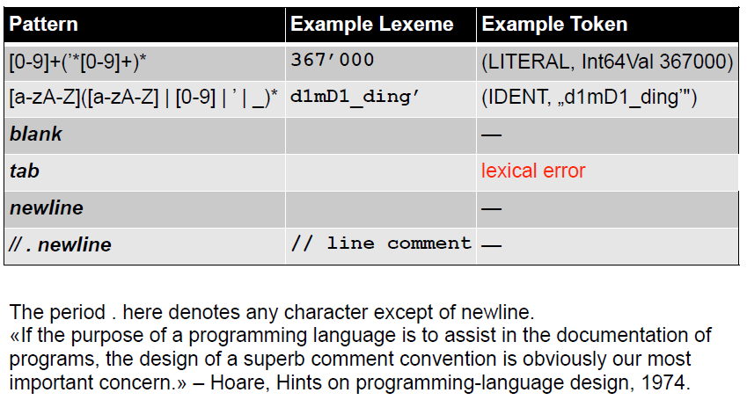

### Symbols

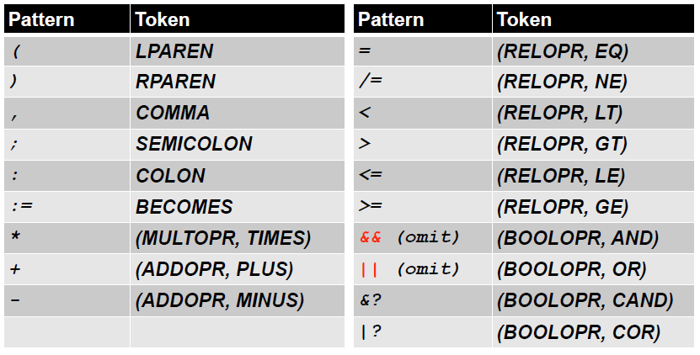

### Keywords

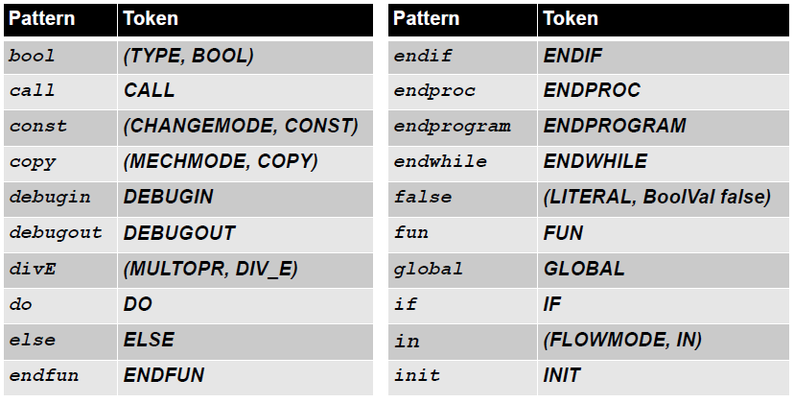

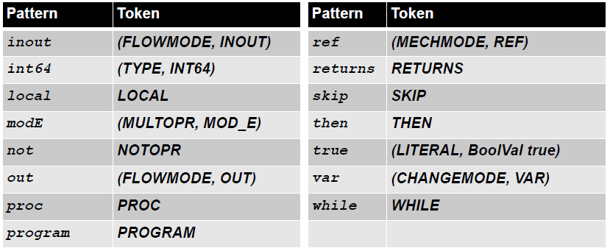

### Programs

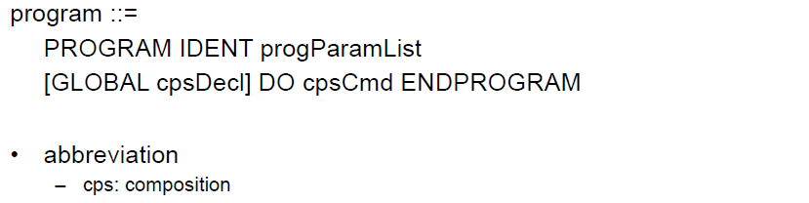

### Declarations

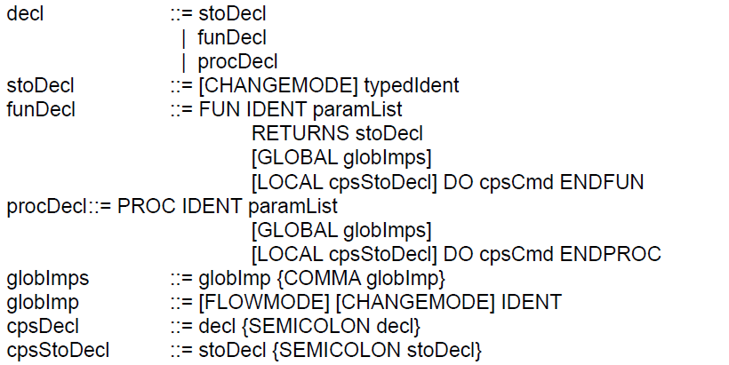

### Parameter Lists

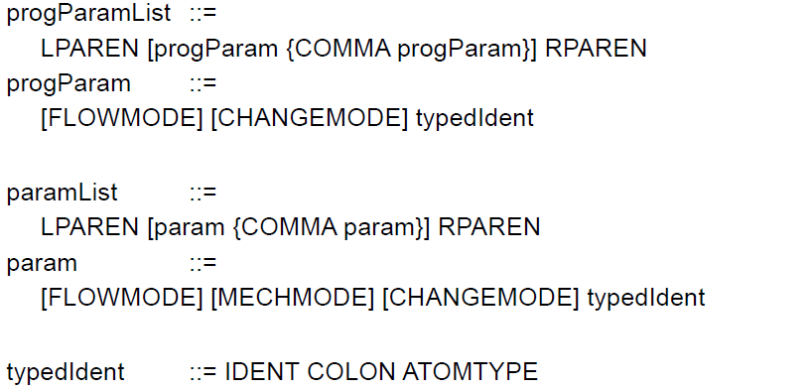

### Commands

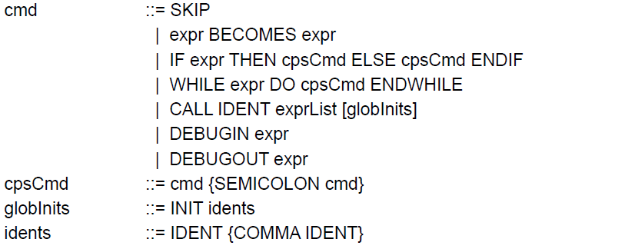

### Expressions (For Language Specification)

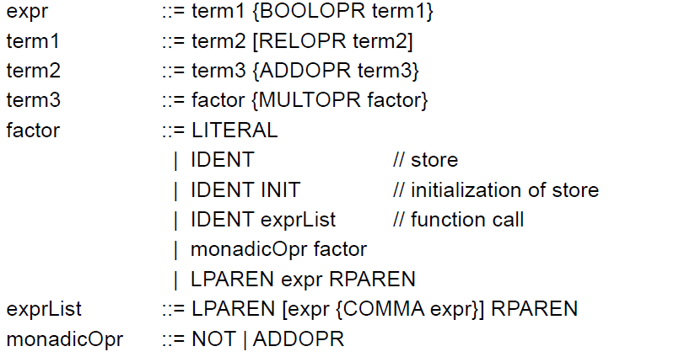

### Expressions (For Language Implementation)

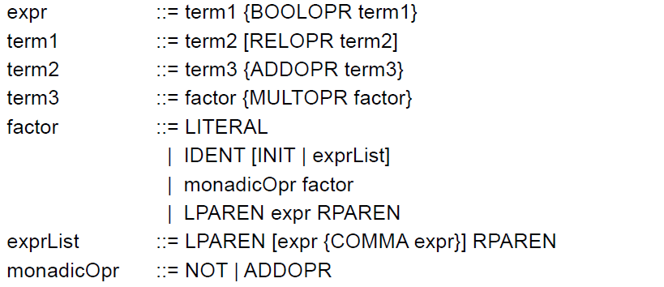

### Expressions in IML

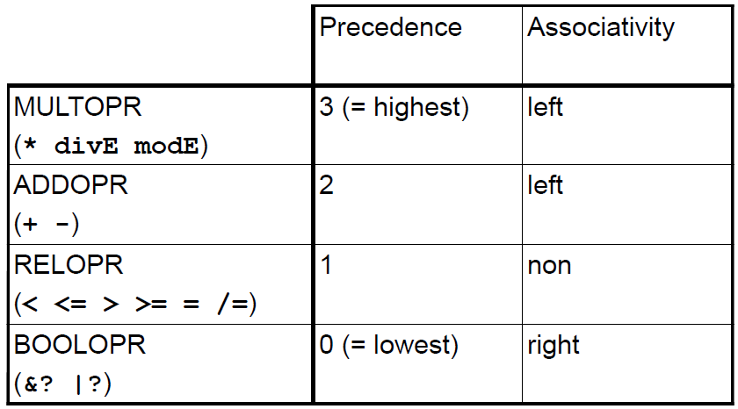

# Woche 2

## Lexical Analysis

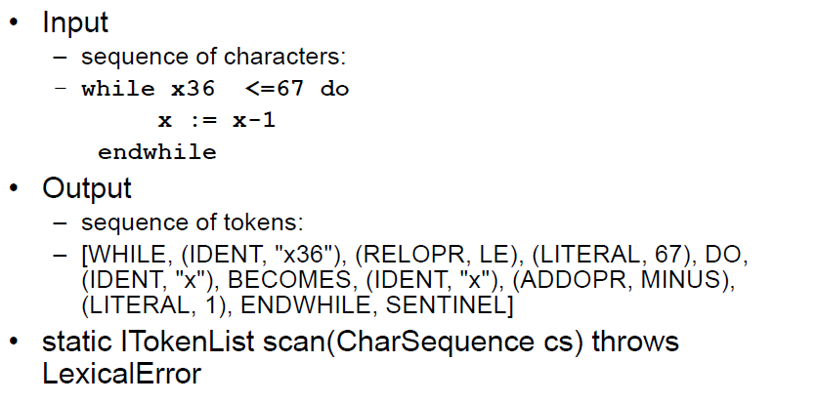

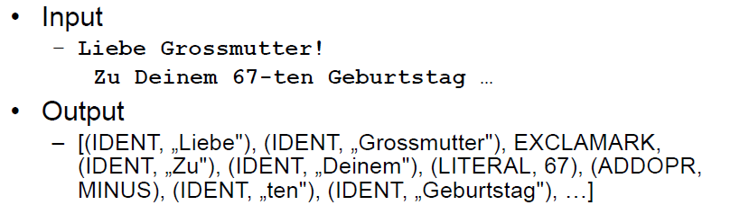

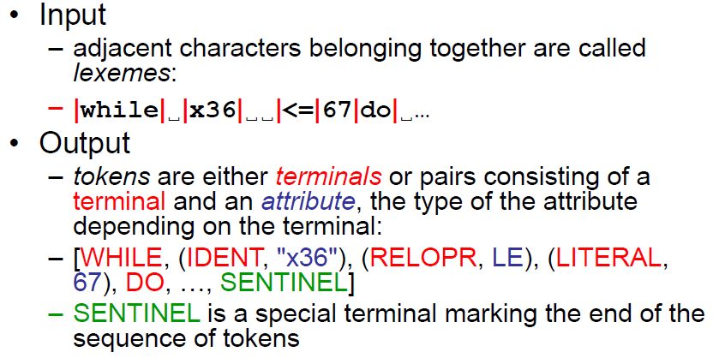

## Data Structures (Terminals etc.)

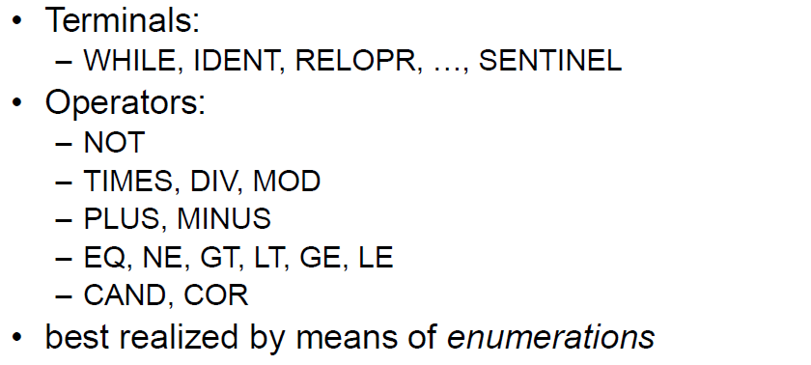

## Data Structures (Tokens)

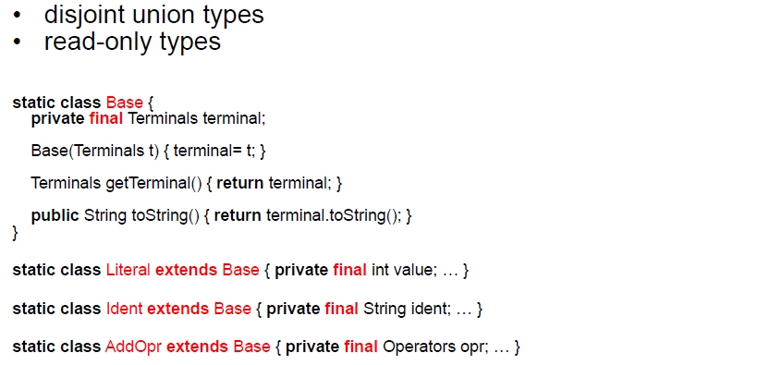

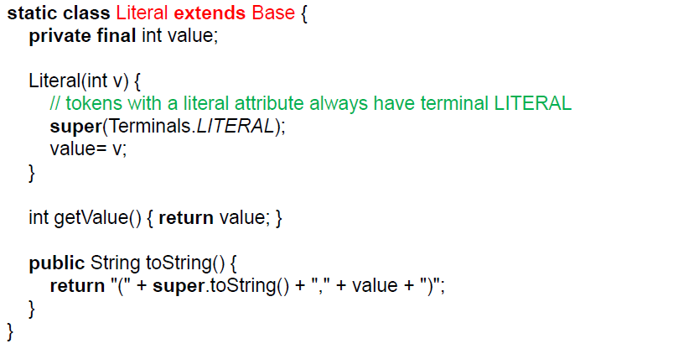

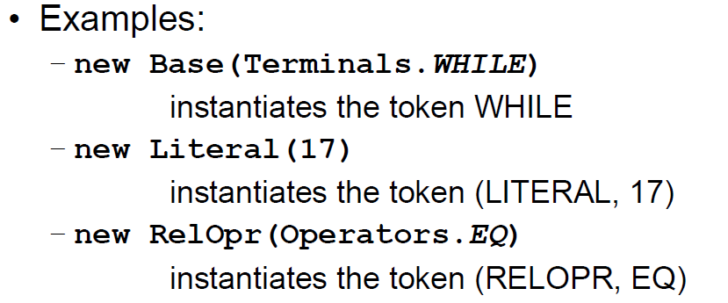

## Data Structures (Token List)

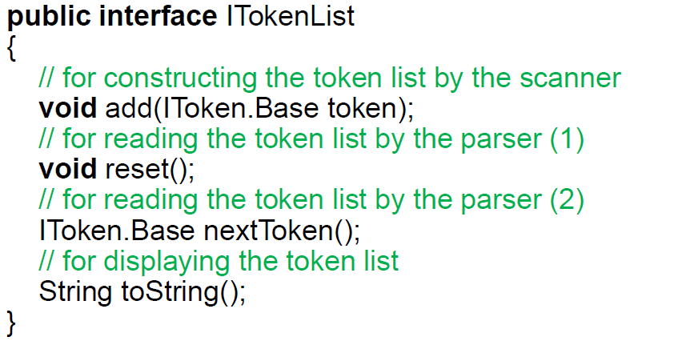

## Patterns, Lexemes and Tokens

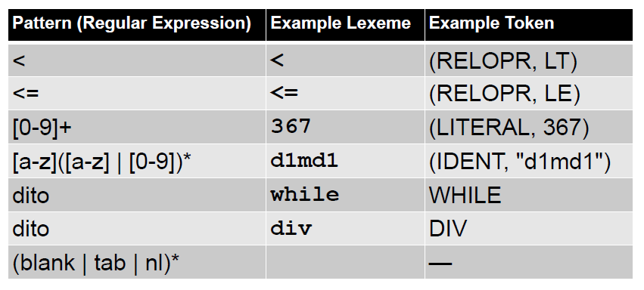

## Keywords

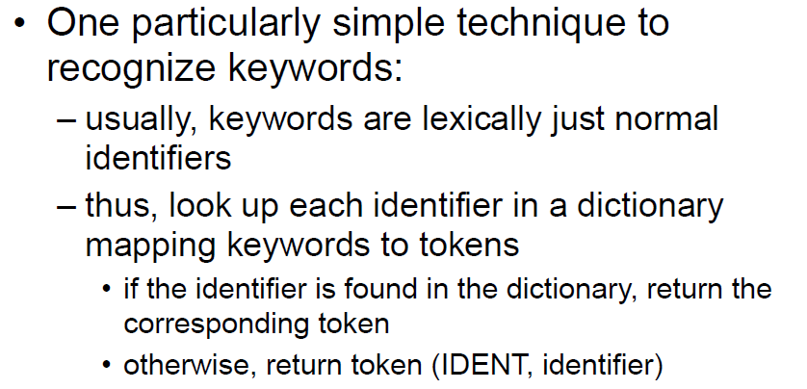

## Scanning Algorithm

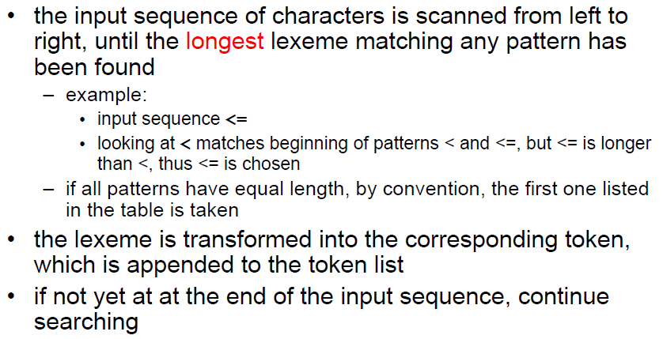

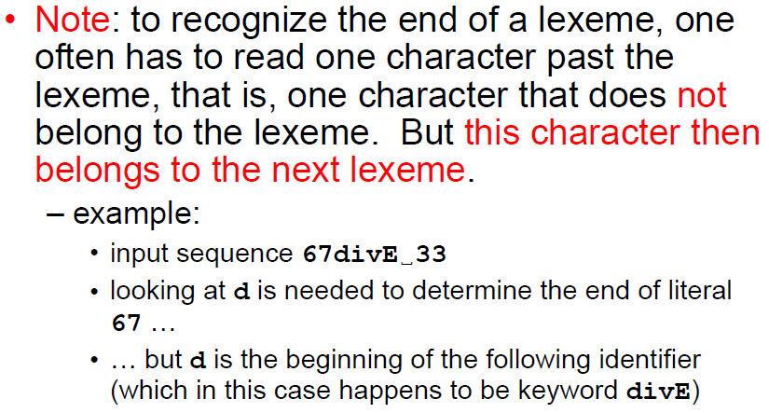

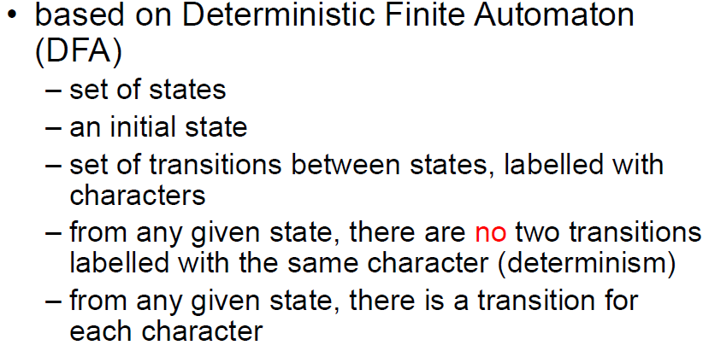

## Scanner in Java

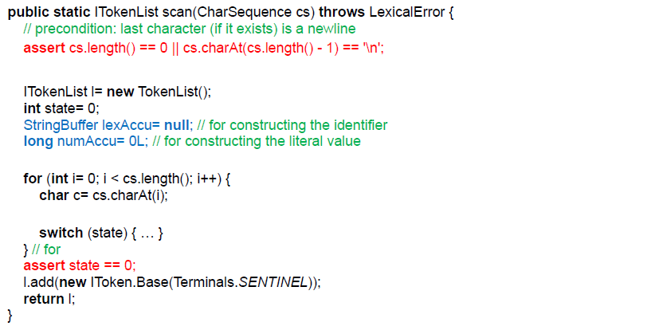

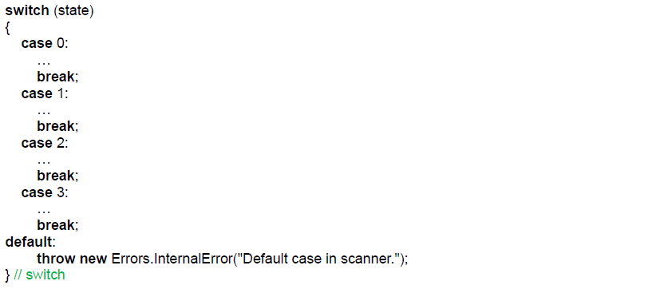

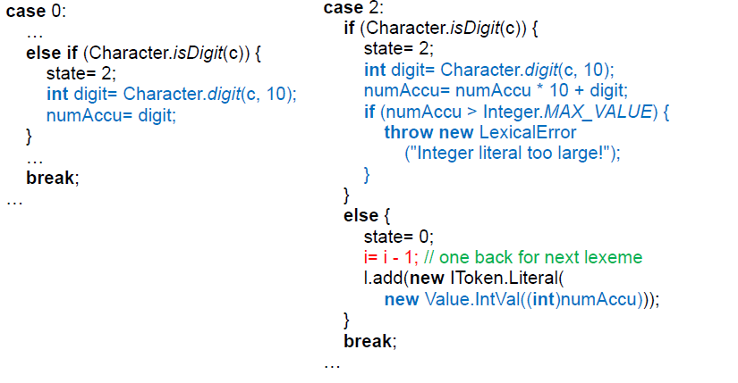

## Scanner in Haskell

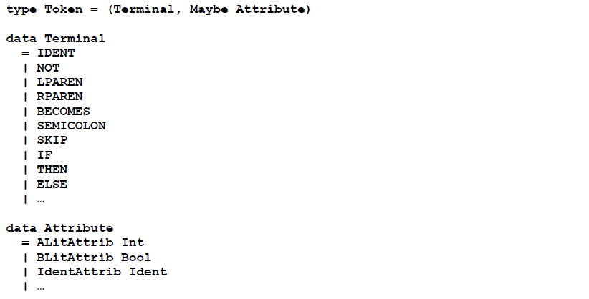

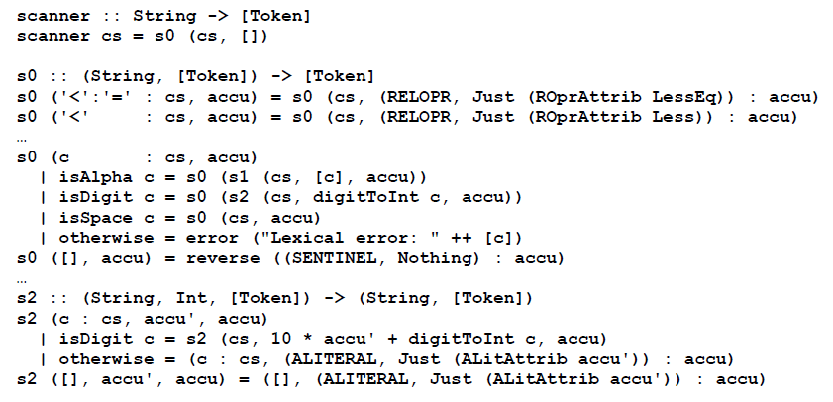

## IM Lexical Syntax

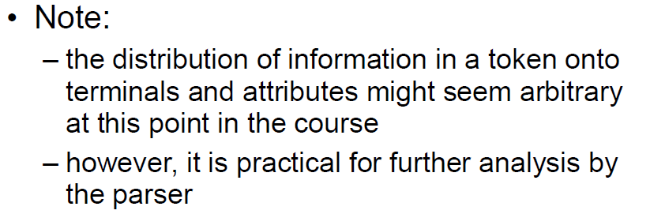

## Your Task

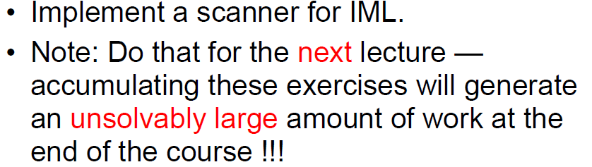

# Woche 3

## Example Command

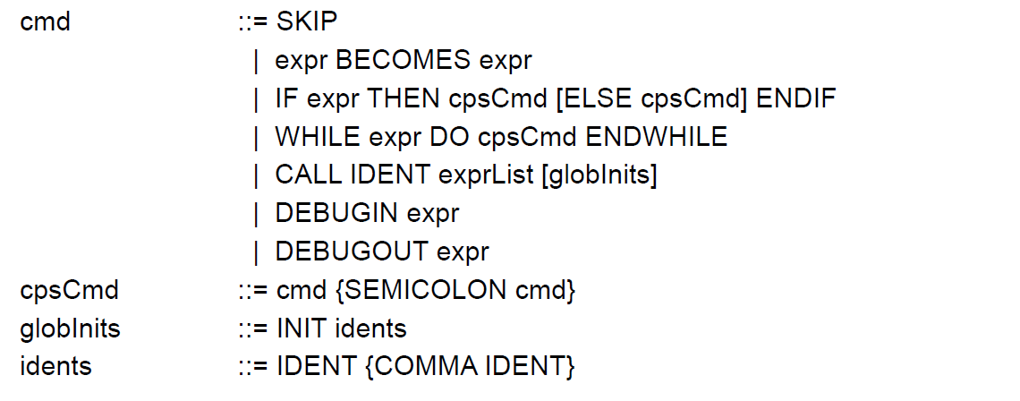

## Alphabet

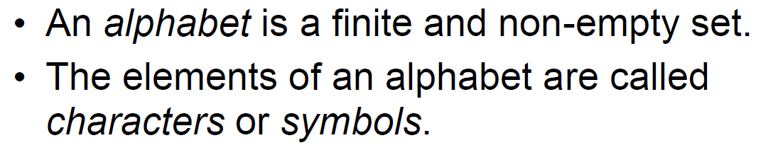

## Context Free Grammars

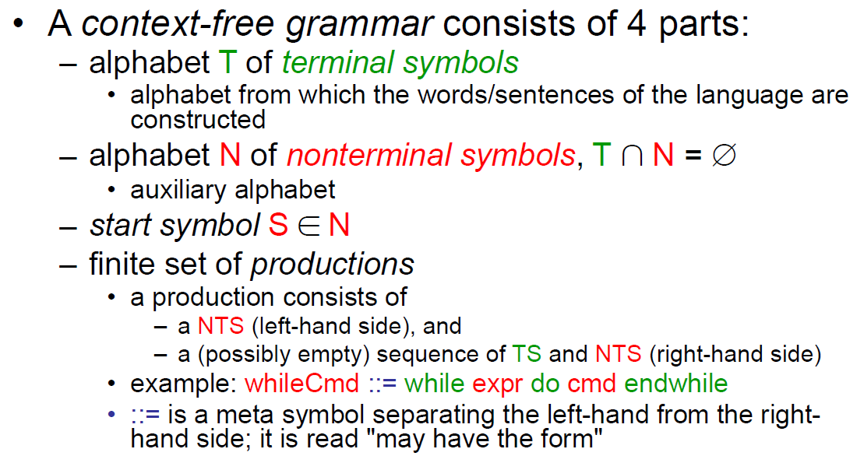

## Notational Convention

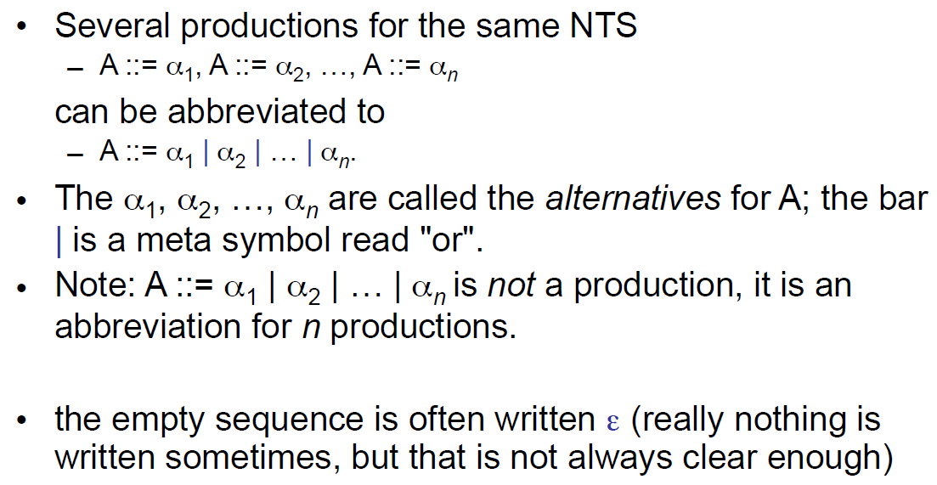

## Derivations

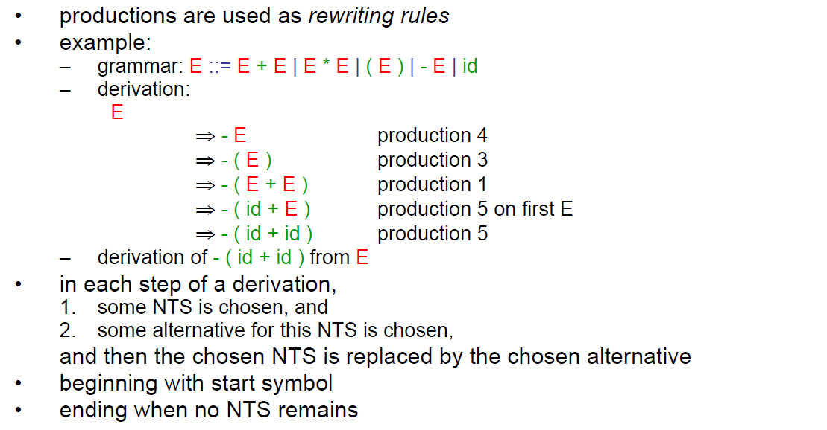

## Leftmost and rightmost Derivations

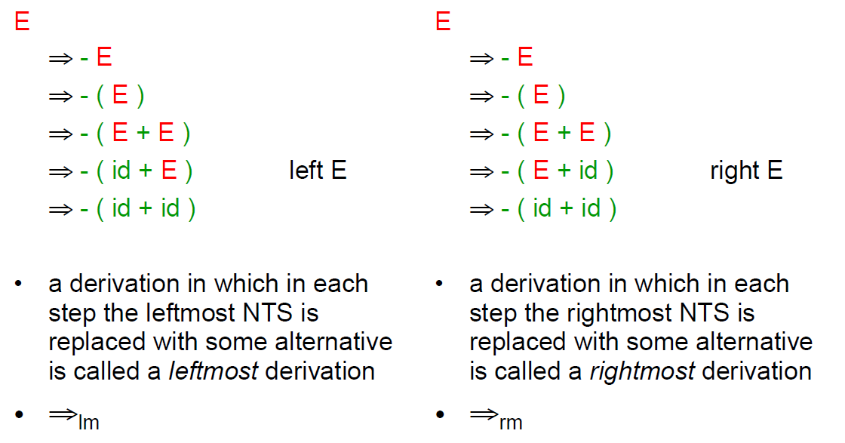

## Derivations

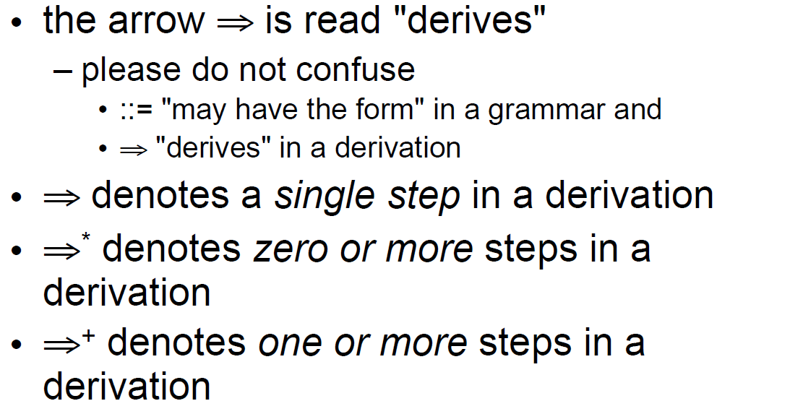

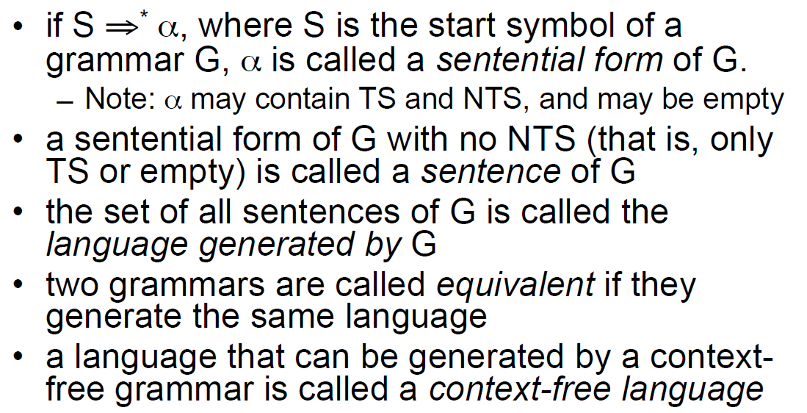

## Parse Trees and Derivations

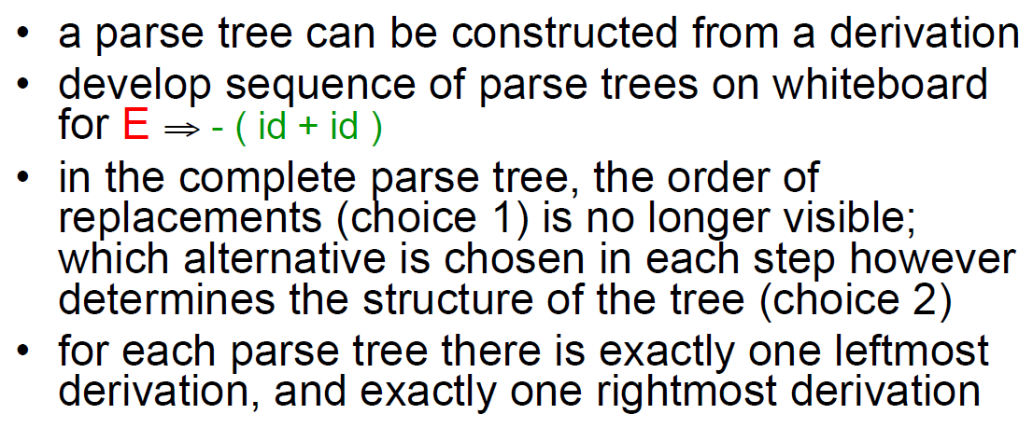

## Ambiguity

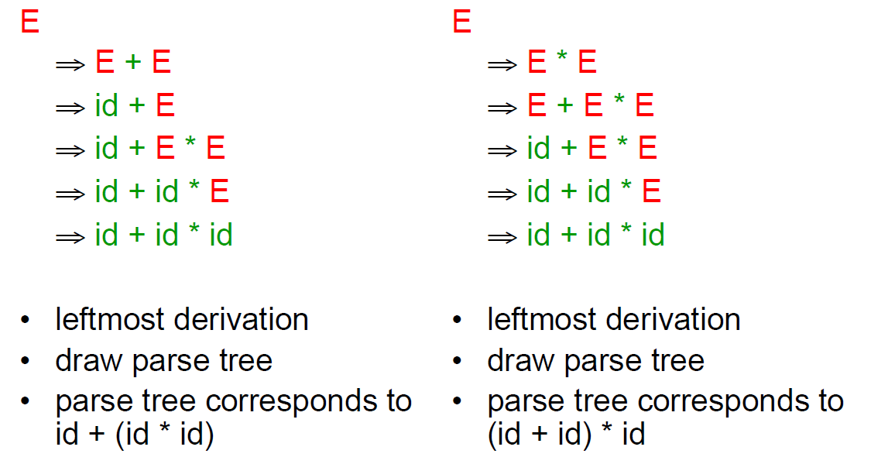

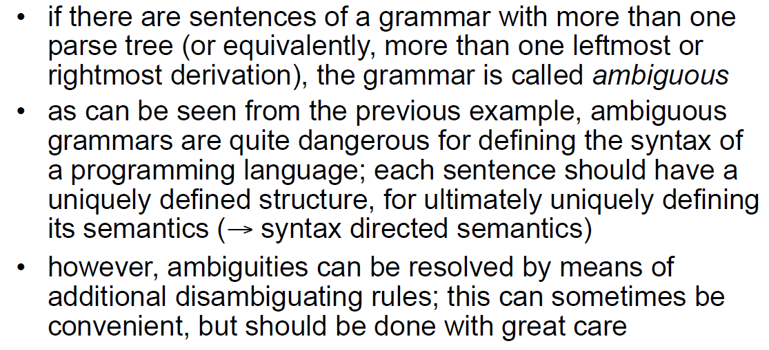

## From BNF to EBNF

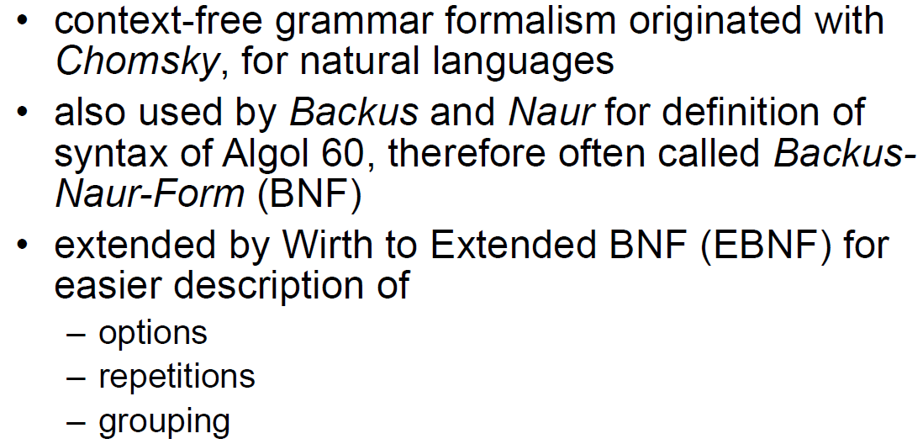

## EBNF

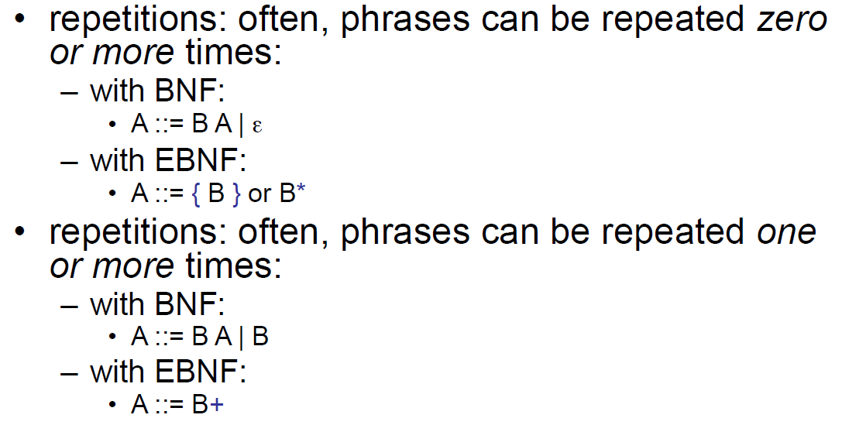

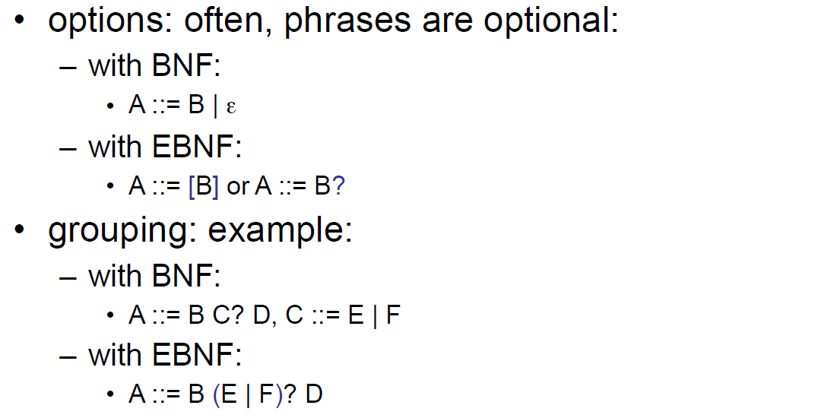

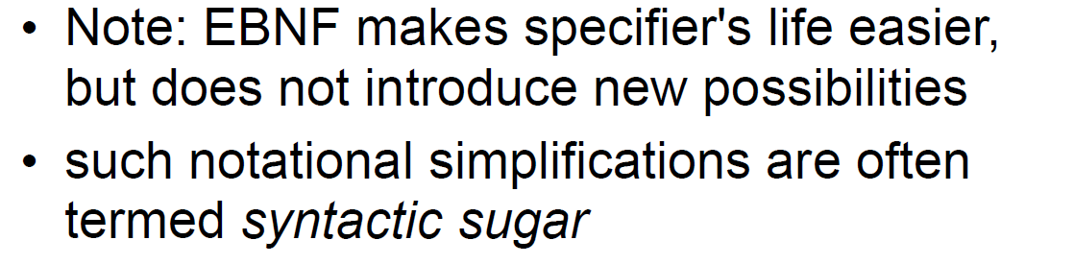

## Regular Languages

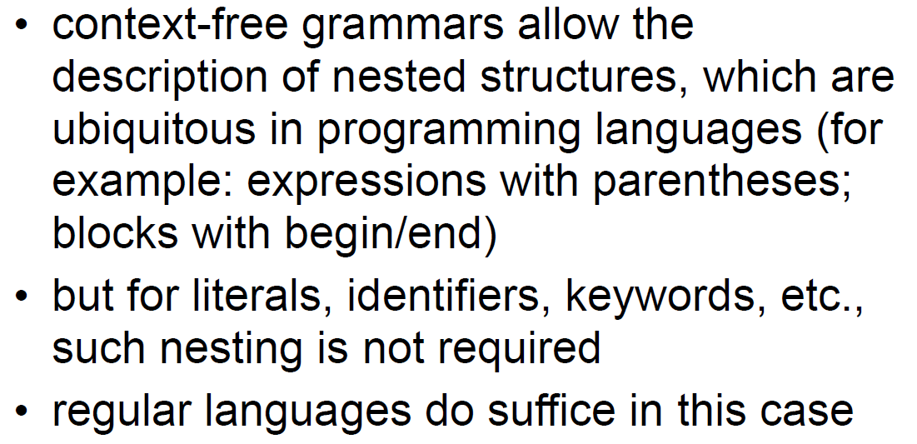

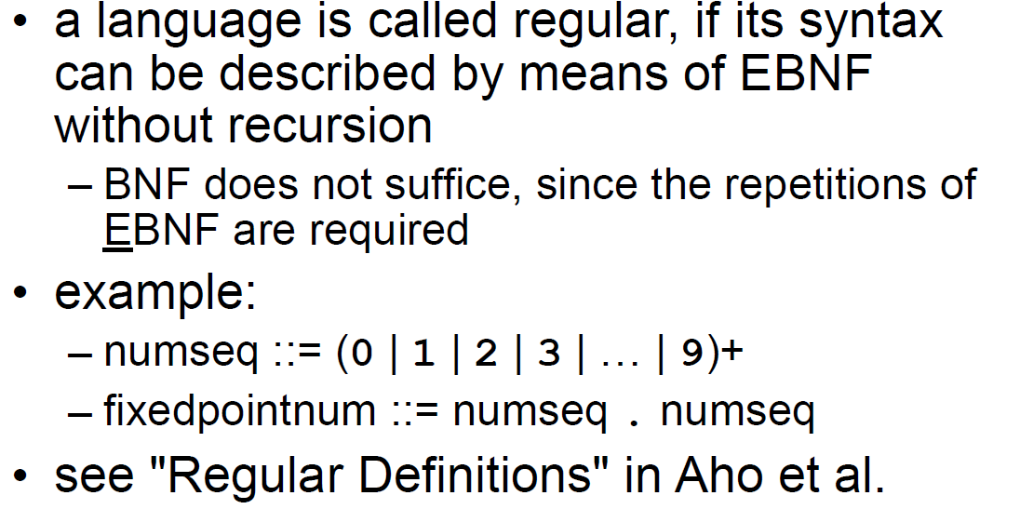

## Context Free Grammars and Context Dependencies

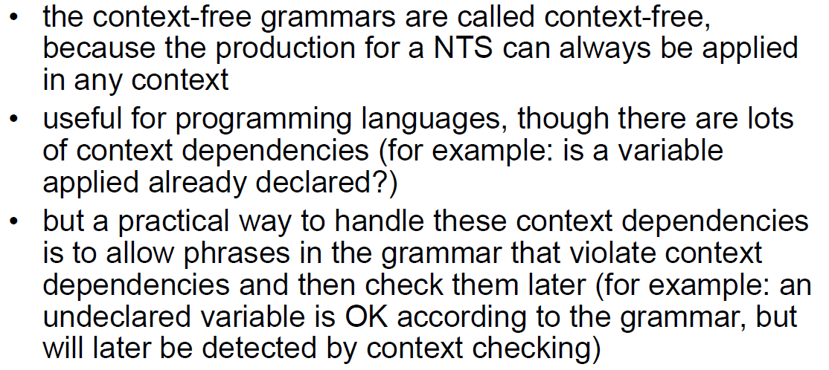

## Example CFG versus Context Checking

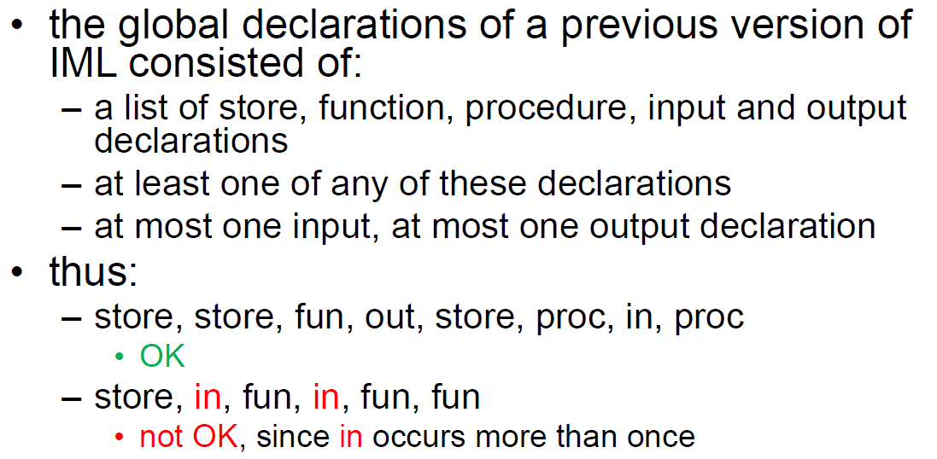

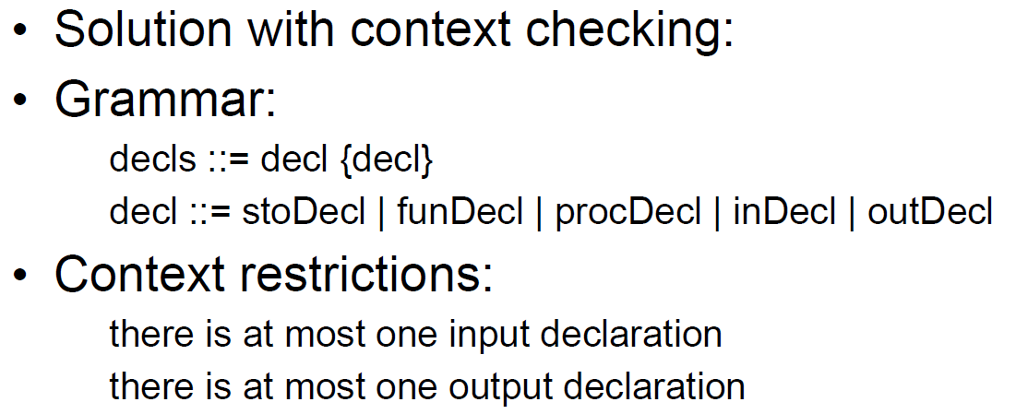

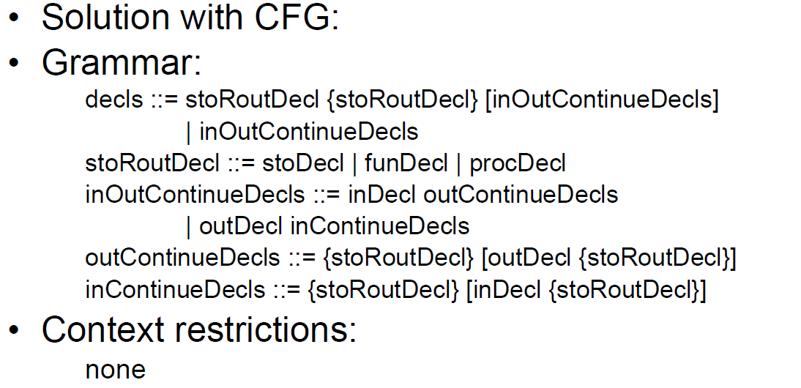

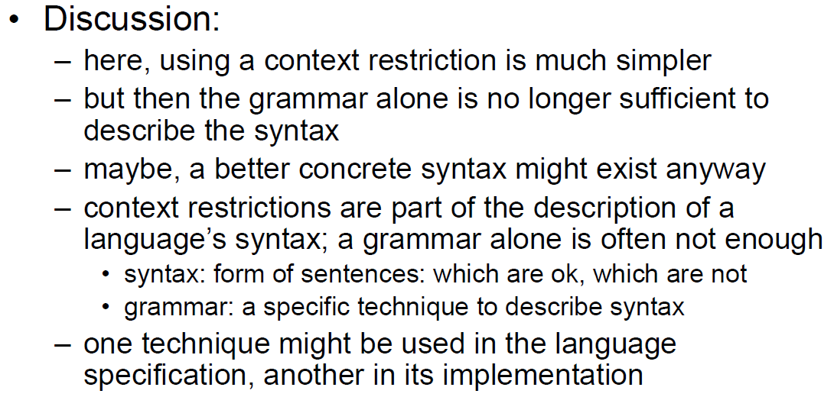

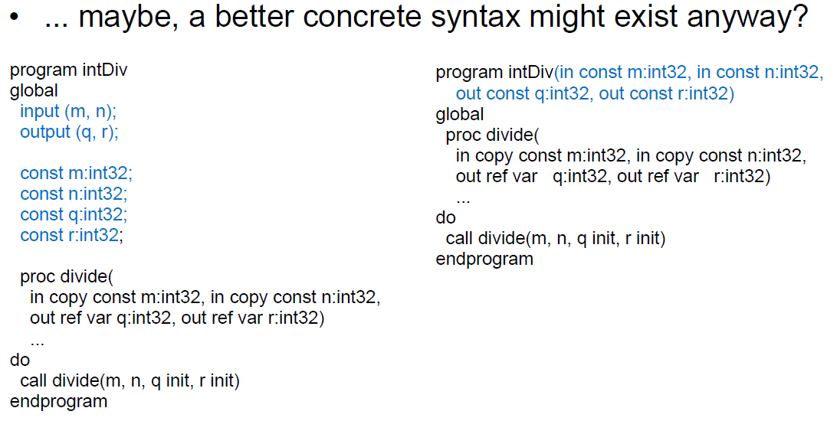

# Woche 4

## Order of Evaluation in Expressions

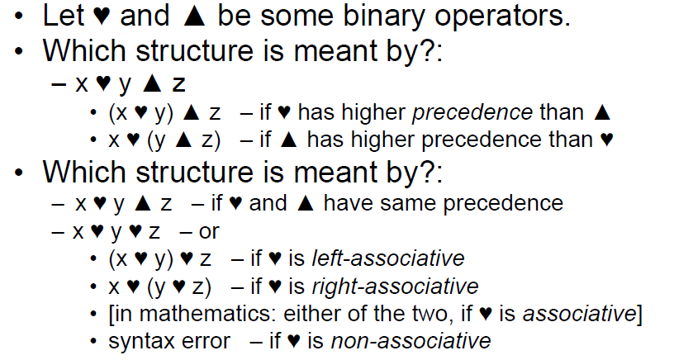

## Examples of Associativities

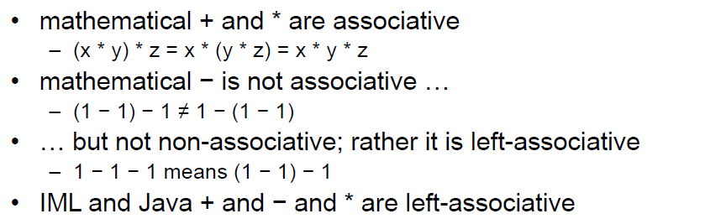

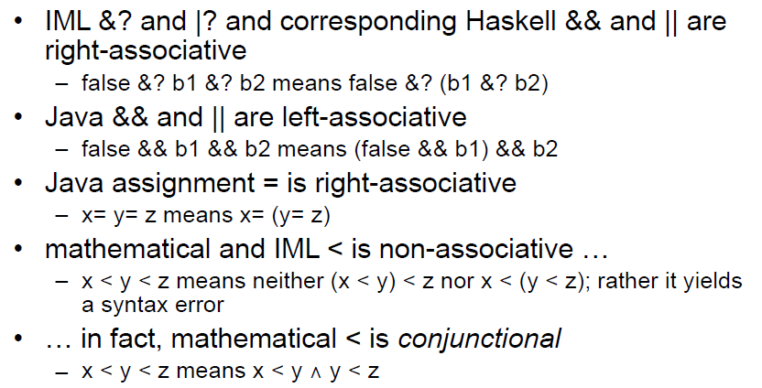

## Order of Evaluation in Expressions

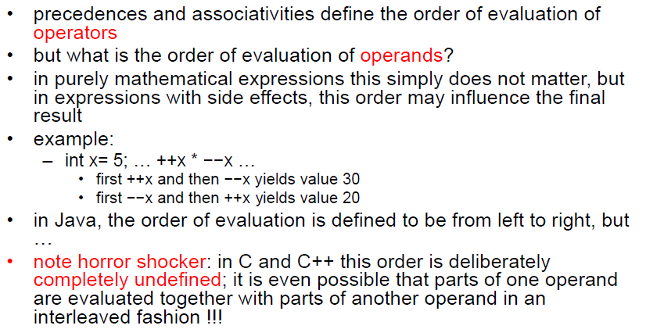

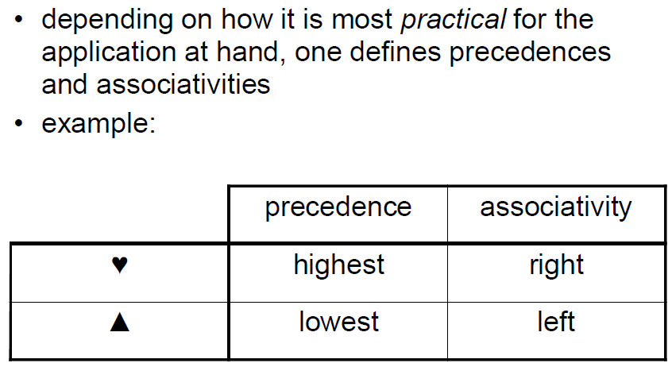

## Grammar for Expressions (Precedence without Associativity)

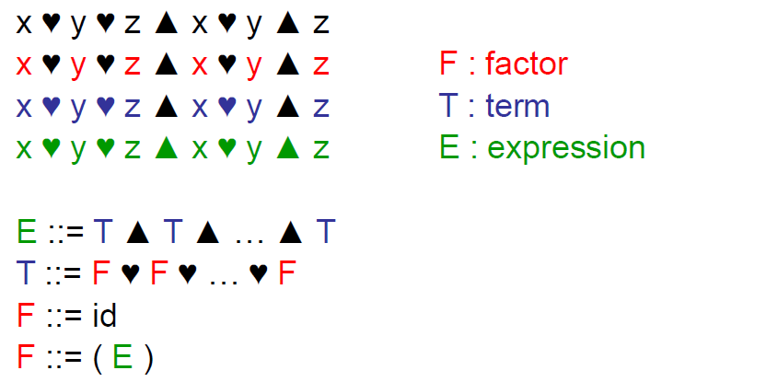

## Grammar for Expressions (Associativity)

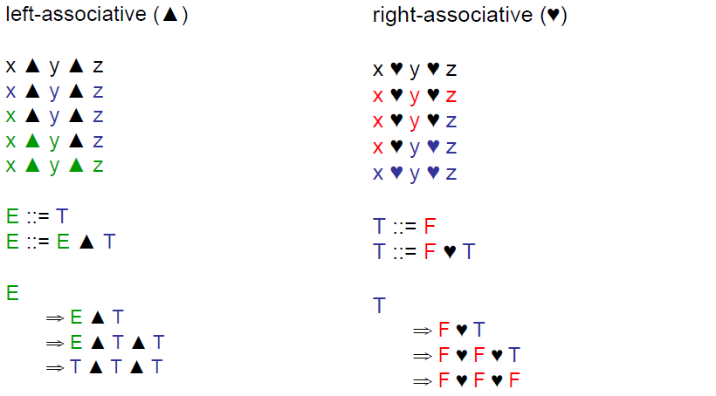

## Grammar for Expressions (Complete)

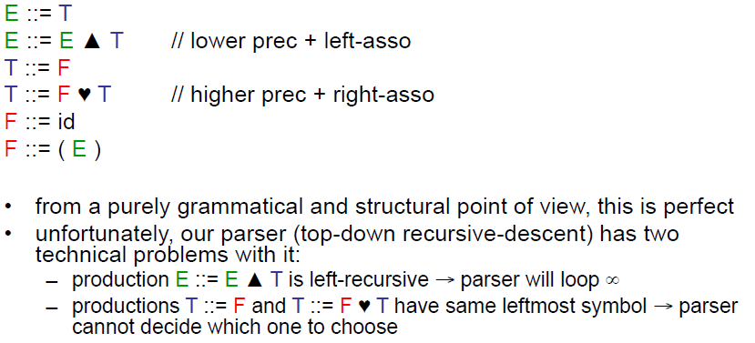

## Grammar for Expressions

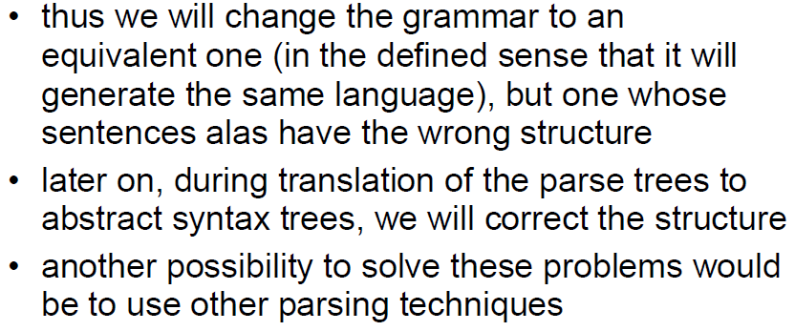

## Problem 1: Left Recursion

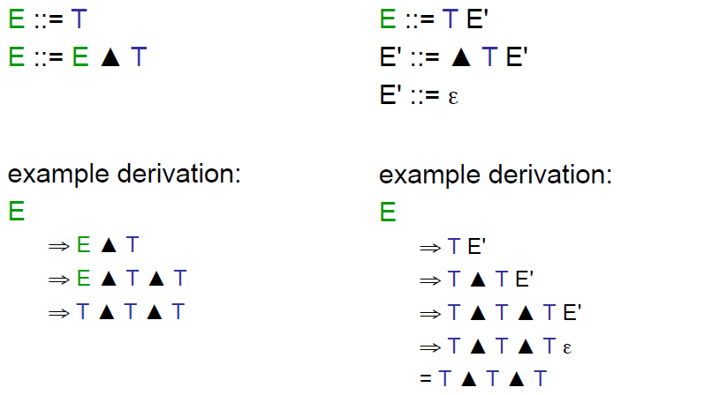

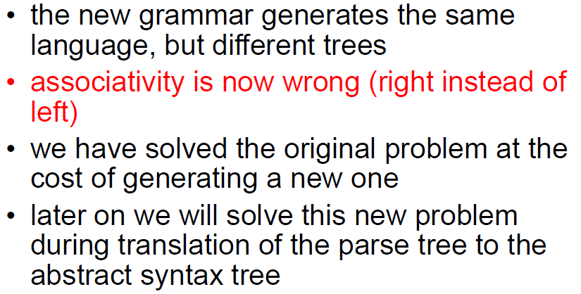

## Problem 2: Alternatives with the same leftmost Symbol

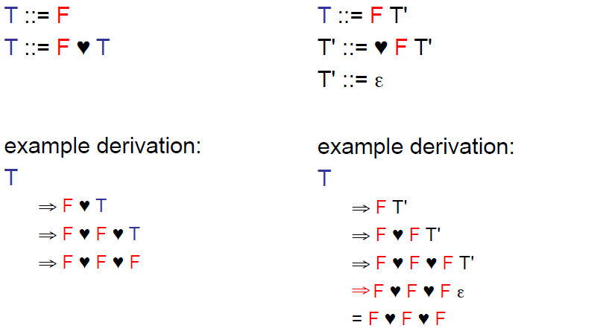

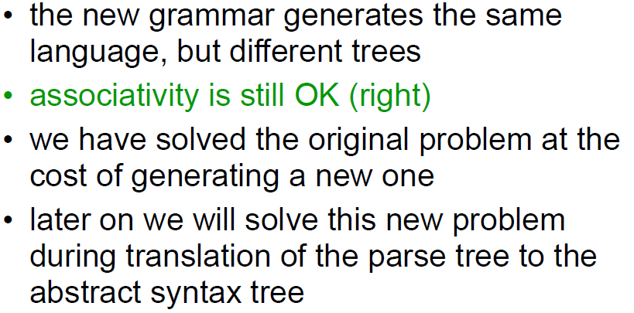

## New Grammar for Expressions (Complete)

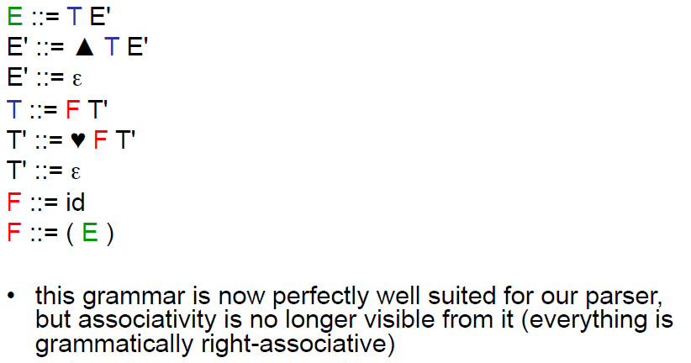

## Expressions in IML

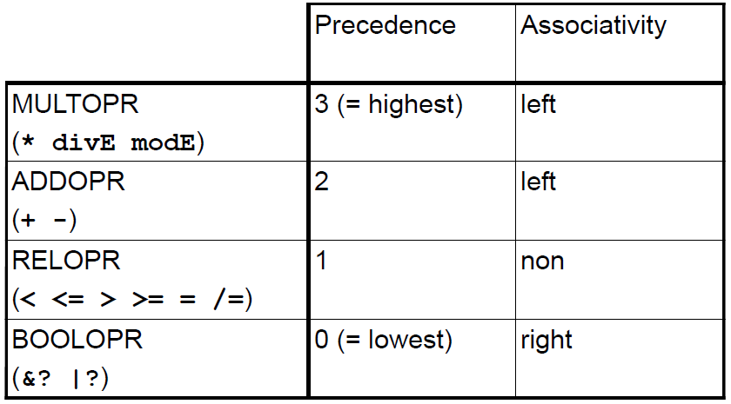

## Expressions: User’s Grammar

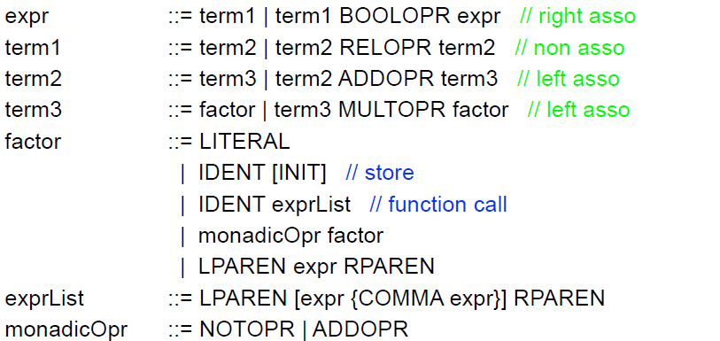

## Expressions: Implementor’s Grammar

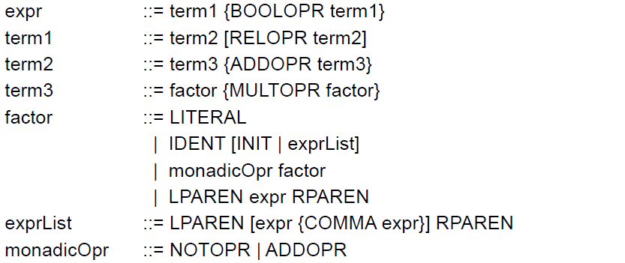

## Simplified Expressions in IML

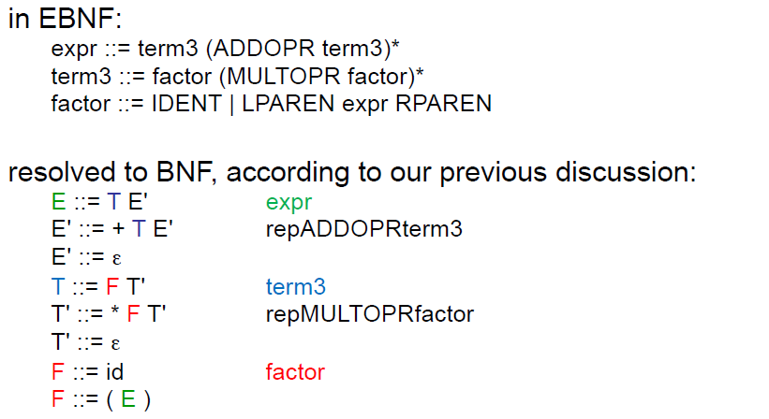

## Boolean Expressions

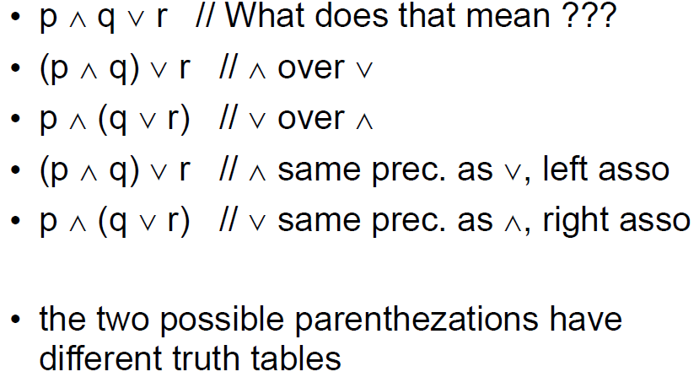

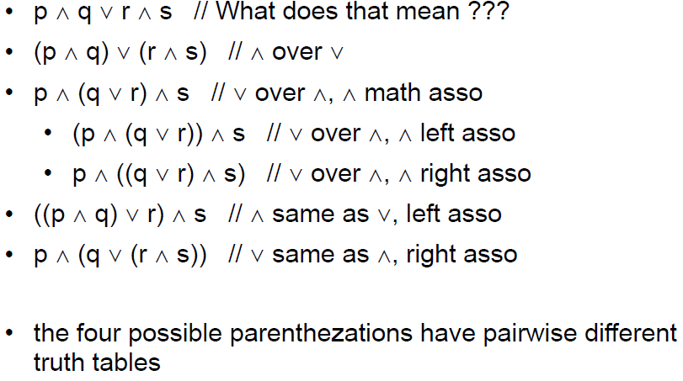

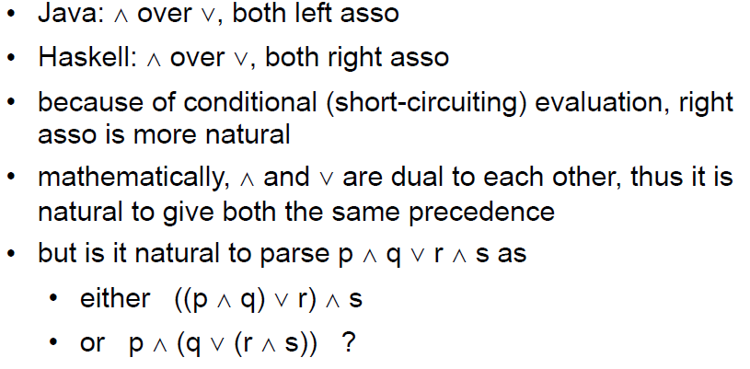

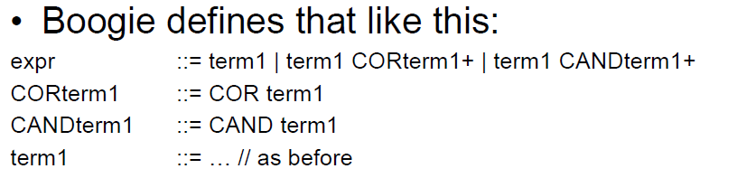

## Exercise

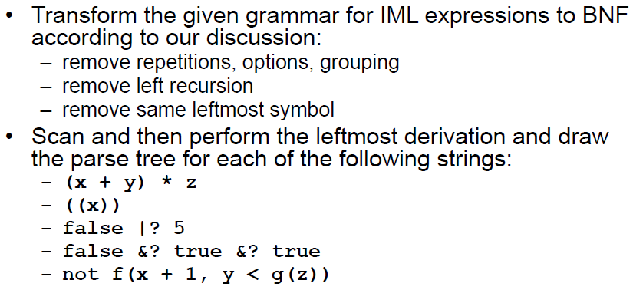

## Parser

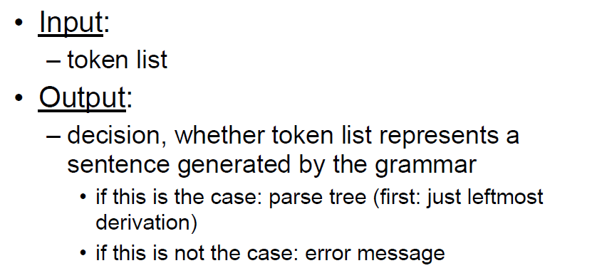

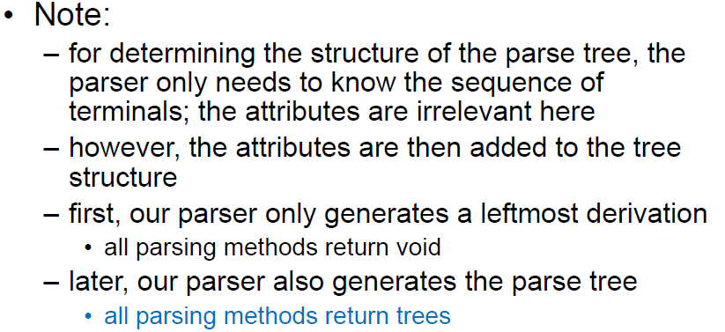

## Parser in Java

### Interface

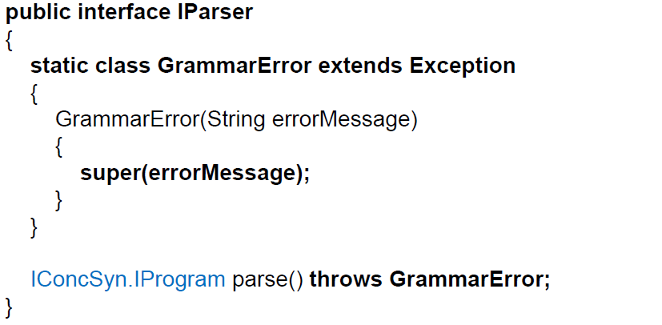

### Class and Constructor

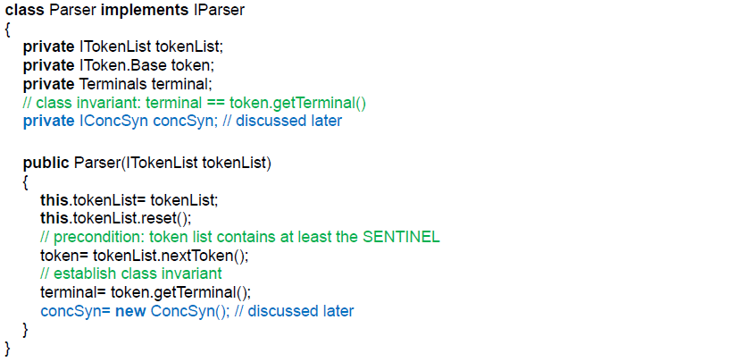

### Consume Method

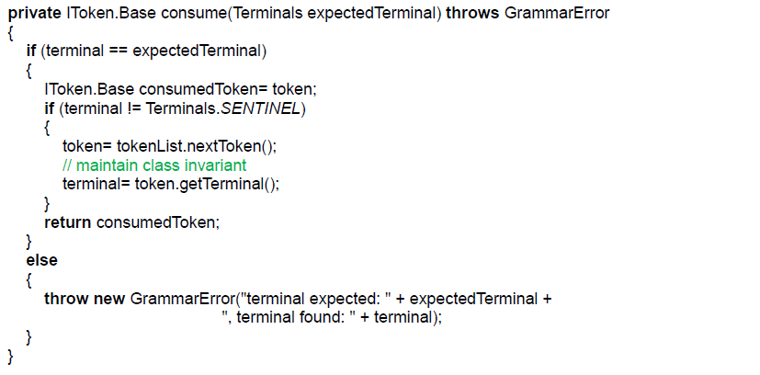

### Parse Method

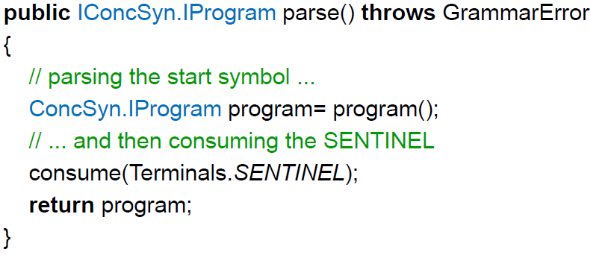

## Basic Idea of the Parser

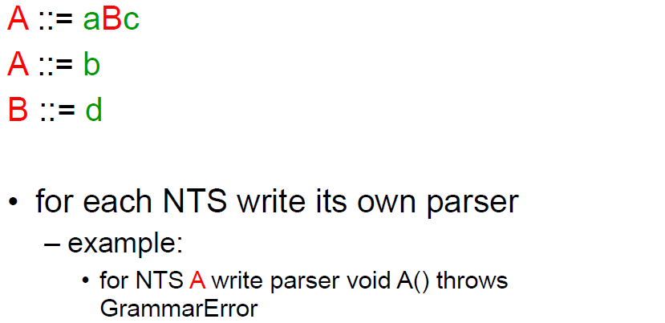

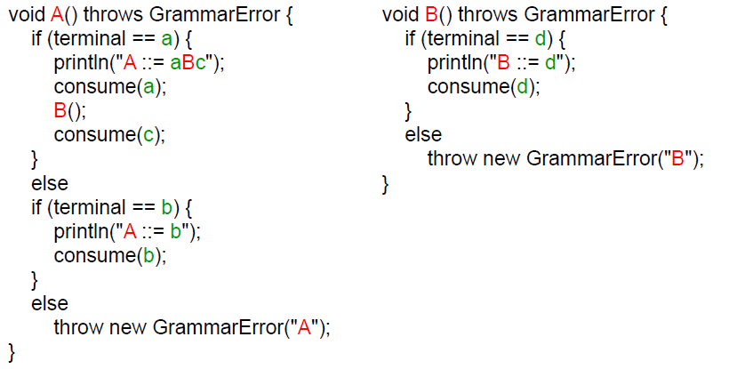

## Already known Problems for the Parser

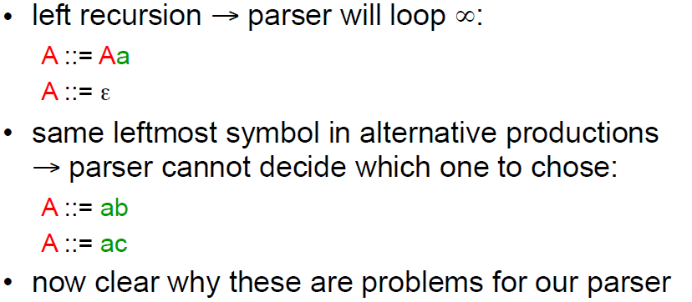

## Parser Table of the Parser

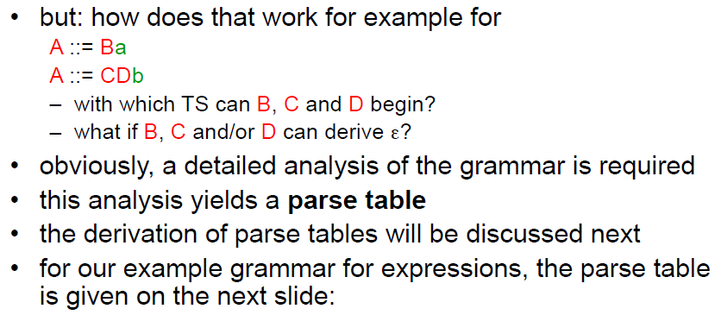

## Parser Table for our Expressions

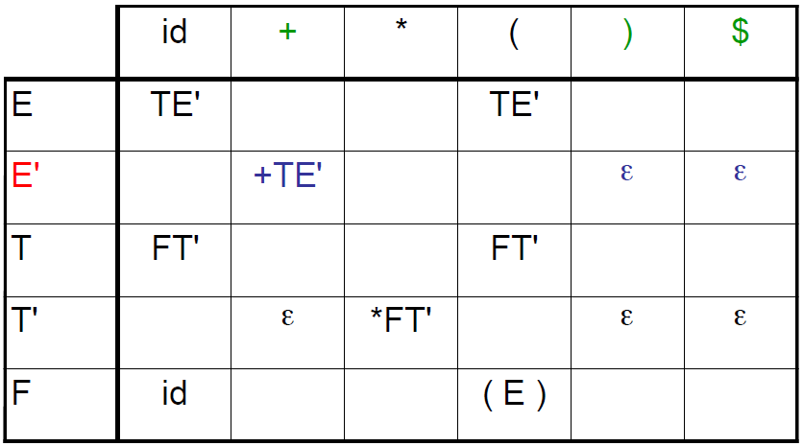

## Example Parser Table

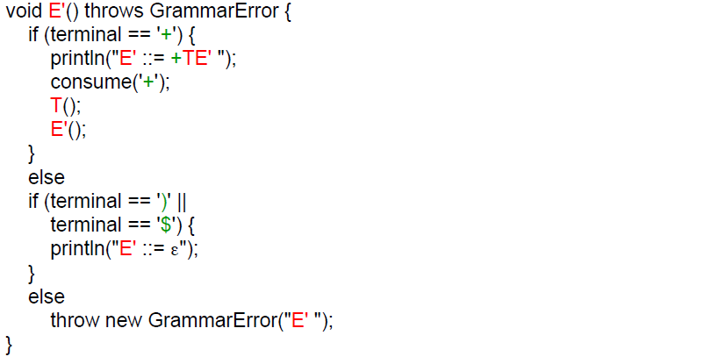

# Woche 5

## Construction of Parse Tables

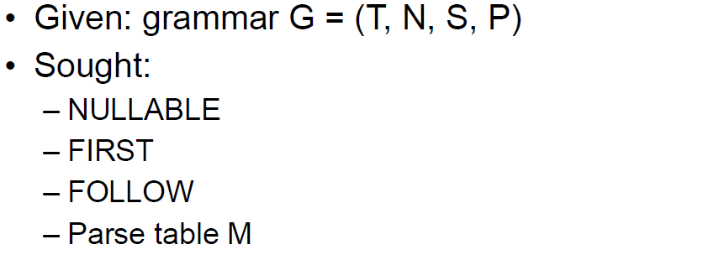

## Conventions

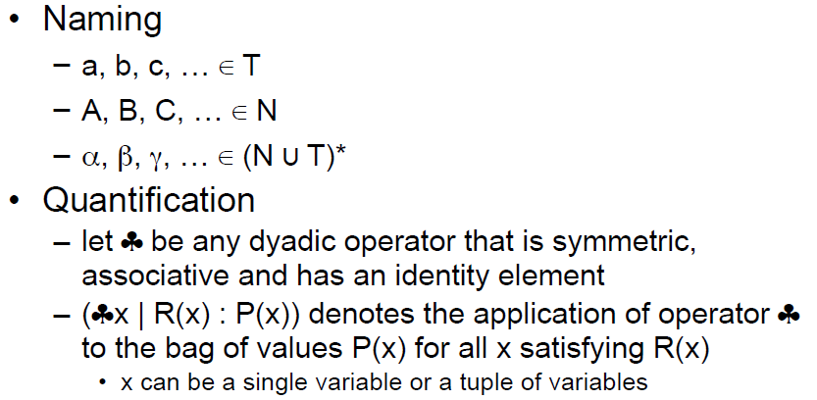

## NULLABLE

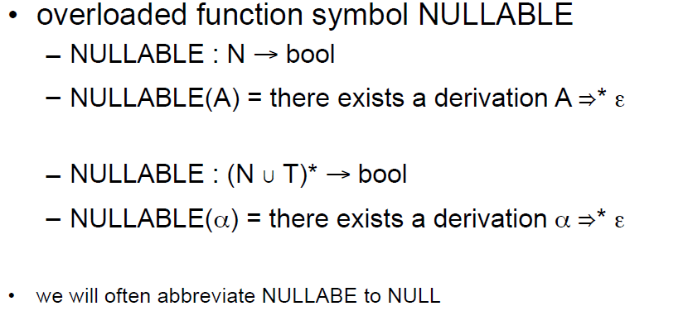

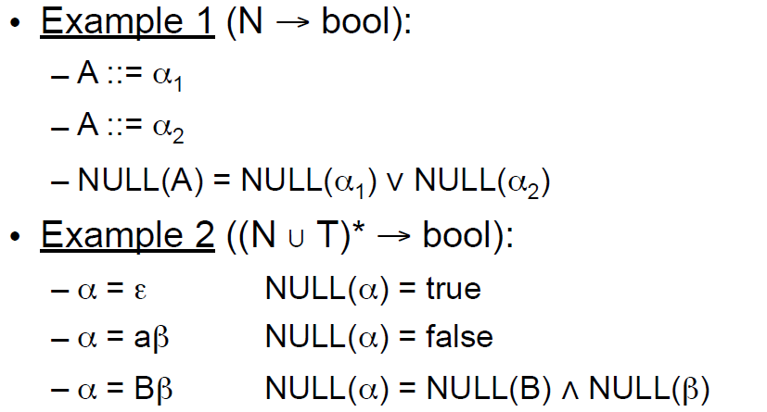

## NULLABLE in general

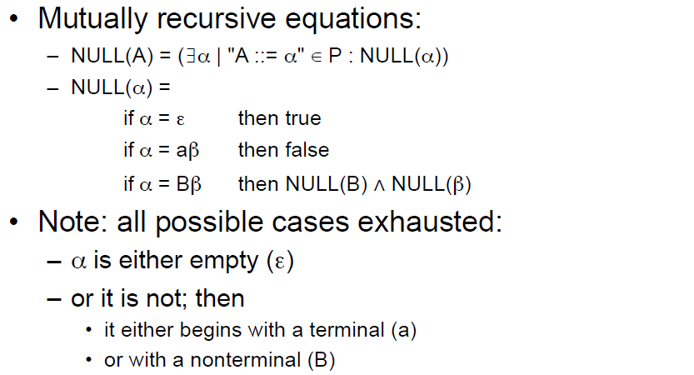

## FIRST

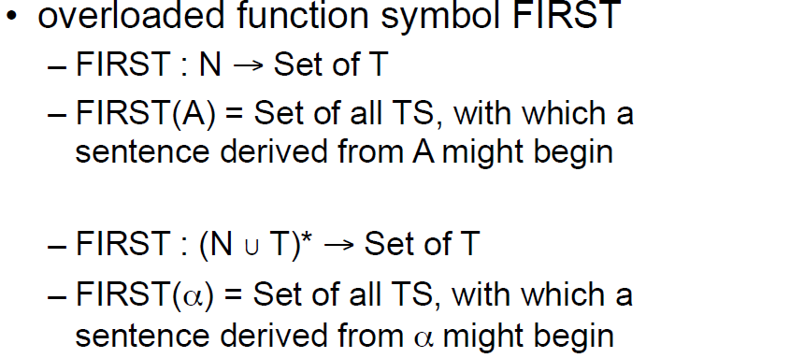

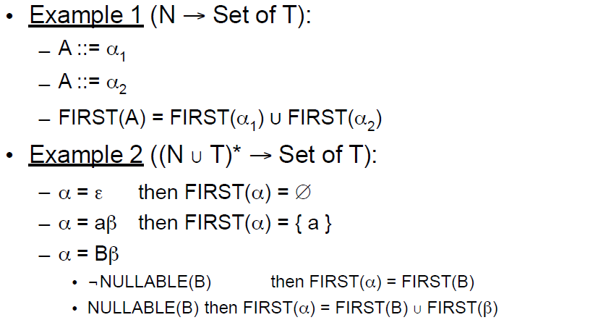

## FIRST in general

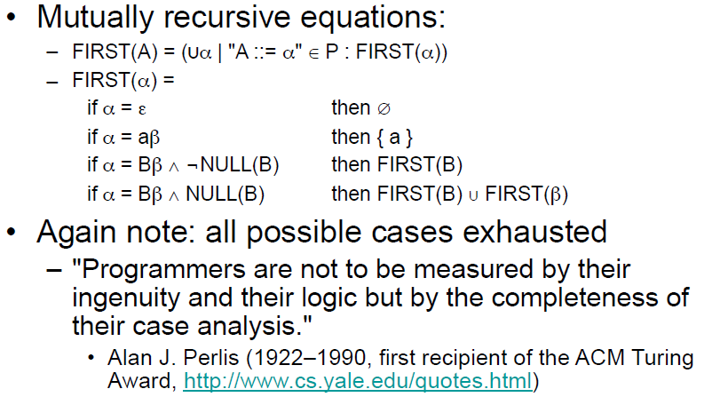

## FOLLOW

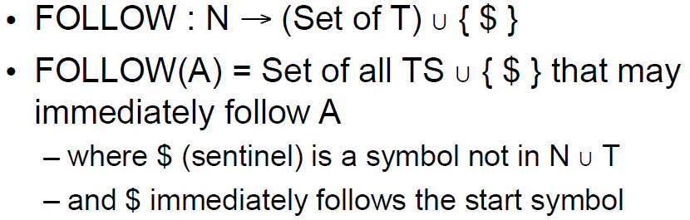

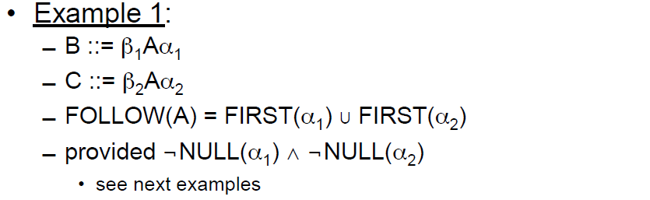

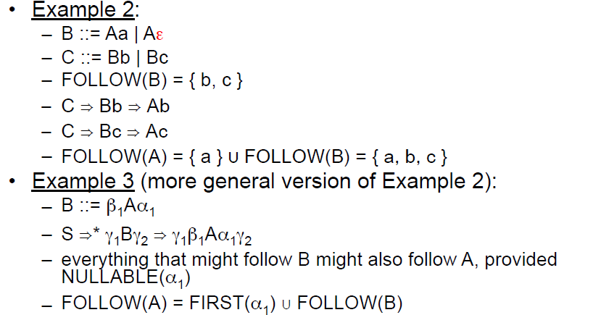

## FOLLOW in general

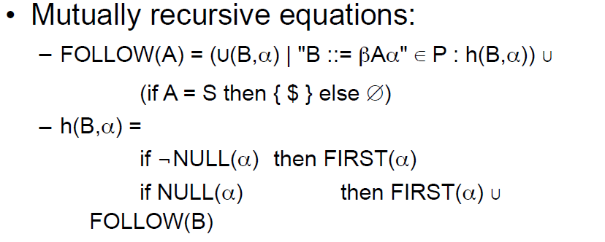

## Example

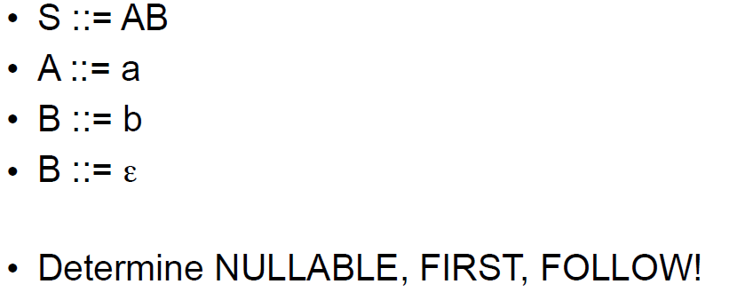

## Strange Recursion

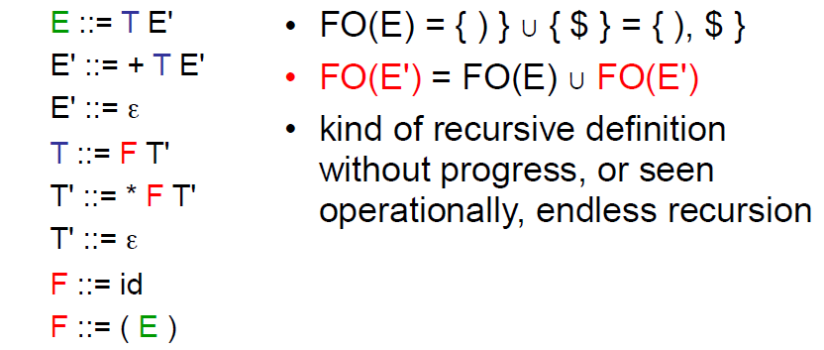

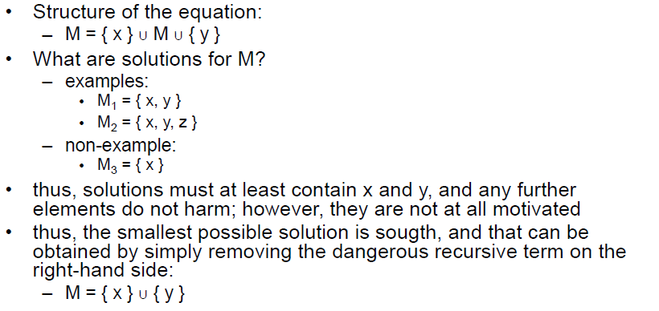

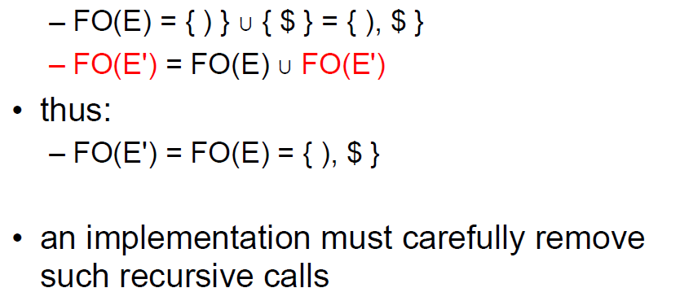

## Construction of Parse Table

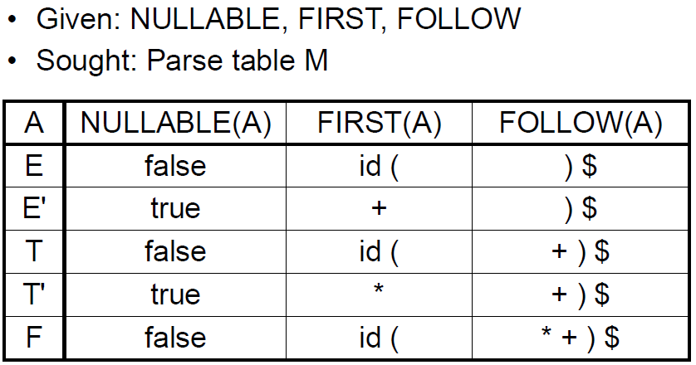

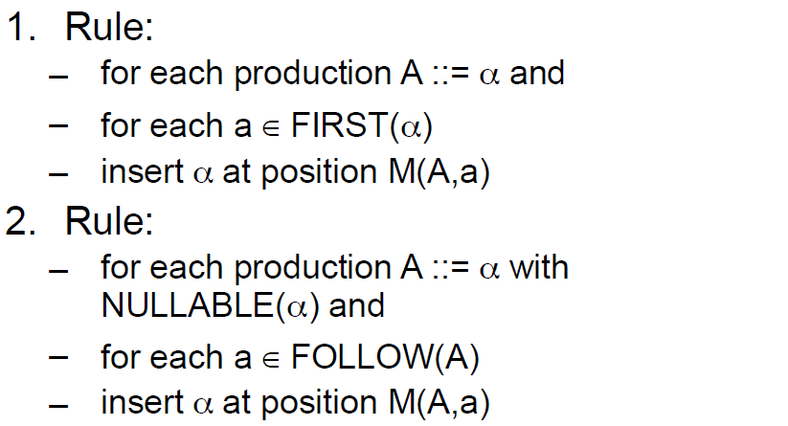

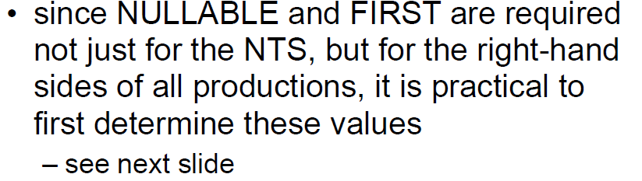

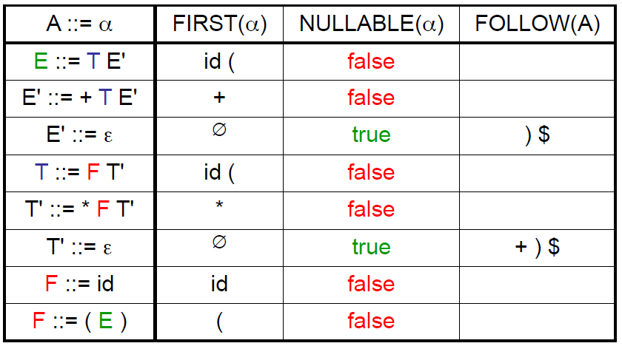

## Resulting Parse Table

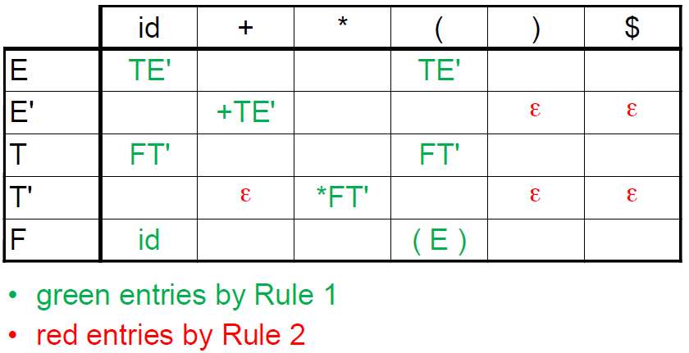

## LL(1) Grammars

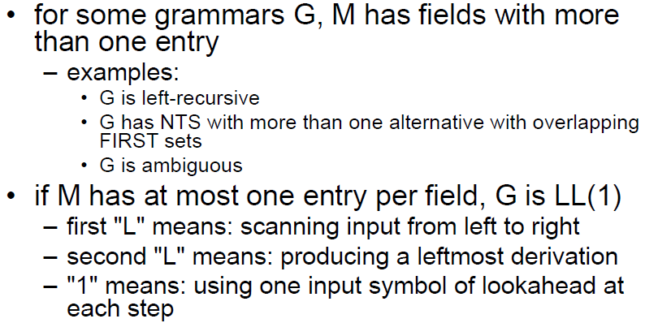

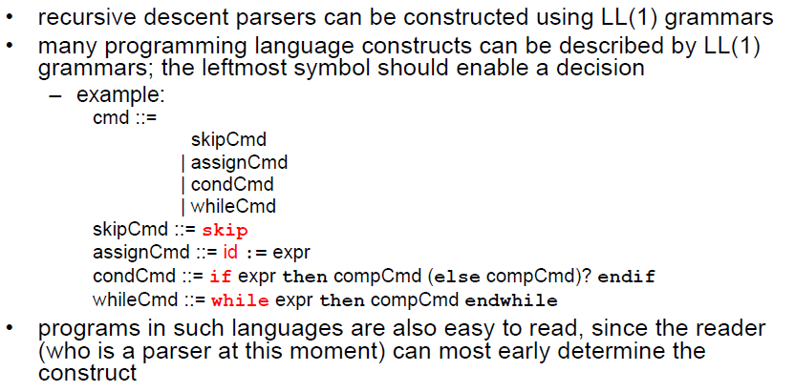

# Woche 6 & 7

## Syntax Trees

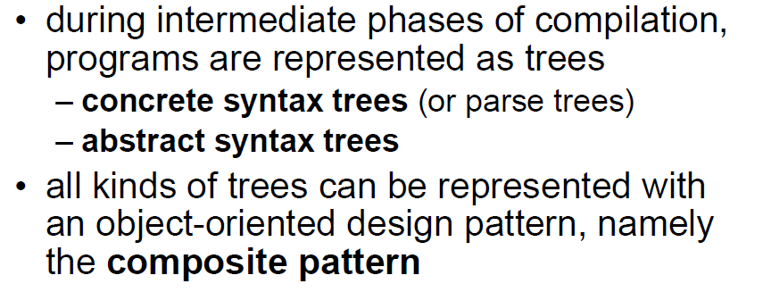

## Concrete Syntax Tree

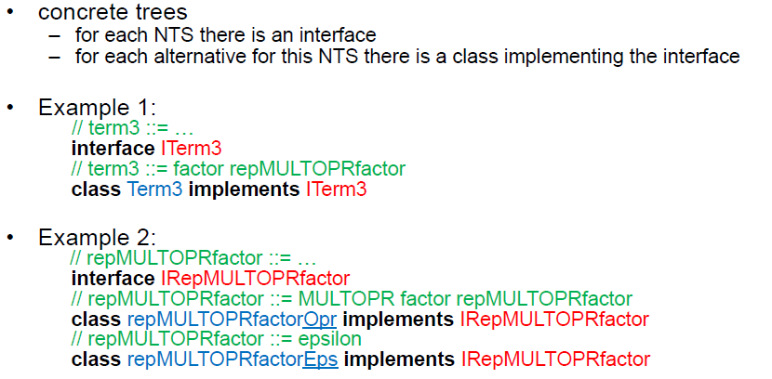

## Class ITerm3

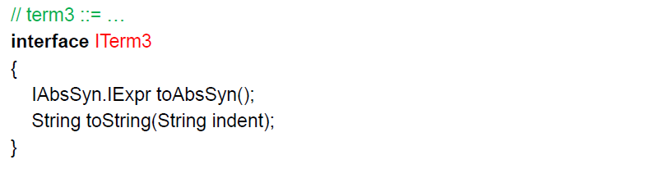

## Class Term3

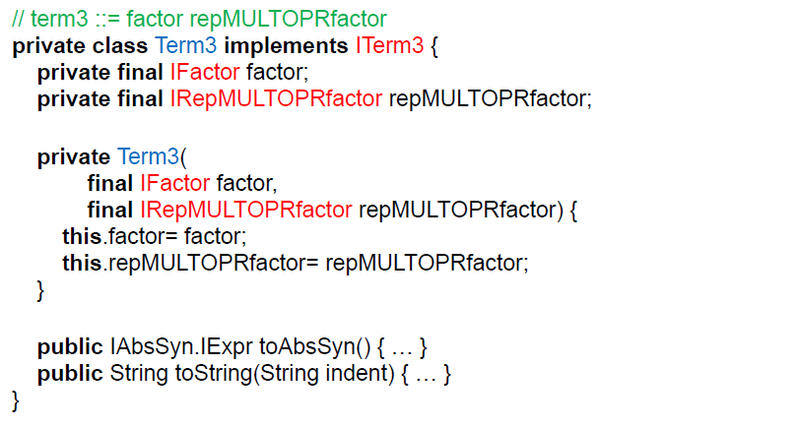

## Class IRepMULTOPRfactor

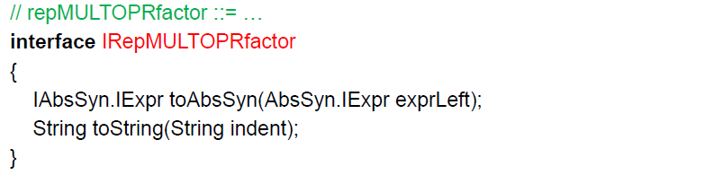

## Class RepMULTOPRfactorOpr

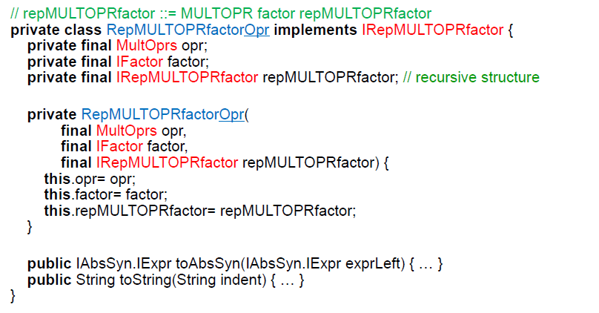

## Class RepMULTOPRfactorEps

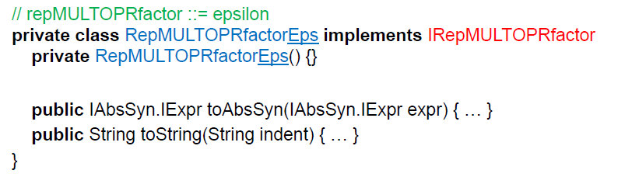

## Extension of Parser to return Concrete Syntax Trees

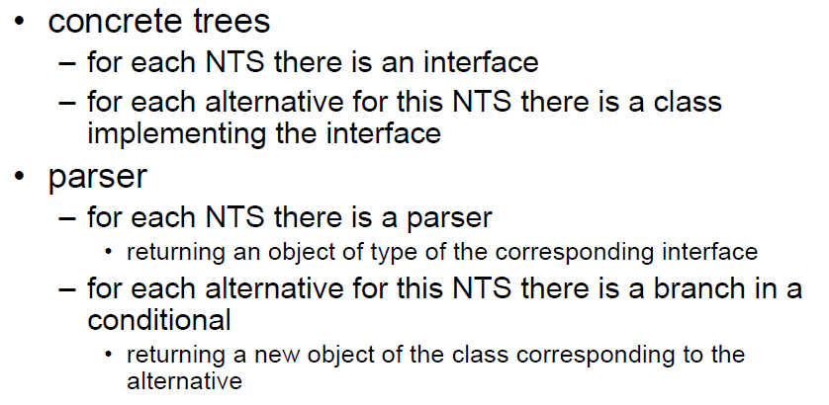

## Extension of Parser to return Syntax Trees

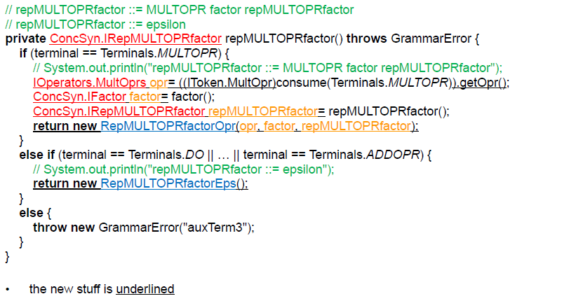

## Concrete versus Abstract Syntax

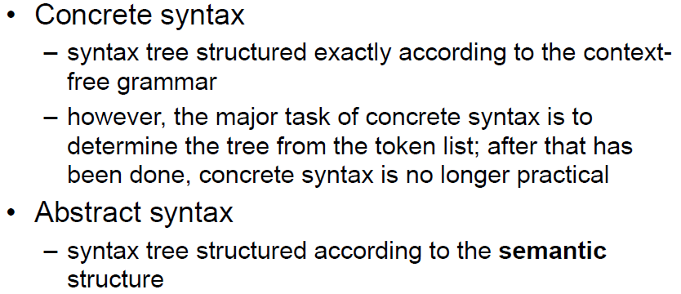

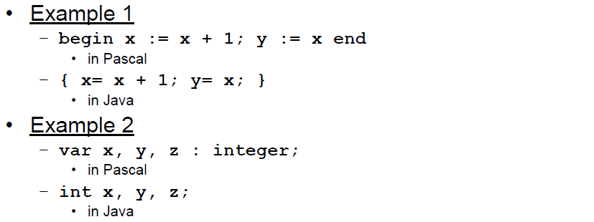

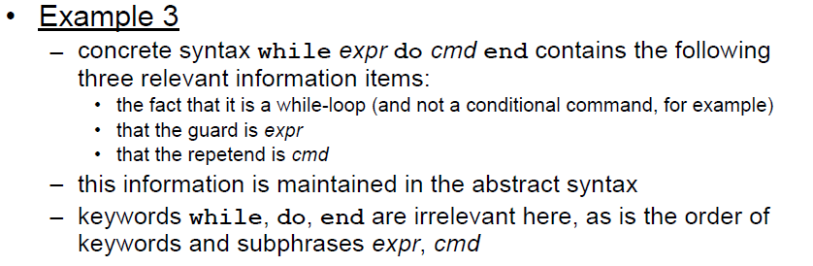

## Abstract Syntax

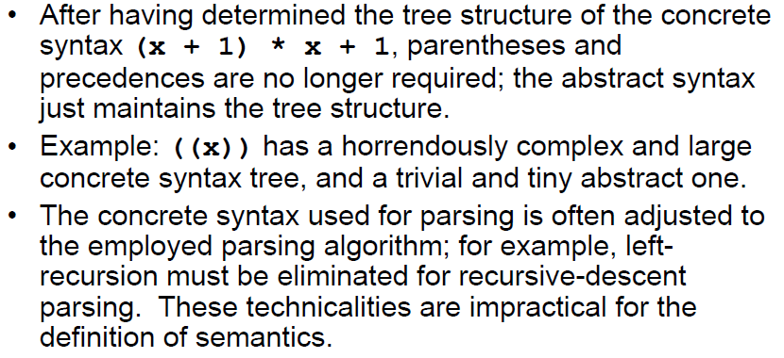

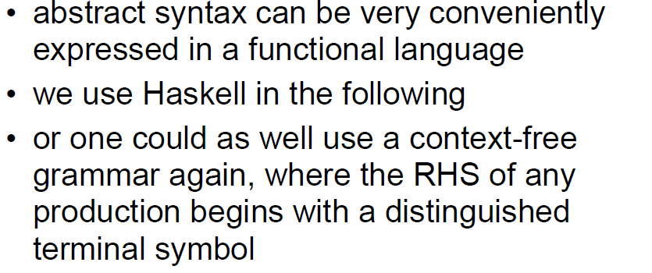

## Grammar IML (Expressions)

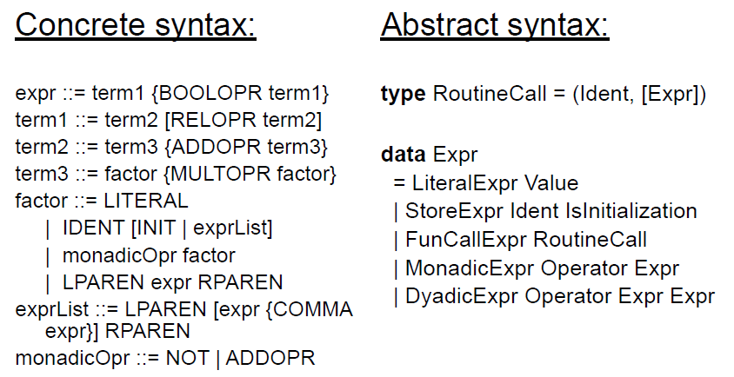

## Grammar IML (Base)

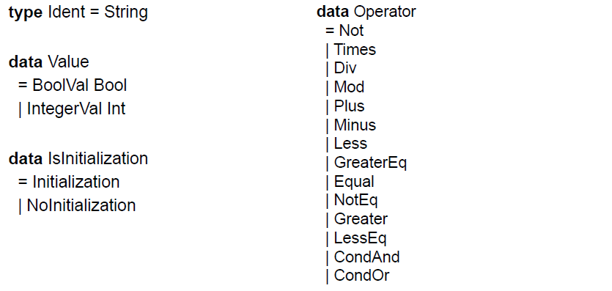

## Grammar IML (Commands)

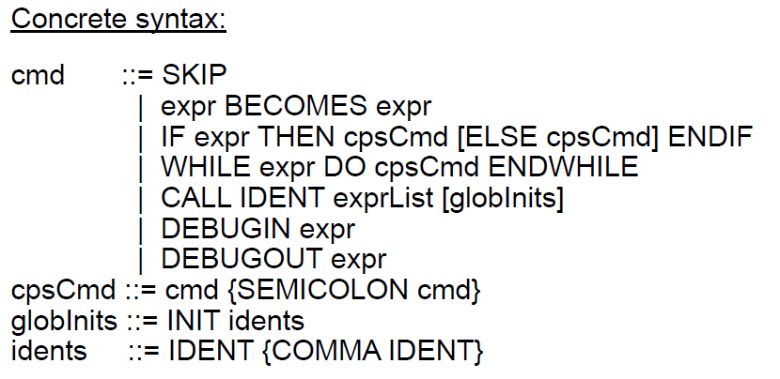

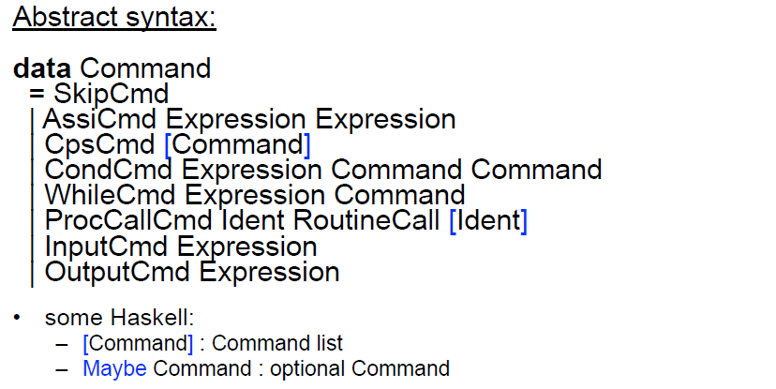

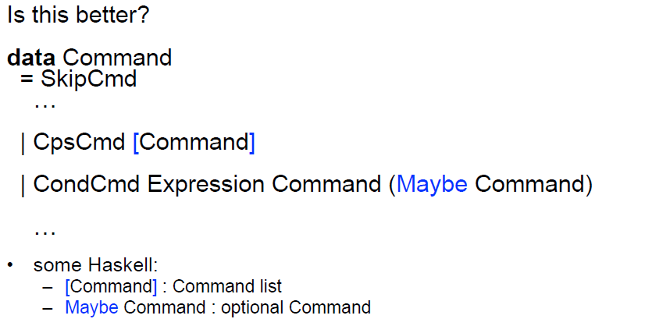

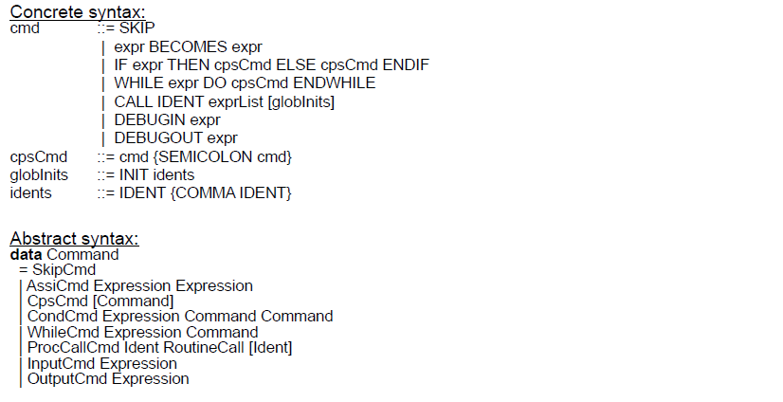

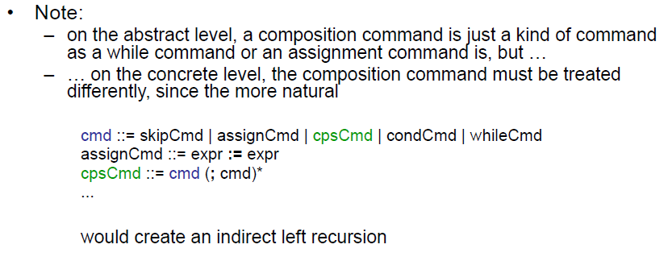

## Conversion

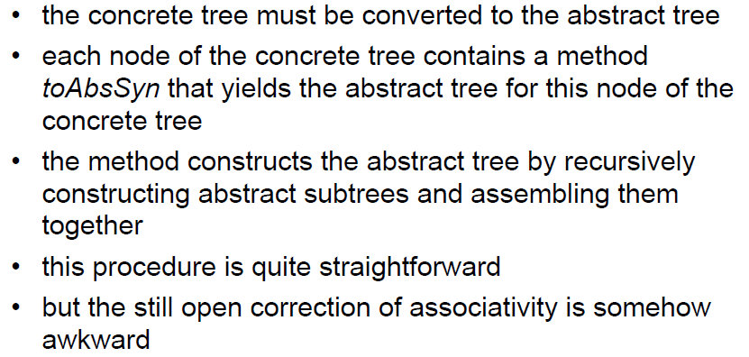

## Test Program

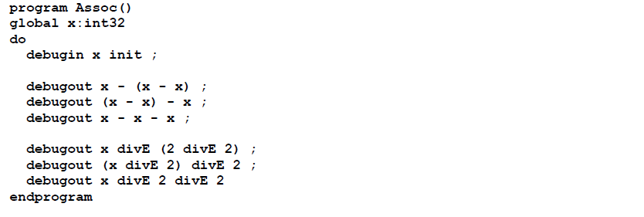

## Correcting Associativity

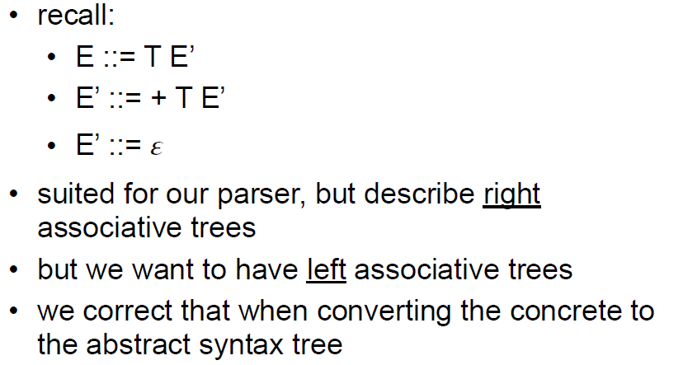

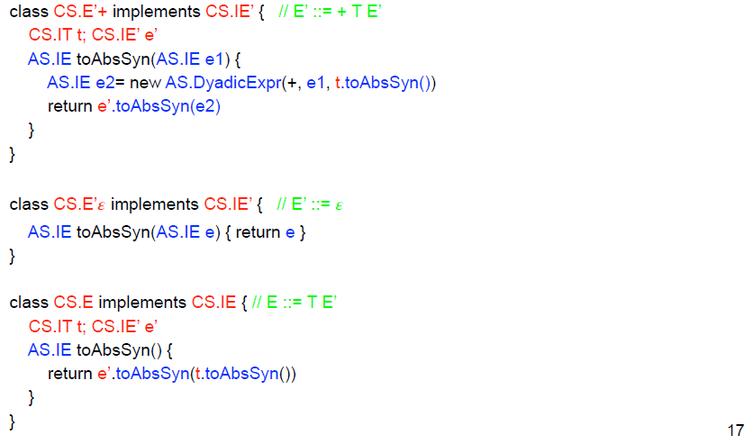

# Woche 8

In Woche 8 fanden die ersten Vorträge zu den Zwischenberichten statt.

# Woche 9

In Woche 9 fanden die nächsten Vorträge zu den Zwischenberichten statt.

# Woche 10 & 11

## Machine Specification

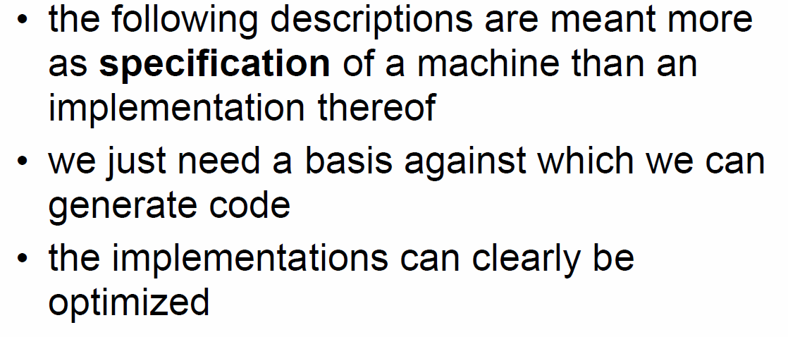

## Implementations of Virtual Machine

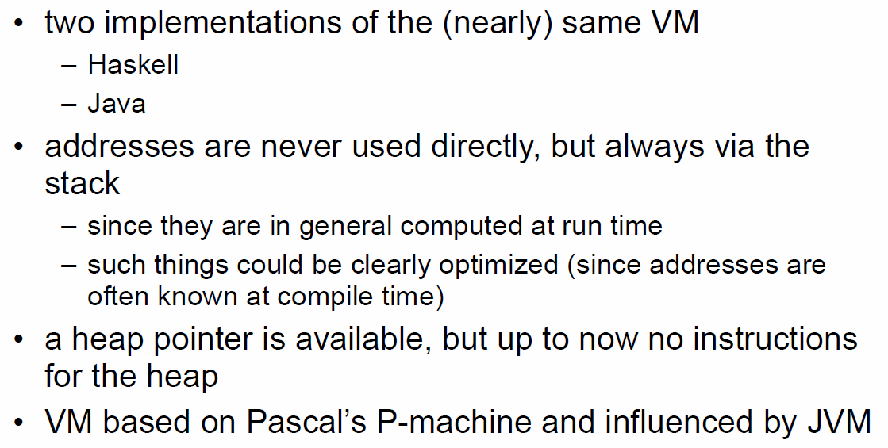

## Storage

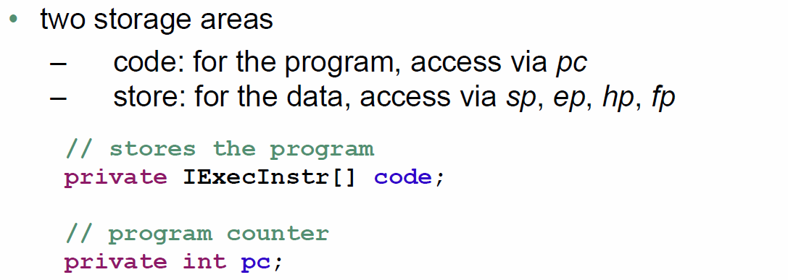

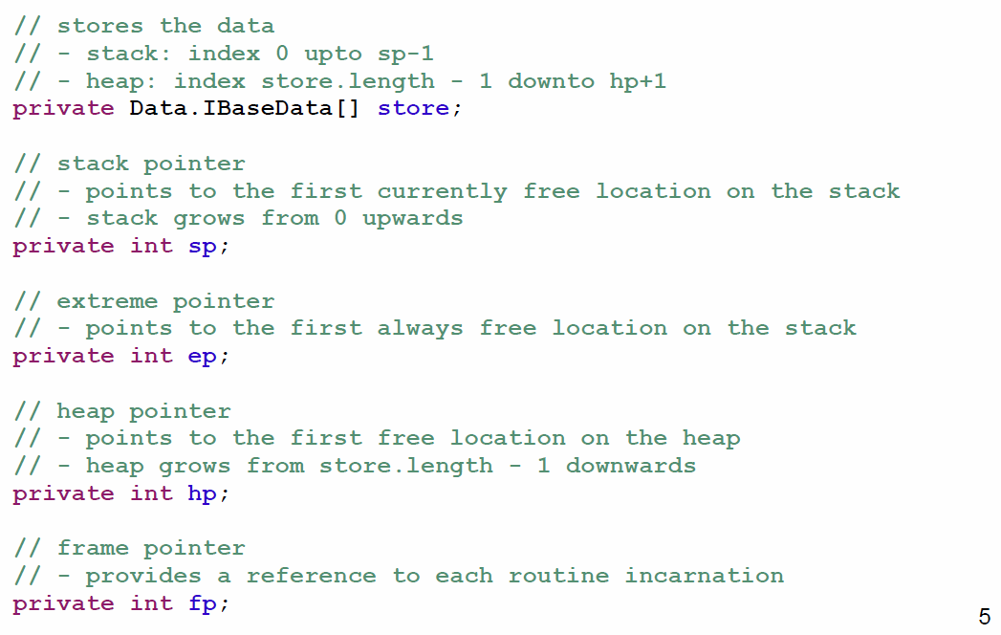

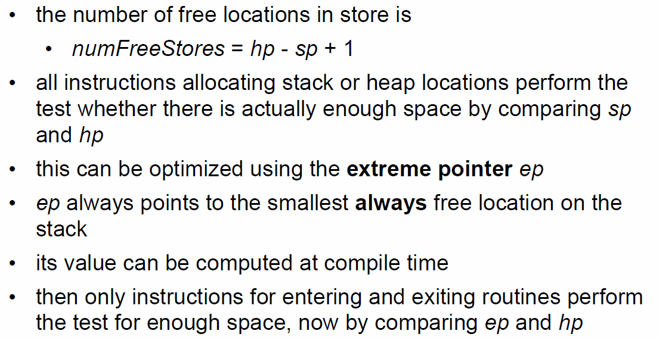

## Initialization

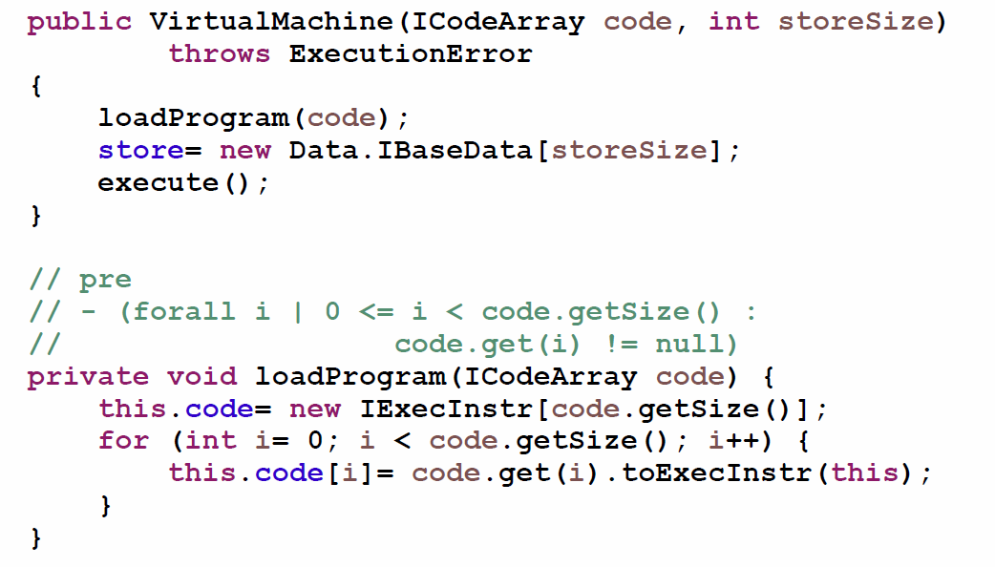

## Data

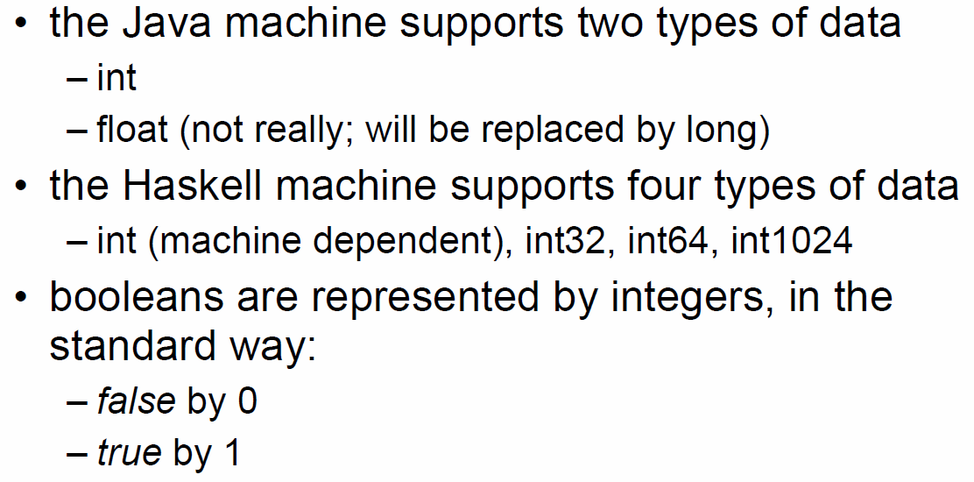

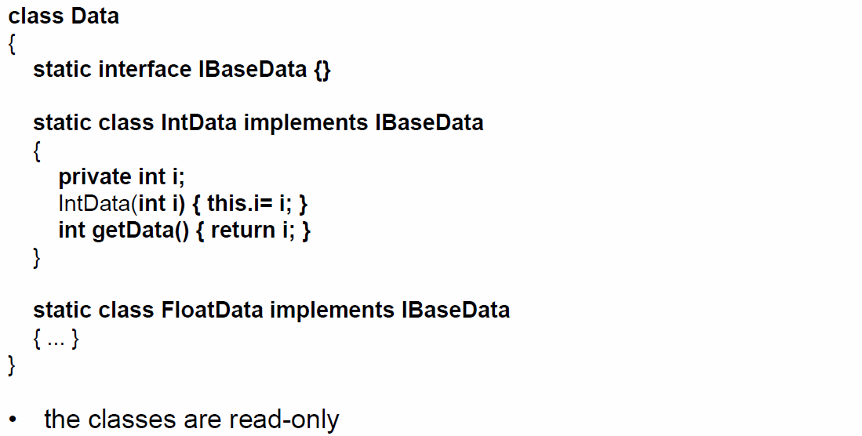

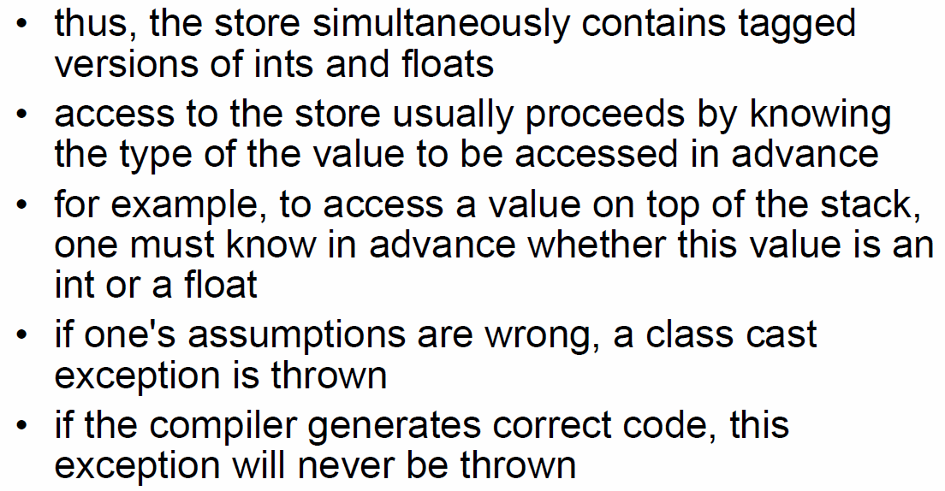

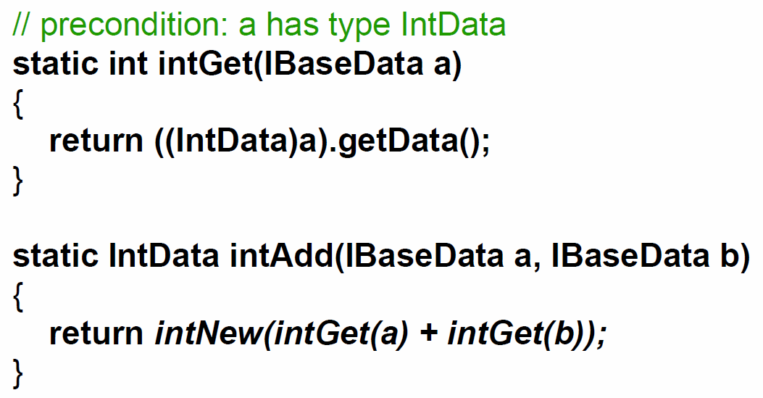

## Instructions

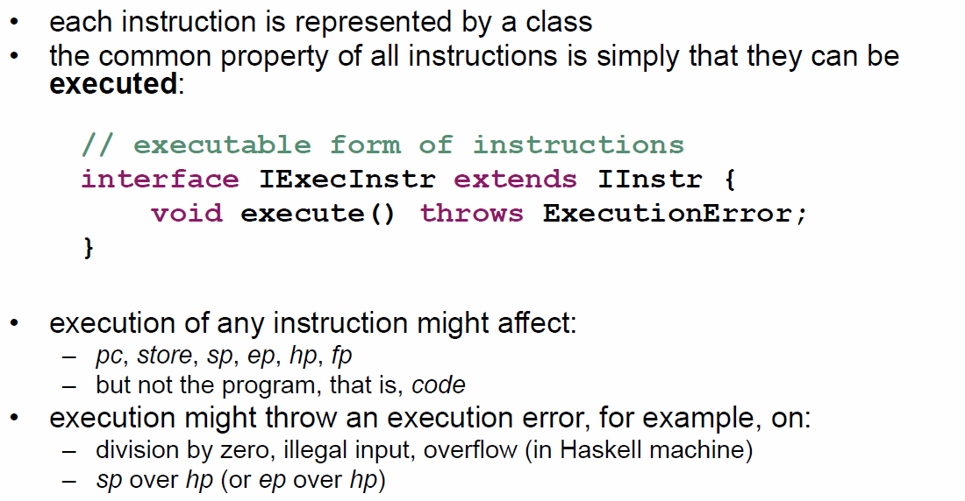

## Main Loop

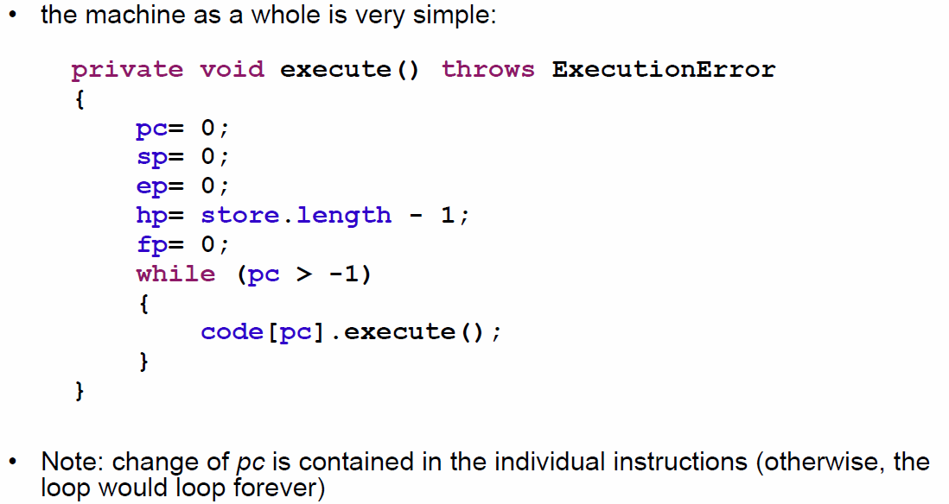

## A very important Instructions

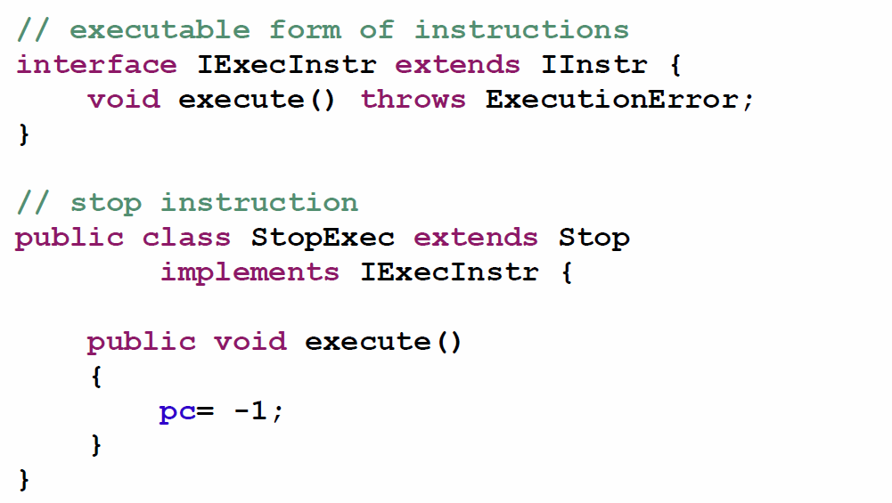

## Inner Classes

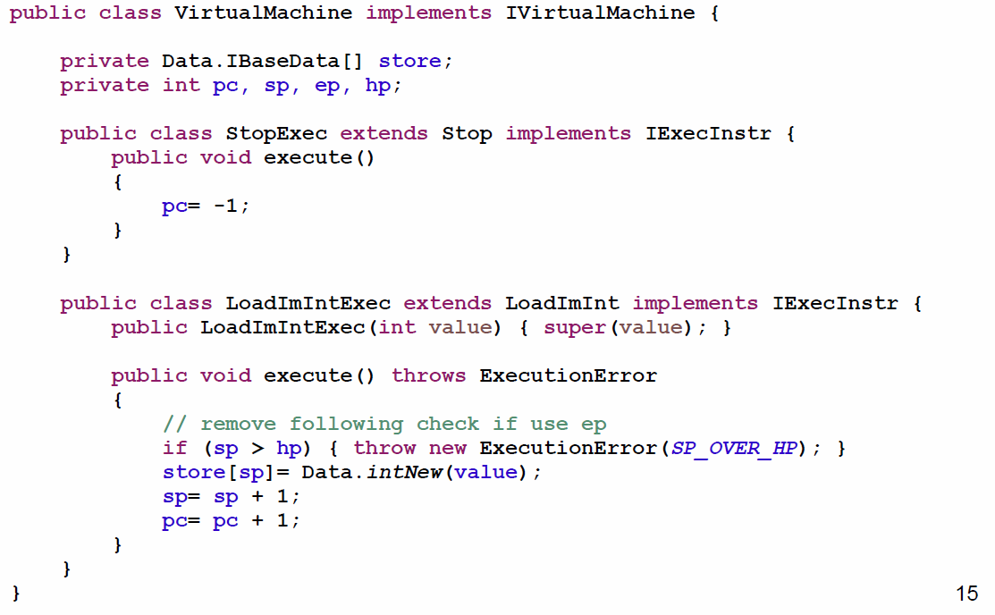

## Programming the Machine

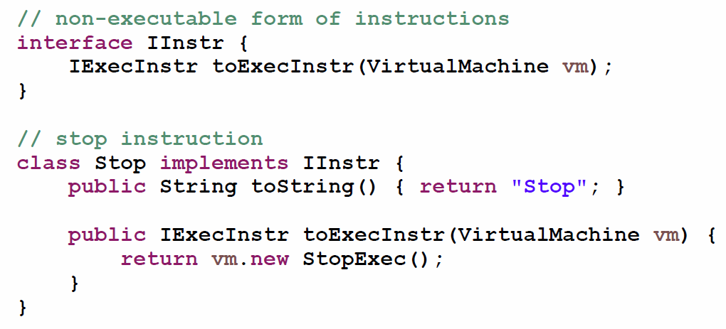

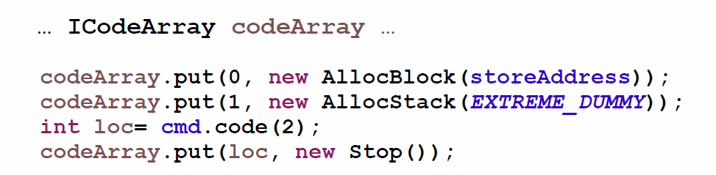

## Kind of Instructions

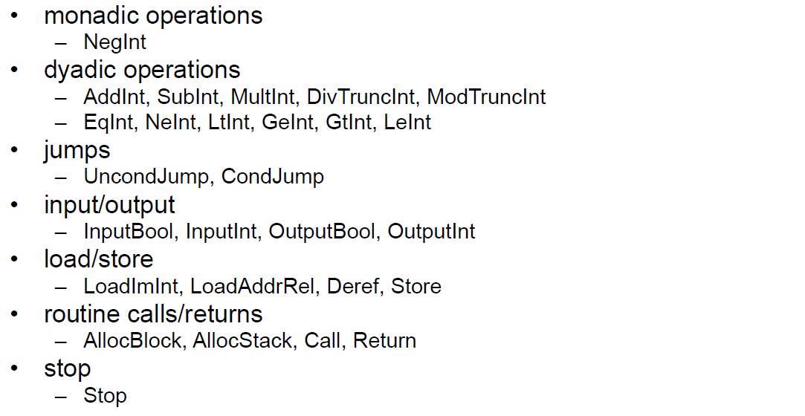

## Further Example: SubInt

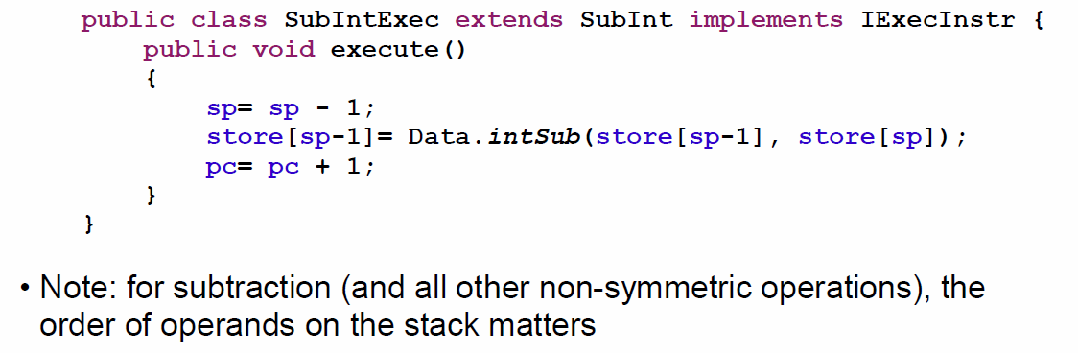

## Parameters

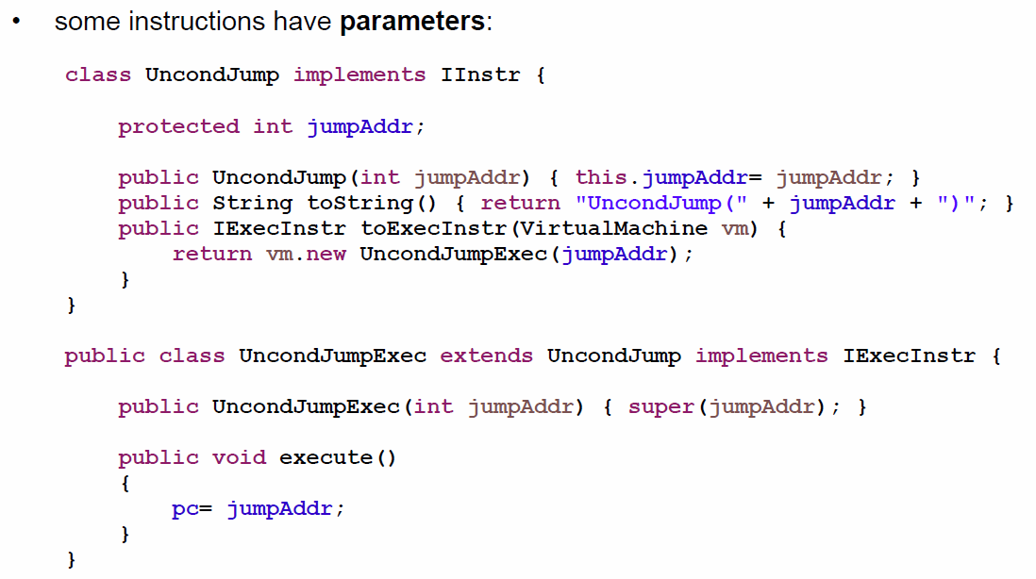

## Format for Instructions

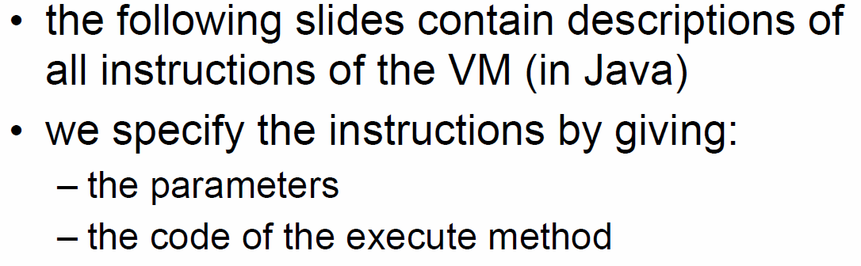

## NegInt

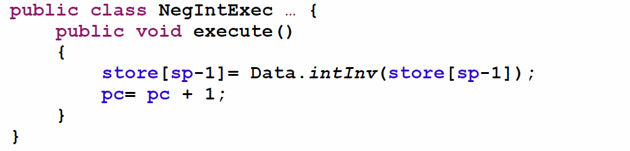

## AddInt, SubInt

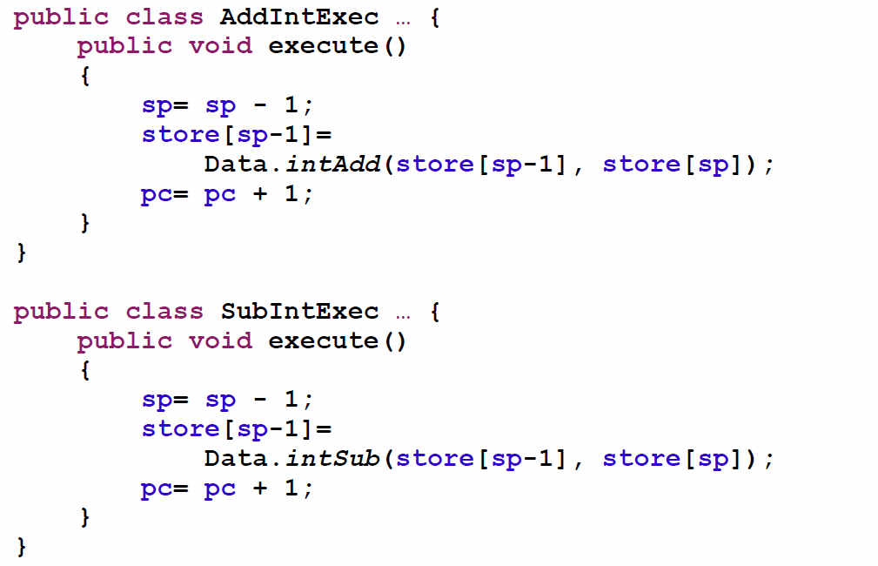

## MultInt, DivTruncInt, ModTruncInt

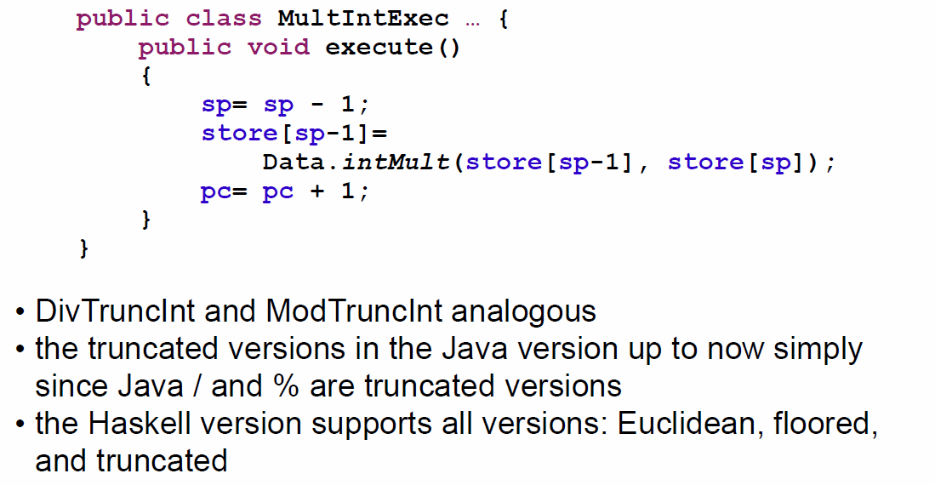

## EqInt, NeInt, GtInt, GeInt, LtInt, LeInt

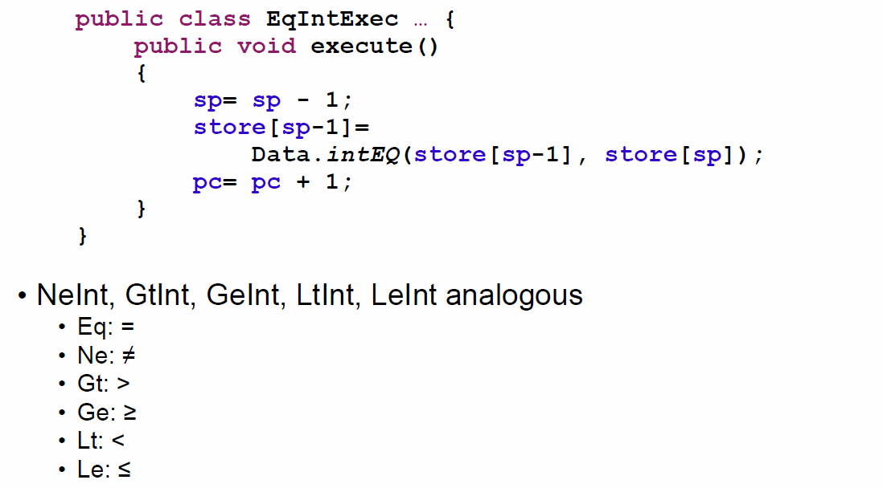

## UncondJump, CondJump

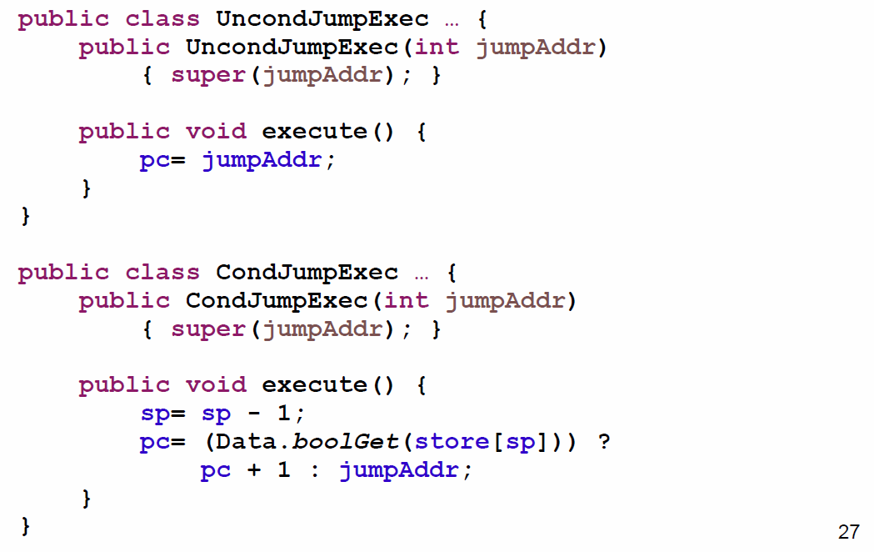

## InputBool, InputInt

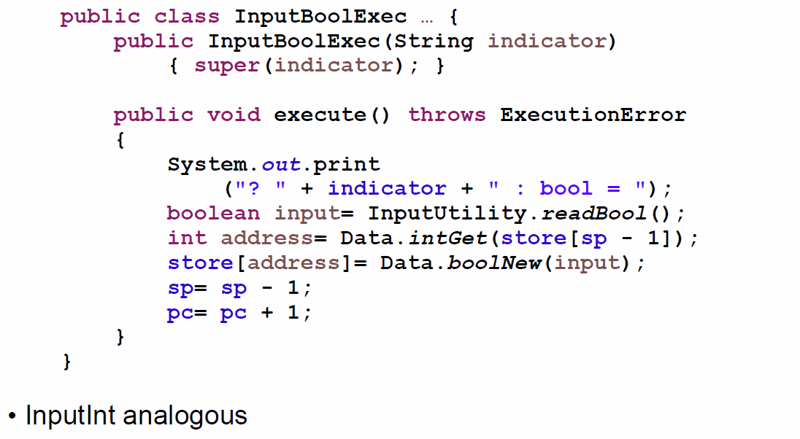

## OutputBool, OutputInt

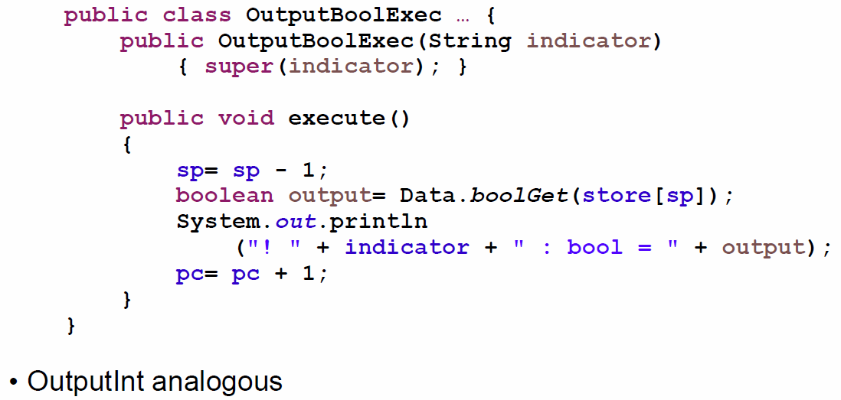

## LoadImInt

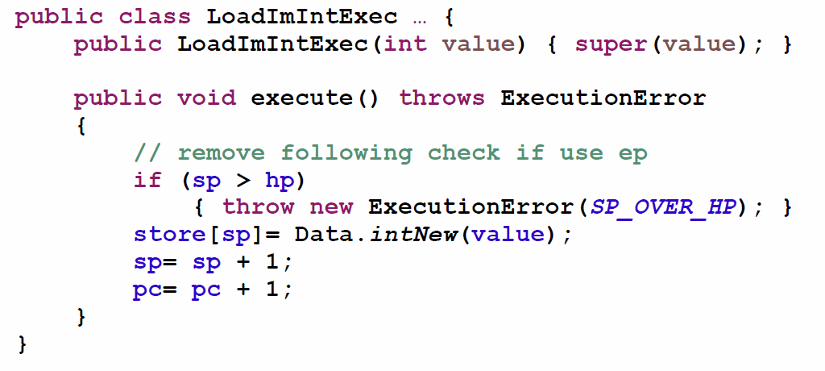

## LoadAddrRel

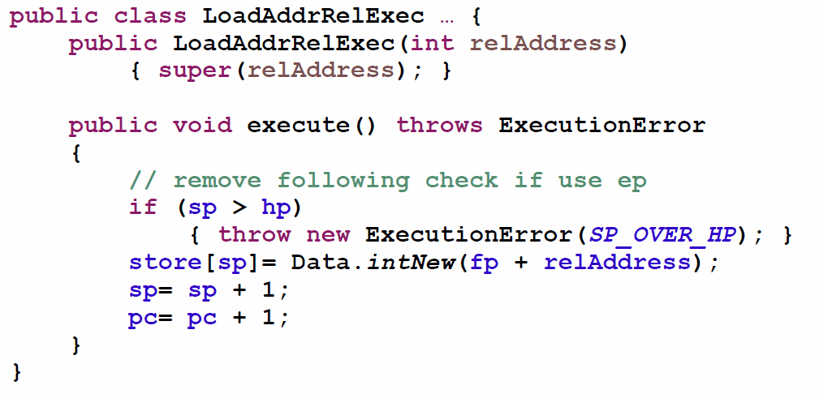

## Deref

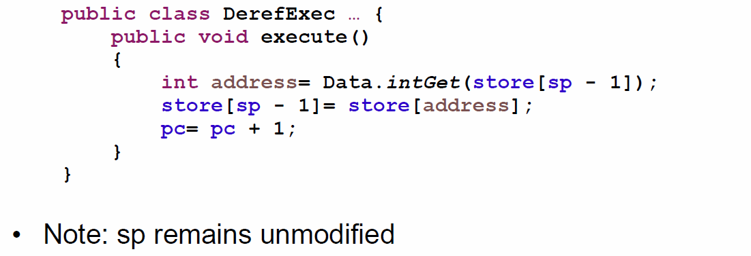

## Store

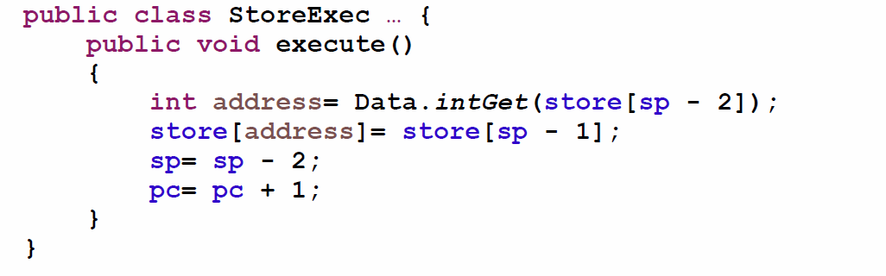

## Dup

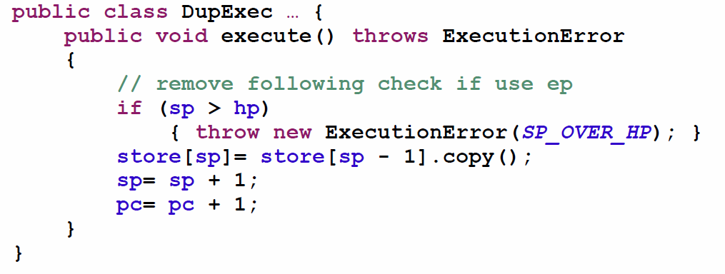

## AllocBlock

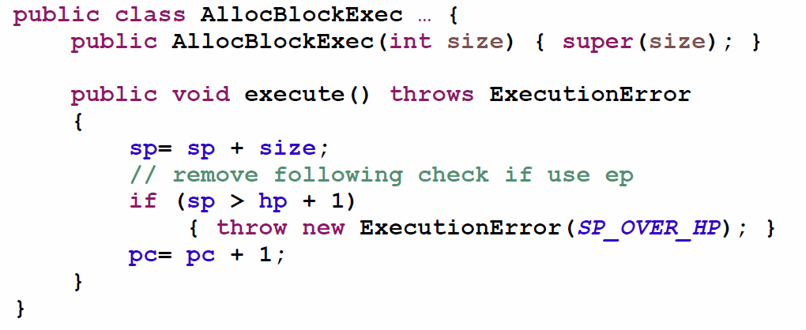

## AllocStack

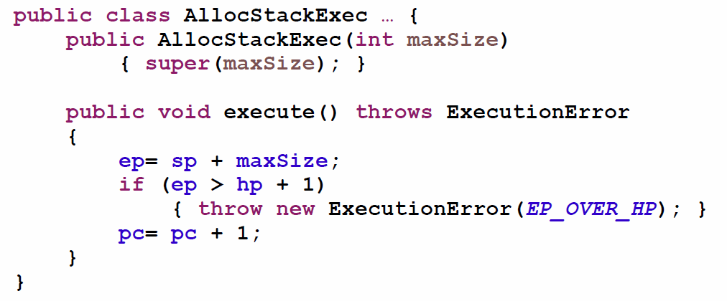

## Call

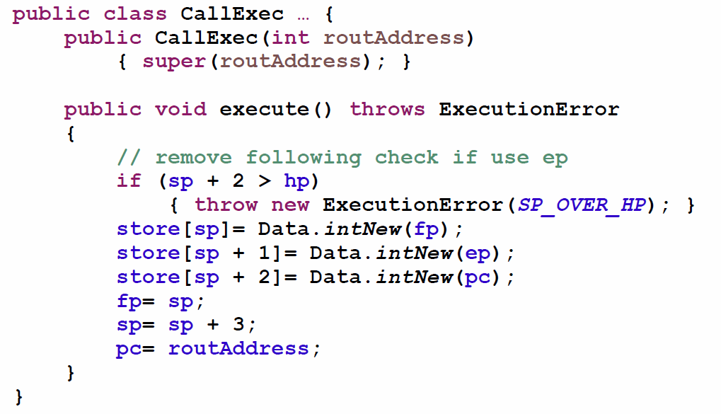

## Return

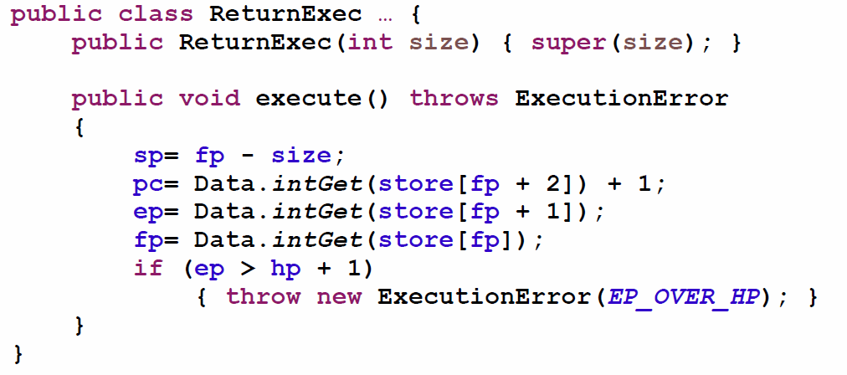

## Stop

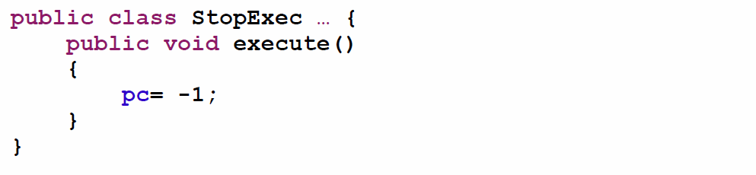

## Static Analysis

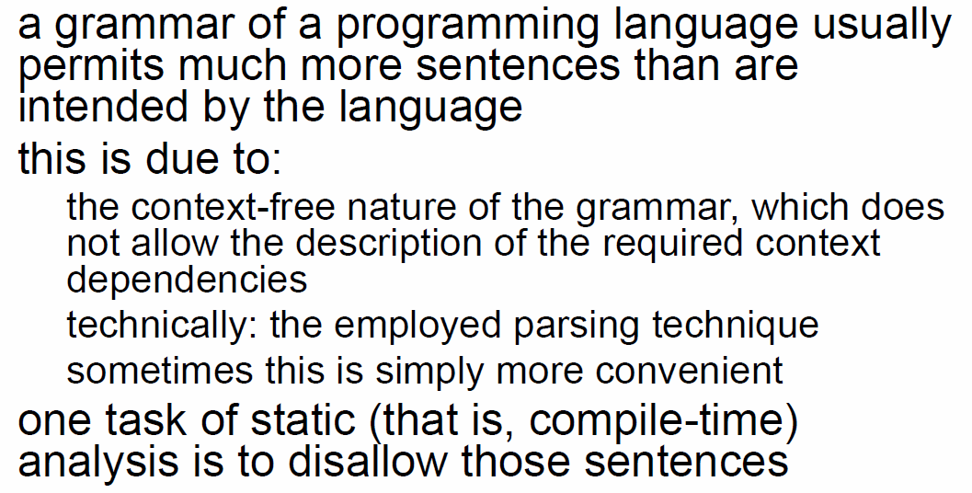

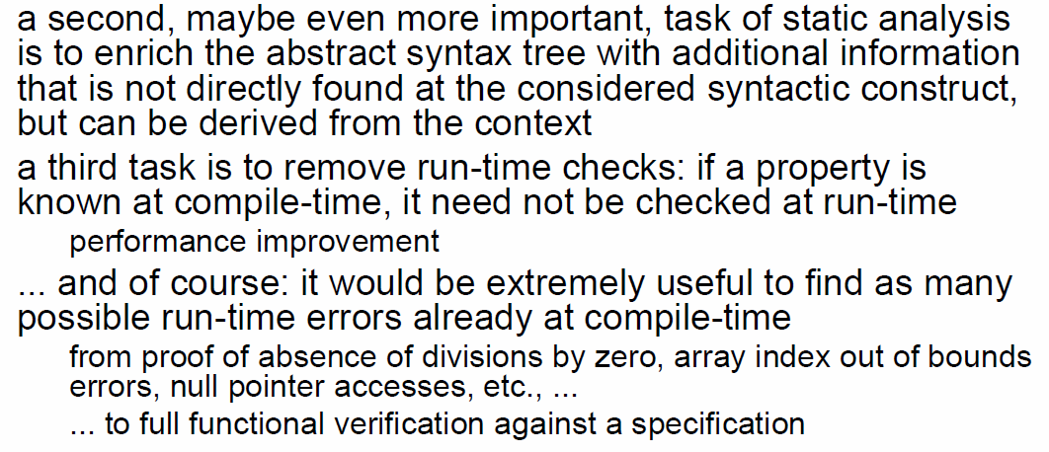

## Static Analysis in IML

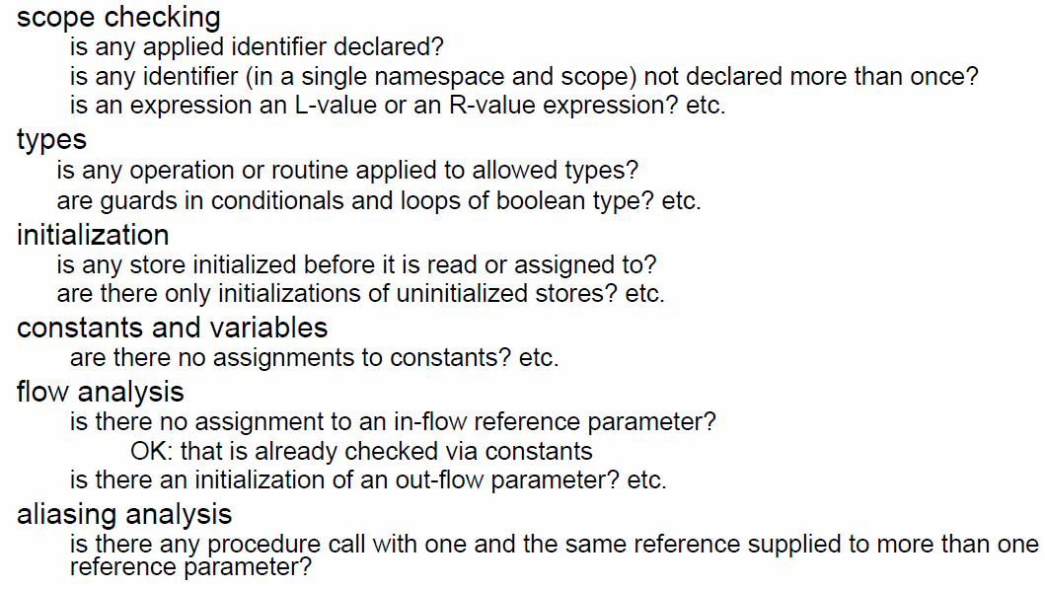

## Terminology

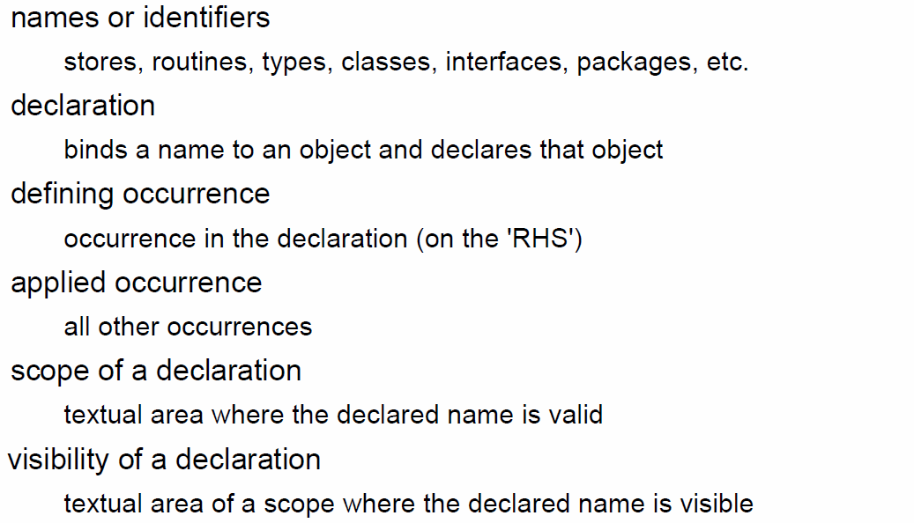

## Scope and Visibility

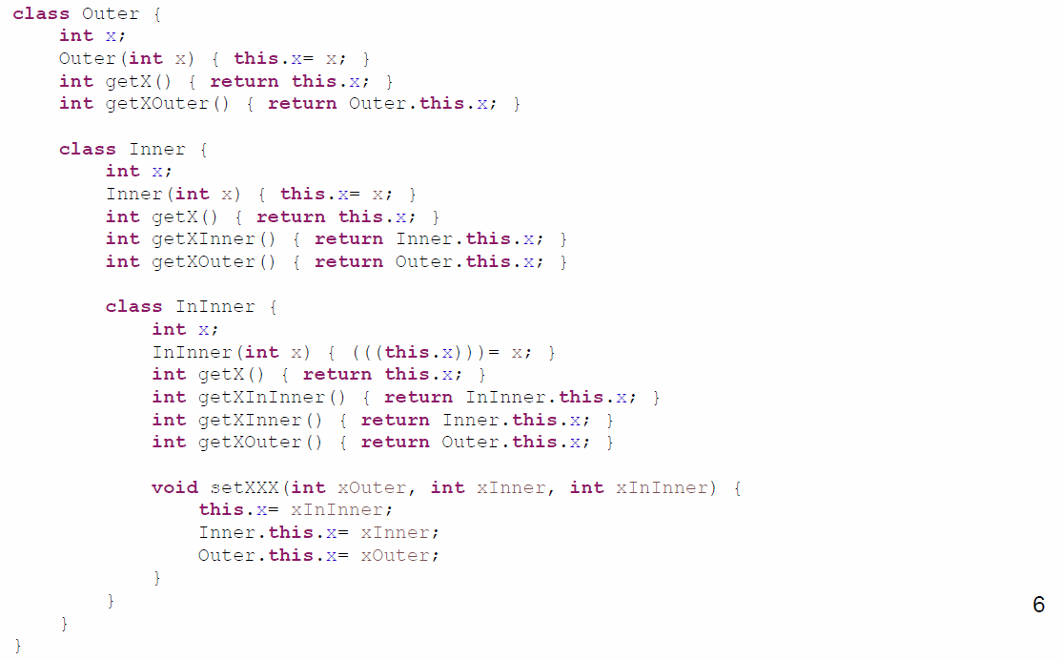

## Scopes in IML

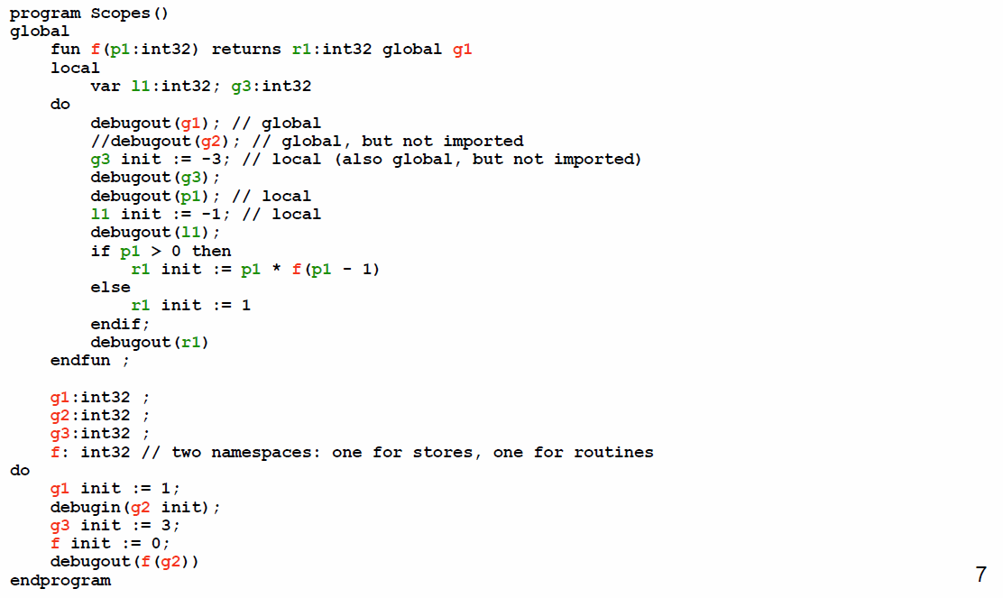

## Scopes

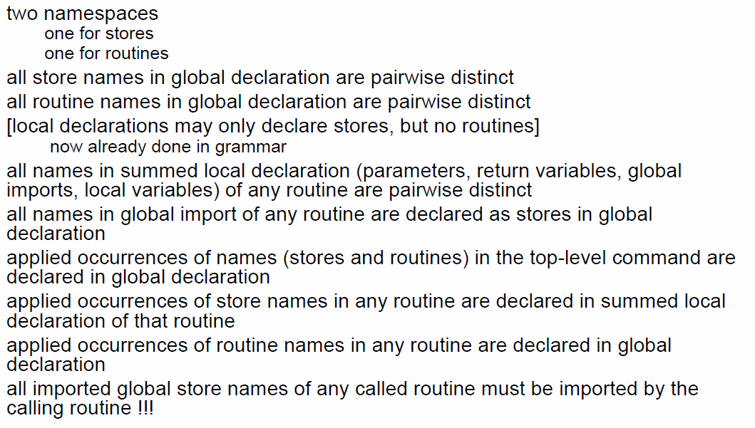

## Global Imports

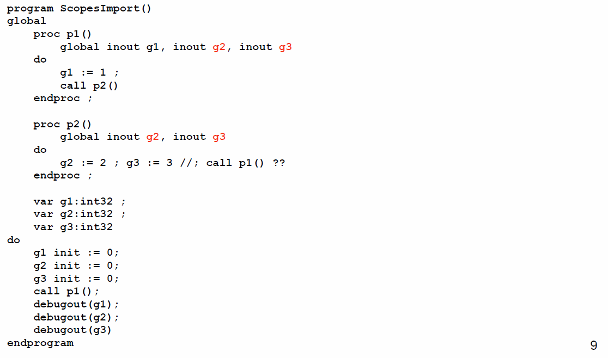

## Example: Assignment Commands

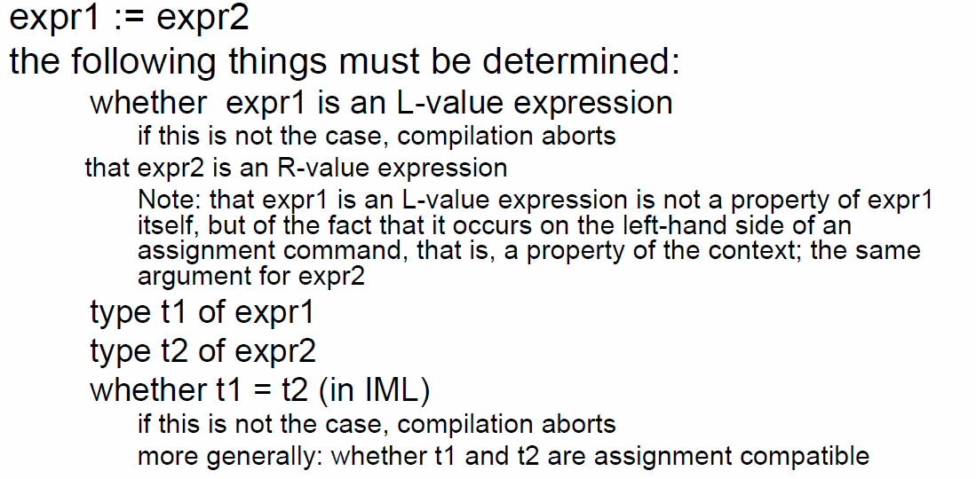

## Example: Routine Calls

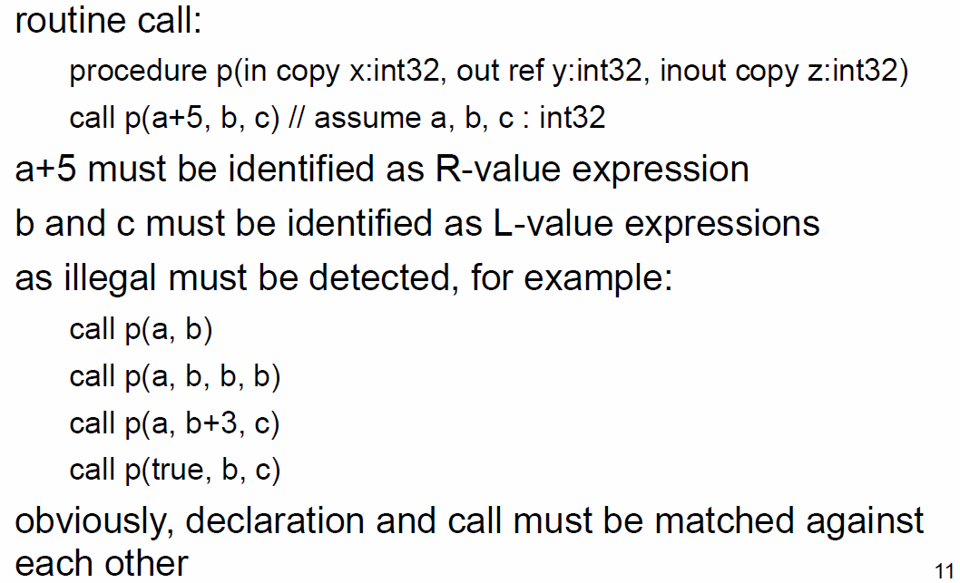

## L-Value and R-Value Expressions

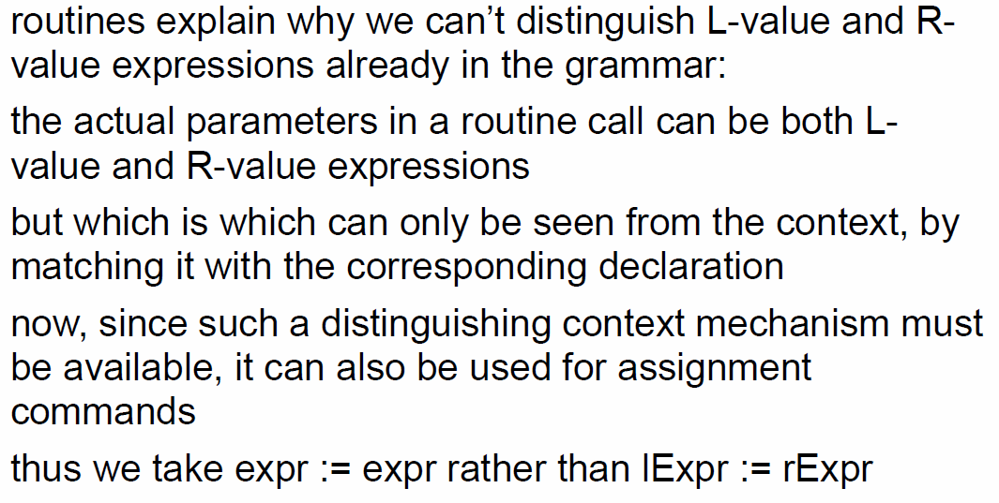

## Result of Scope Checking

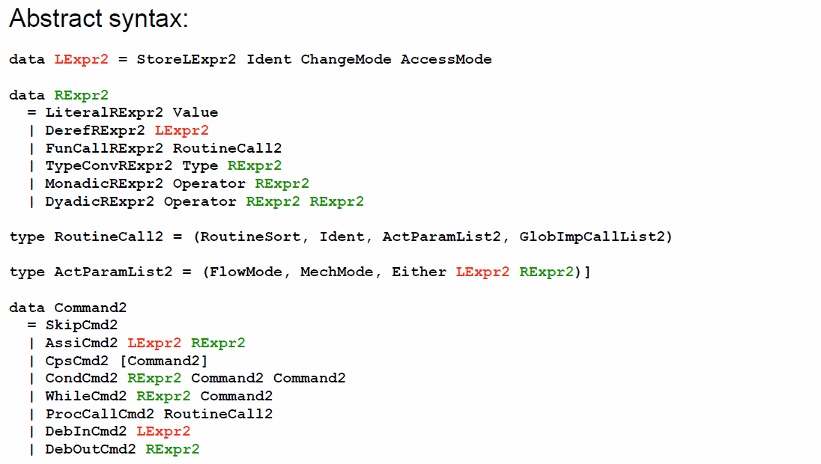

## Scopes and Access Modes

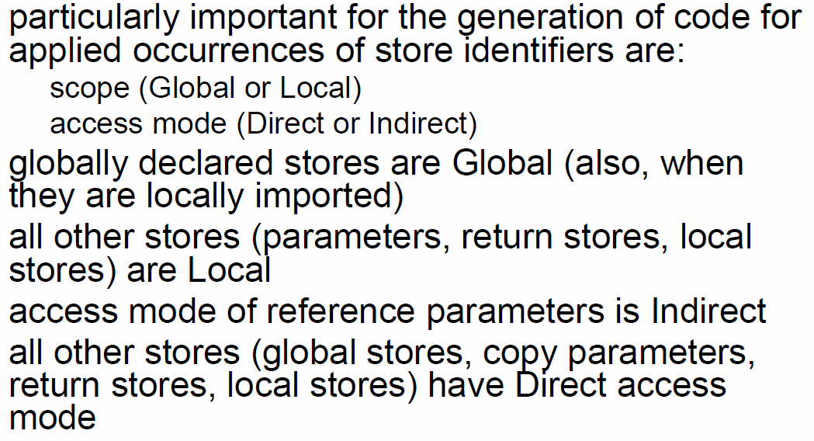

## Example

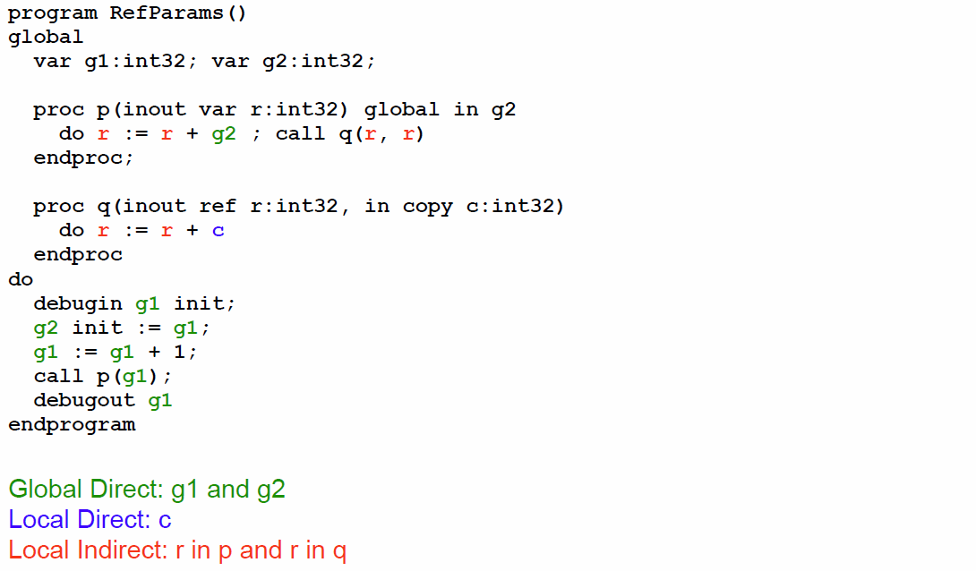

## Default Modes

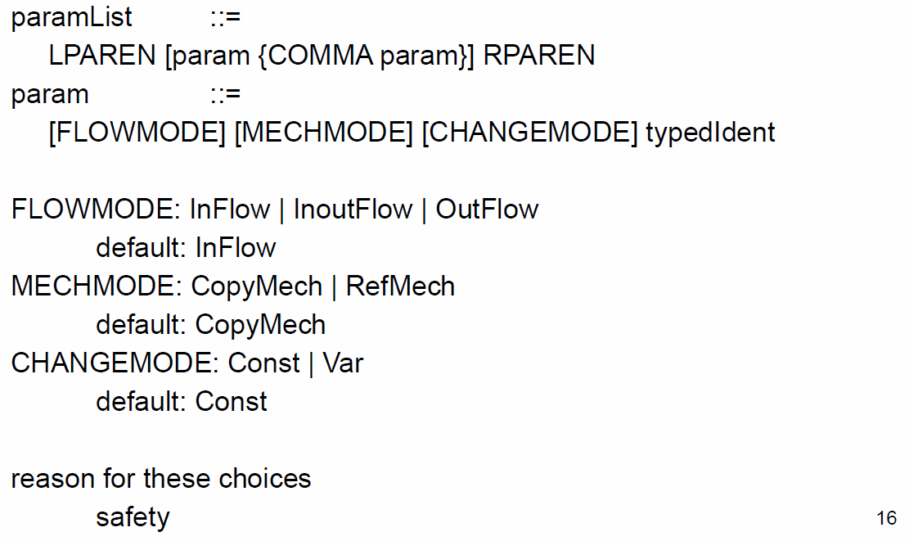

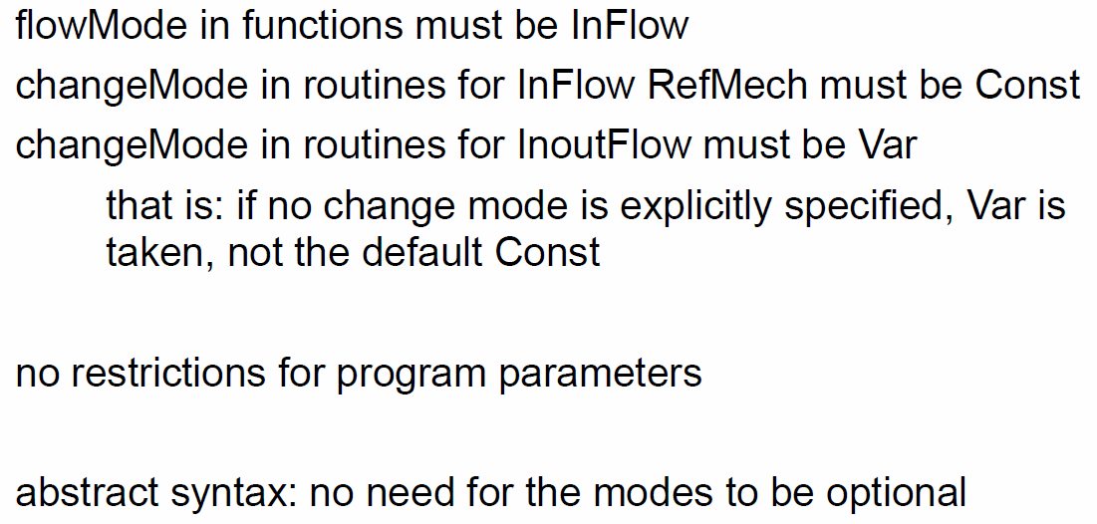

## Implementation

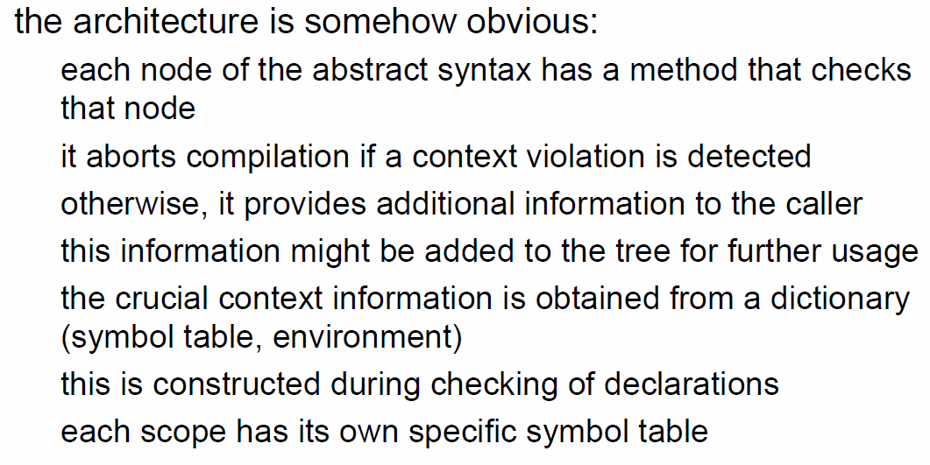

## Example Type of DyadicExpr

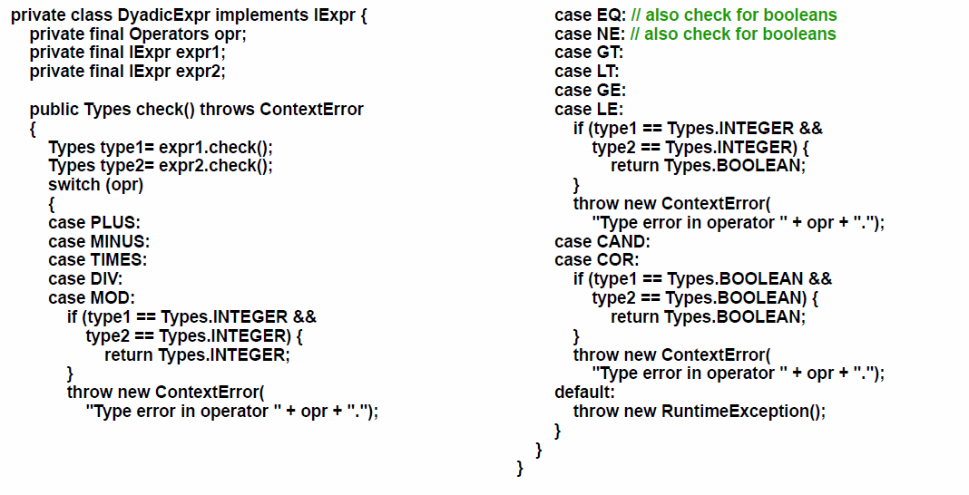

## Example Type of VarExpr

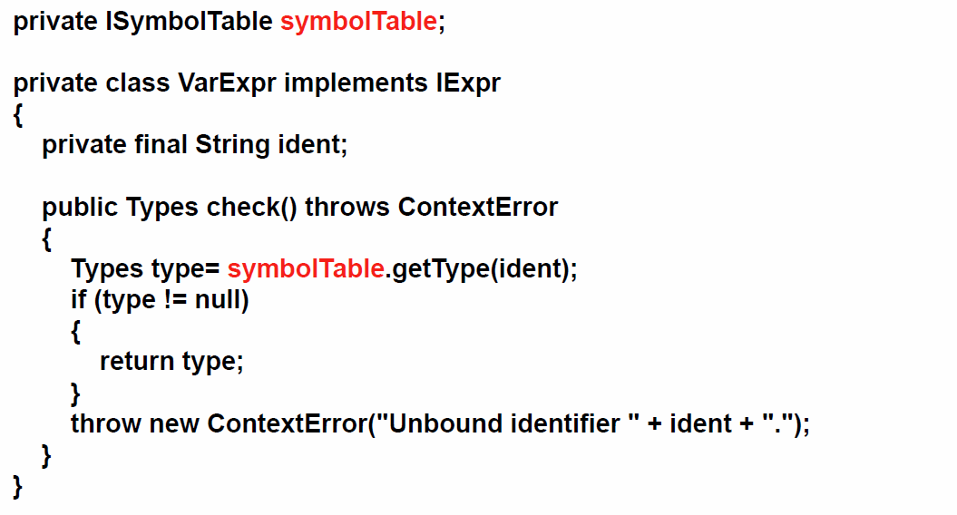

# Woche 12 & 13

## Static Analysis

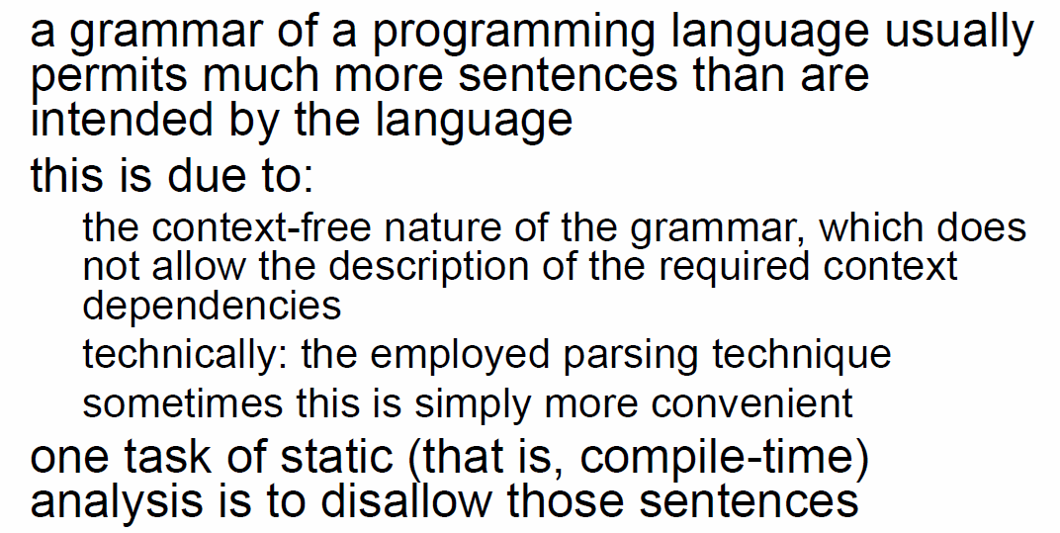

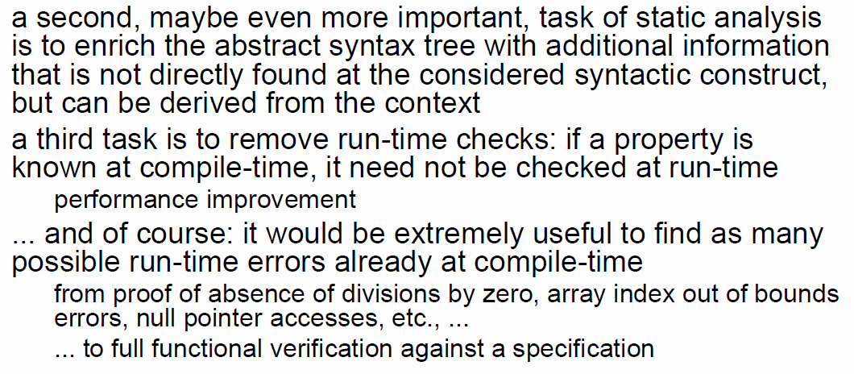

## Static Analysis in IML

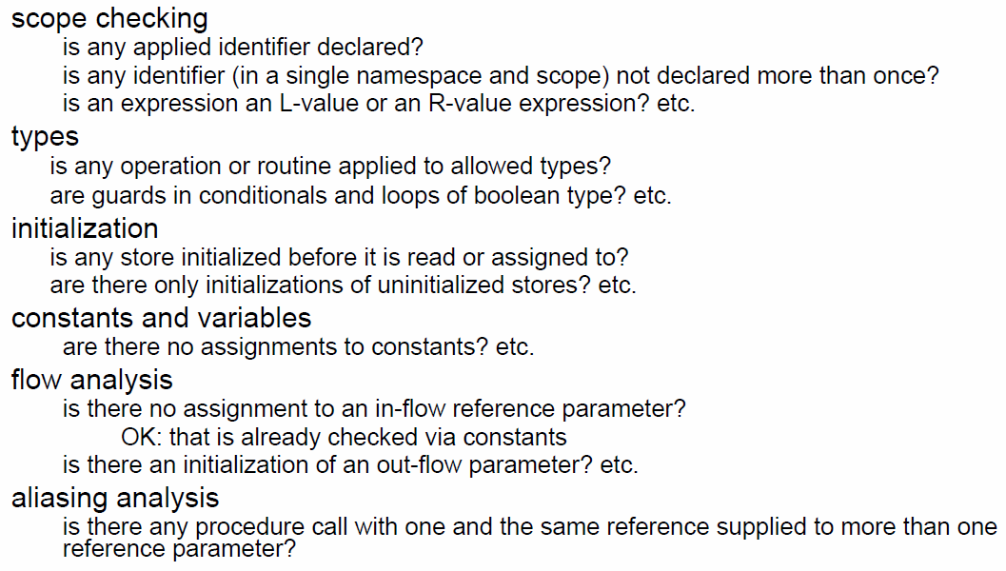

## Terminology

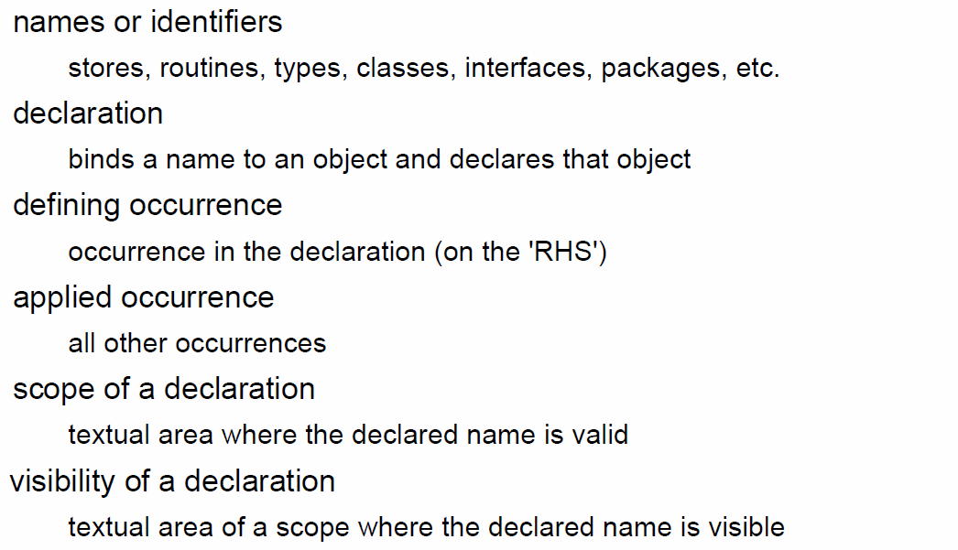

## Scoping and Visibility

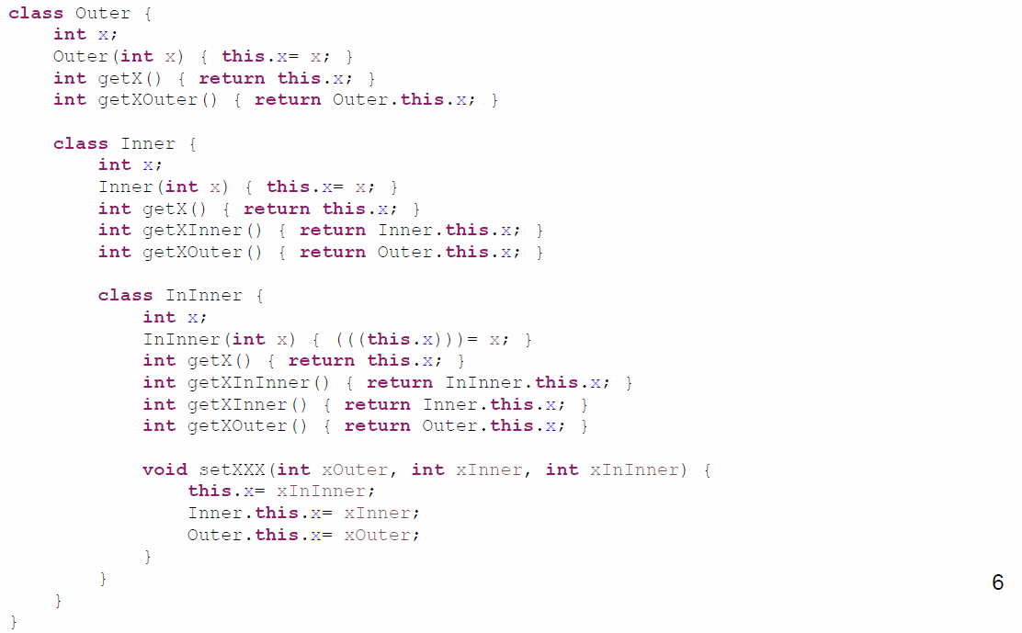

## Scopes in IML

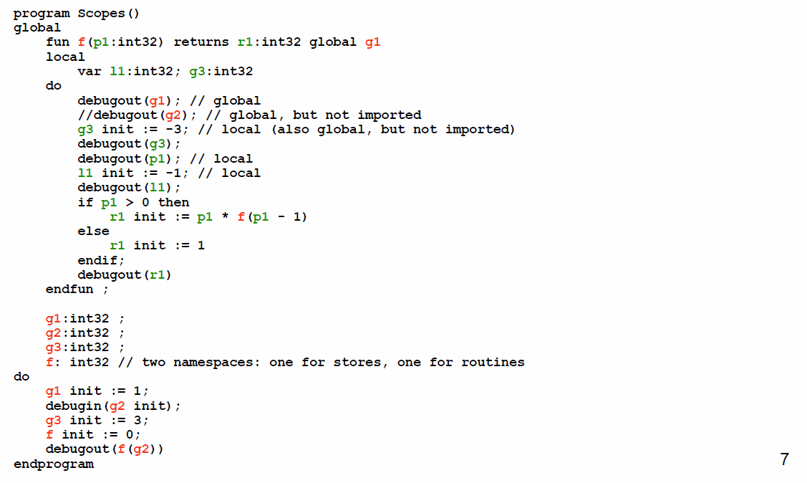

## Scopes

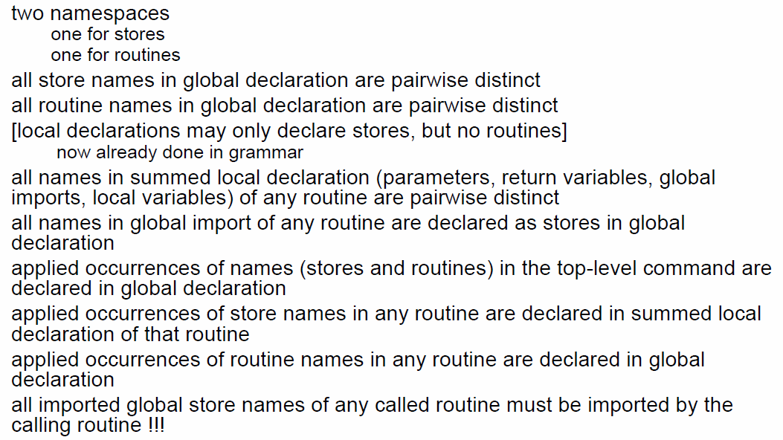

## Global Imports

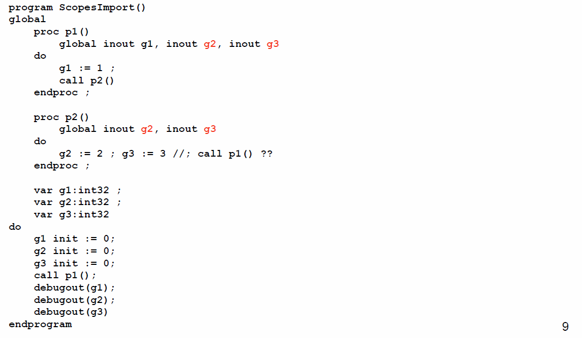

## Example: Assignment Commands

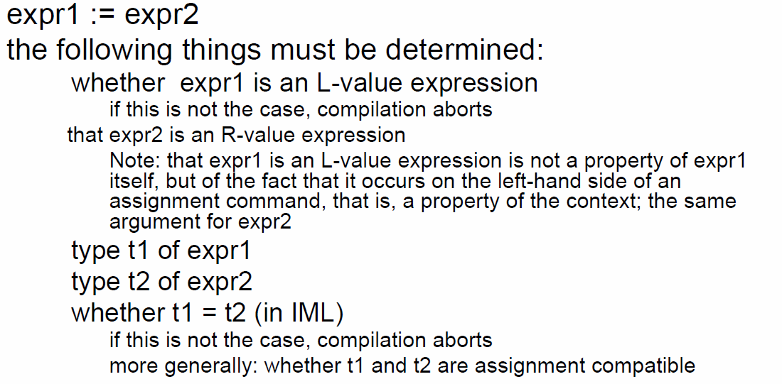

## Example: Routine Calls

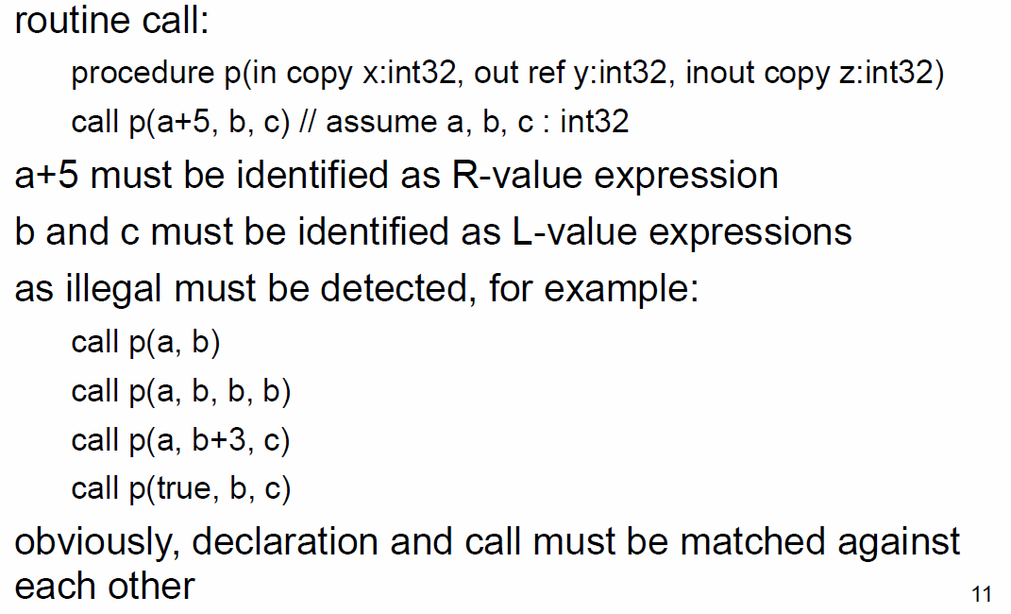

## L-Value and R-Value Expressions

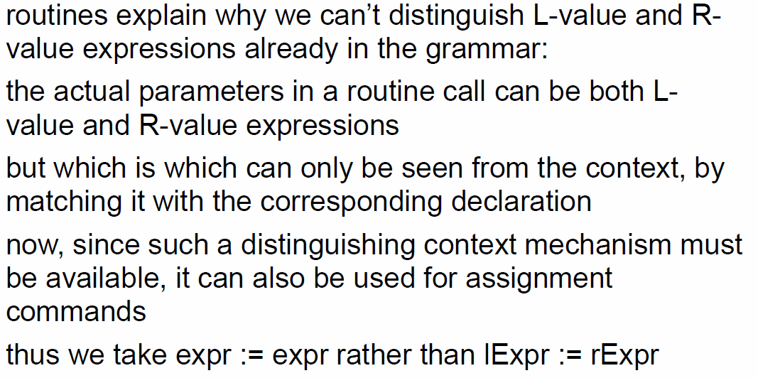

## Result of Scope Checking

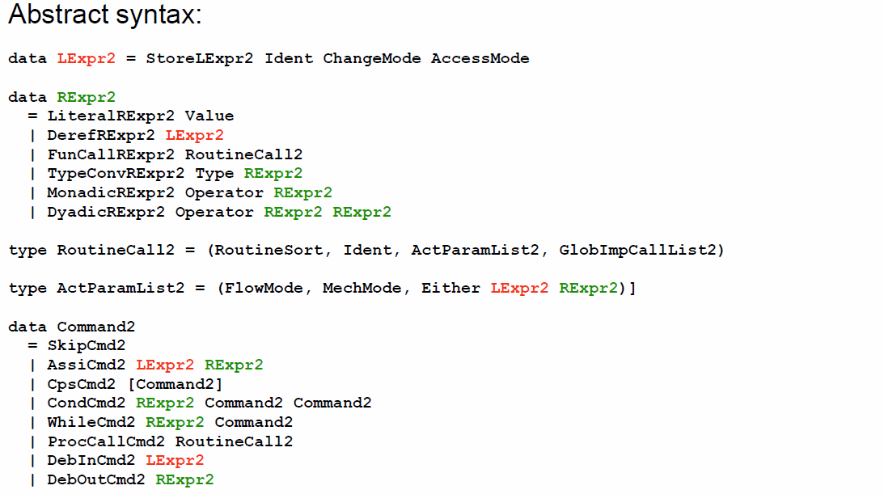

## Scopes and Access Modes

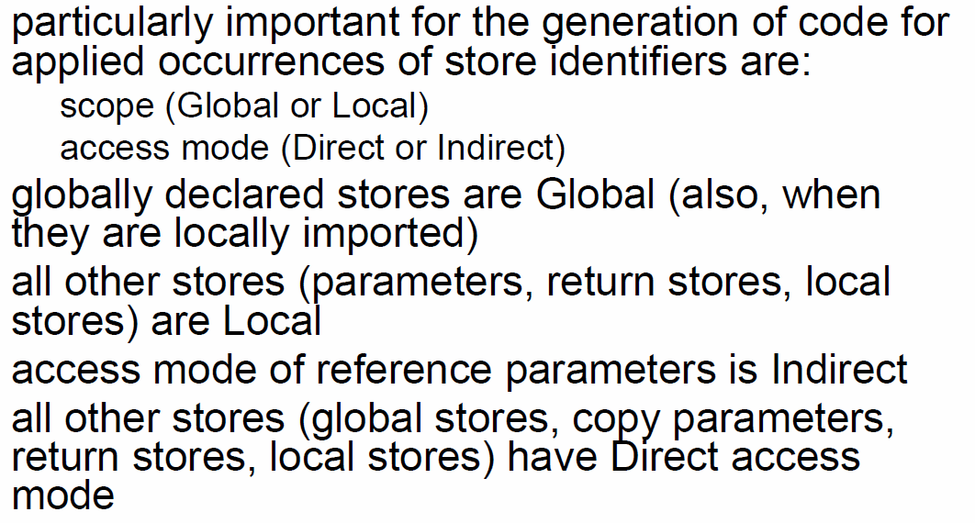

## Example

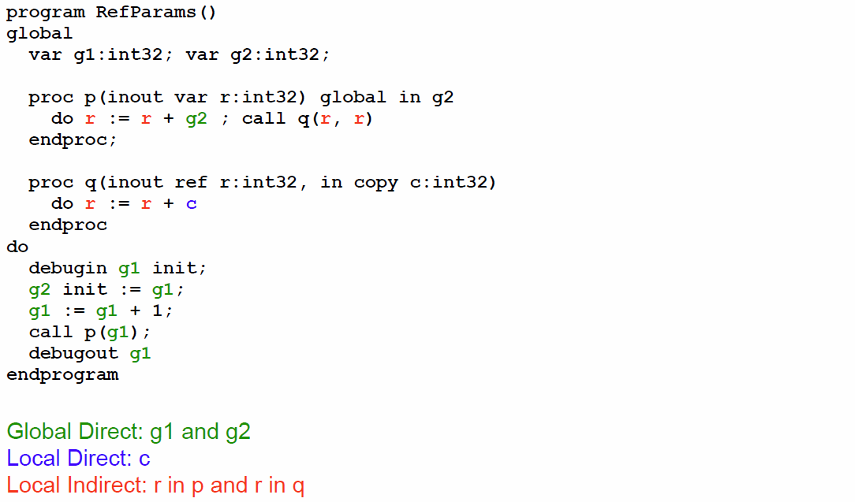

## Default Modes

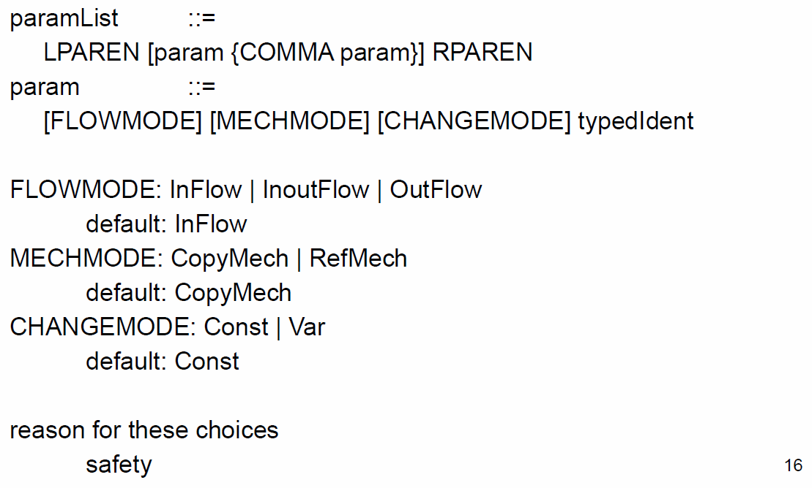

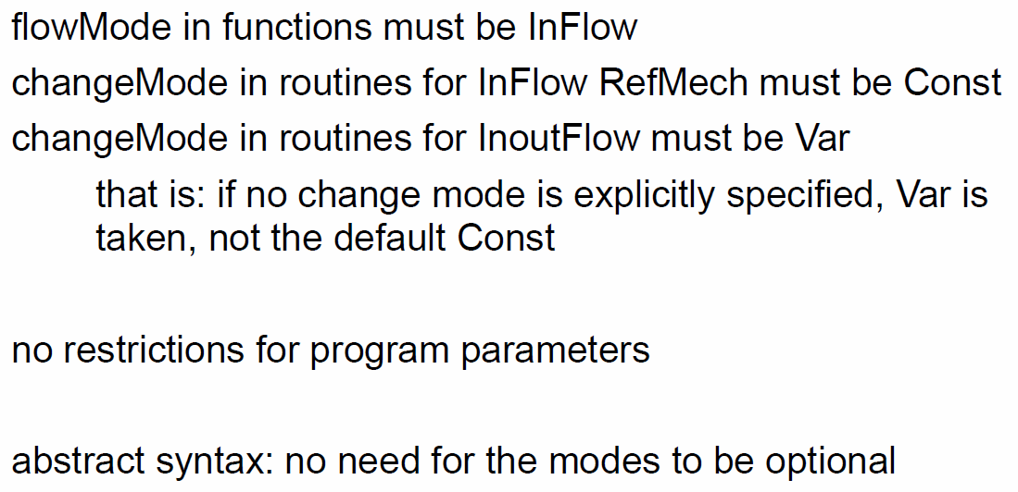

## Implementation

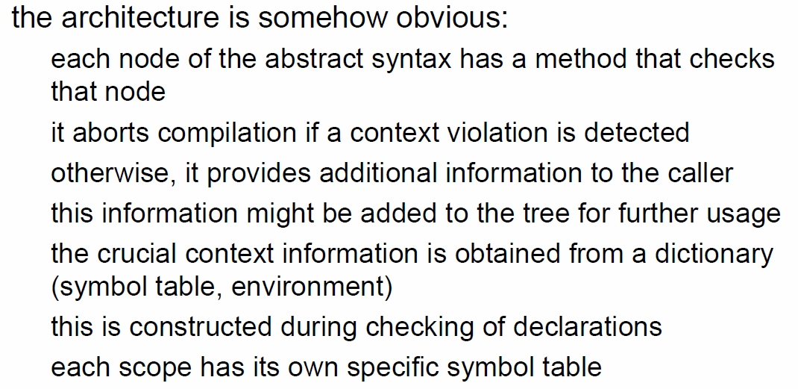

## Example Type of DyadicExpr

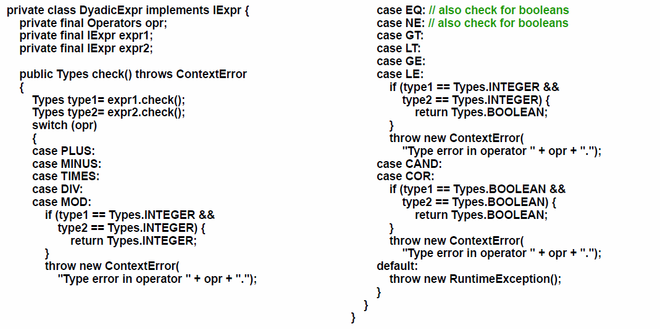

## Example Type of VarExpr

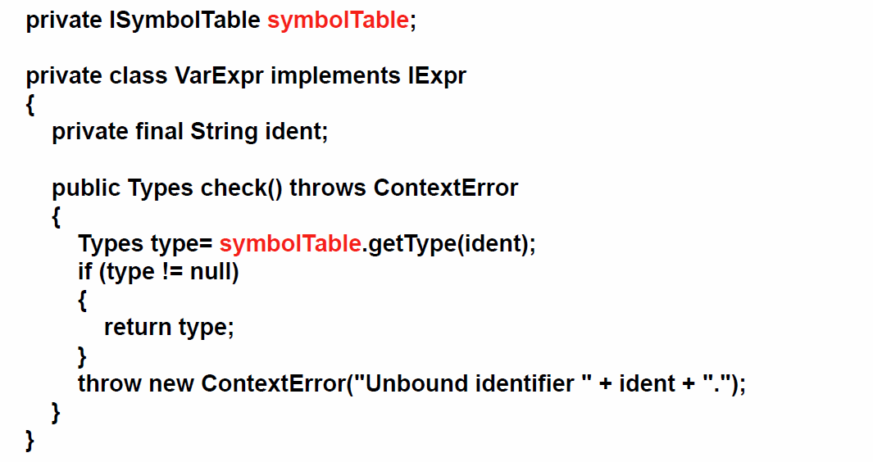

# Woche 14

In Woche 14 fanden die ersten Vorträge statt.

# Woche 15

In Woche 15 fanden die nächsten Vorträge statt.